**INDEX**

|  |  |  |  |  |  |
| --- | --- | --- | --- | --- | --- |
| Practical No. | | Description | Page No | Date | Sign |
| 1. |  | **Conversion from different file formats to HORUS format.** |  |  |  |
|  | A | Conversion from text delimited csv to HORUS format. |  | 23/9/2022 |  |
|  | B | Conversion from XML to HORUS format. |  | 23/9/2022 |  |
|  | C | Conversion from JSON to HORUS format. |  | 24/9/2022 |  |
|  | D | Conversion from MYSQL database to HORUS format. |  | 24/9/2022 |  |
|  | E | Conversion from picture (jpeg) to HORUS format. |  | 30/9/2022 |  |
|  | F | Conversion from video to HORUS format. |  | 30/9/2022 |  |
|  | G | Conversion from audio to HORUS format. |  | 30/9/2022 |  |
| **2.** |  | **Utilities and Auditing** |  |  |  |
|  | A | Fixer Utilities  1. Removing leading and lagging spaces from data entry  2. Removing non-printable characters from data entry  3. Reformatting data entry to match specific formatting criteria |  | 7/10/2022 |  |
|  | B | Data Binning and Bucketing |  | 7/10/2022 |  |
|  | C | Averaging of data |  | 8/10/2022 |  |
|  | D | Outlier Detection |  | 8/10/2022 |  |
|  | E | Logging: Write python/R program for basic logging in Data Science. |  | 8/10/2022 |  |
| **3** |  | **Retrieving Data** |  |  |  |
|  | A | Perform data processing using R |  | 15/10/2022 |  |
|  | B | Program to retrieve different attributes of data |  | 15/10/2022 |  |
|  | C | Data Pattern  Example 1  Example 2 |  | 15/10/2022 |  |
|  | D | Loading IP_DATA_ALL  Haversine distance calculation using Vermeulen dataset |  | 21/10/2022 |  |
|  | E | Building a diagram for scheduling of jobs |  | 21/10/2022 |  |
|  | F | Picking content for billboards |  | 21/10/2022 |  |
| **4** |  | **Assessing Data** |  |  |  |
|  | A | Perform error management on the given data  1. Drop the columns where all elements are missing values  2. Drop the columns where any of the elements is missing values 3. Keep only the rows that contain a maximum of two non-missing values  4. Fill All Missing Values with the Mean, Median, Mode, Minimum, and Maximum of the Particular Numeric Column |  | 11/11/2022 |  |
|  | B | Write python/R program to create the network routing diagram from the given data on routers in assess superstep. |  | 11/11/2022 |  |
|  | C | Write python/R program to build directed acyclic graph.  Example 1: Company location DAG  Example 2: Customer location DAG  Example 3: DAG using GPS data |  | 12/11/2022 |  |
|  | D | Write python/R program to pick the content for Billboards for the given data. |  | 12/11/2022 |  |
| **5** |  | **Processing Data** |  |  |  |
|  | A | Build the time hub, links and satellites. |  | 18/11/2022 |  |
|  | B | Golden Nominal |  | 18/11/2022 |  |
|  | C | Vehicles as object hub and satellite using python and SQLite. |  | 19/11/2022 |  |
|  | D | Human-Environment interaction |  | 19/11/2022 |  |
| **6** |  | **Transforming Data** |  |  |  |
|  | A | Program to show the details of hub: person being born. |  | 25/11/2022 |  |
|  | B | Building dimension Person, Time and fact PersonBornAtTime |  | 25/11/2022 |  |
|  | C | Building a Data warehouse for transform superstep. |  | 25/11/2022 |  |
|  | D | Write python program to demonstrate Simple Linear Regression. |  | 25/11/2022 |  |
| **7** |  | **Organizing Data** |  |  |  |
|  | A | Write python/R program to perform the horizontal style subset or slice of the data warehouse data. |  | 26/11/2022 |  |
|  | B | Write python/R program to perform the vertical style subset or slice of the data warehouse data. |  | 26/11/2022 |  |
|  | C | Write python/R program to perform the island style subset or slice of the data warehouse data. |  | 26/11/2022 |  |
|  | D | Write python/R program to perform the secure vault style subset or slice of the data warehouse data and attach the result to the person who performs the query. |  | 26/11/2022 |  |
|  | E | Write python program to demonstrate Association rule mining. |  | 26/11/2022 |  |
|  | F | Write python program to create network routing diagram in organizing superstep. |  | 26/11/2022 |  |
| **8** |  | **Generating Data** |  |  |  |
|  | A | Write python/R program to perform data visualization to create following graphs using profit data.  1. Pie Graph  2. Double Pie Graph  3. Line Graph  4. Vertical Bar Graph  5. Horizontal Bar Graph  6. Area Graph  7. Scatter Graph  8. Hex Bin Graph |  | 2/12/2022 |  |
|  | B | Write python/R program to perform data visualization to create following advanced graphs/plots for the data.  1. Kernel Density Estimation (KDE) Graph  2. Scatter Matrix  3. Andrew’s Curves  4. Parallel Coordinates  5. RADVIZ method  6. Lag Plot  7. Autocorrelation Plot  8. Bootstrap Plot  9. Contour Graphs  10. 3D Graph |  | 2/12/2022 |  |
|  |  |  |  |  |  |
| **9** |  | **Data Visualization with Power BI.** |  | 3/12/2022 |  |

# 

**Practical 1**

**AIM: Write Python program to convert files from different formats to HORUS format**

**Theory:** The Homogeneous Ontology for Recursive Uniform Schema (HORUS) is used as an internal data format structure that enables the framework to reduce the permutations of transformations required by the framework. The use of HORUS methodology results in a hub-and-spoke data transformation approach. External data formats are converted to HORUS format, and then a HORUS format is transformed into any other external format. The basic concept is to take native raw data and then transform it first to a single format. That means that there is only one format for text files, one format for JSON or XML, one format for images and video. Therefore, to achieve any-to-any transformation coverage, the framework’s only requirements are a dataformat- to-HORUS and HORUS-to- data-format converter.

**A. Conversion from text delimited csv to HORUS format**

**Code:**

# Utility Start CSV to HORUS =================================

# Standard Tools

import pandas as pd

# Input Agreement ============================================

sInputFileName='C:/VKHCG/05-DS/9999-Data/Country_Code.csv'

InputData=pd.read_csv(sInputFileName,encoding="latin-1")

print('Input Data Values ===================================')

print(InputData)

print('=====================================================')

# Processing Rules ===========================================

ProcessData=InputData

# Remove columns ISO-2-Code and ISO-3-CODE

ProcessData.drop('ISO-2-CODE', axis=1,inplace=True)

ProcessData.drop('ISO-3-Code', axis=1,inplace=True)

# Rename Country and ISO-M49

ProcessData.rename(columns={'Country': 'CountryName'}, inplace=True)

ProcessData.rename(columns={'ISO-M49': 'CountryNumber'}, inplace=True)

# Set new Index

ProcessData.set_index('CountryNumber', inplace=True)

# Sort data by CurrencyNumber

ProcessData.sort_values('CountryName', axis=0, ascending=False, inplace=True)

print('Process Data Values =================================')

print(ProcessData)

print('=====================================================')

# Output Agreement ===========================================

OutputData=ProcessData

sOutputFileName='C:/VKHCG/05-DS/9999-Data/HORUS-CSV-Country.csv'

OutputData.to_csv(sOutputFileName, index = False)

Print('UPGCM')

print('CSV to HORUS - Done')

# Utility done ===============================================

**Output:**

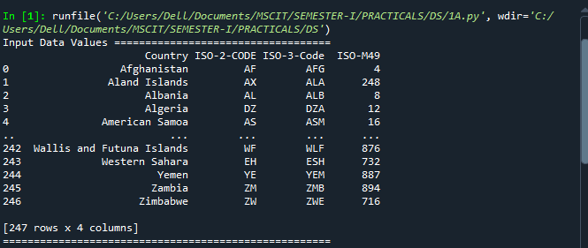

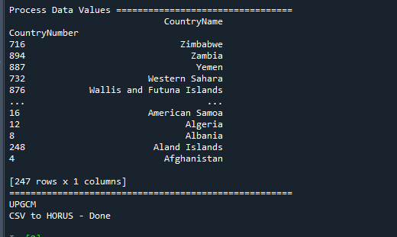

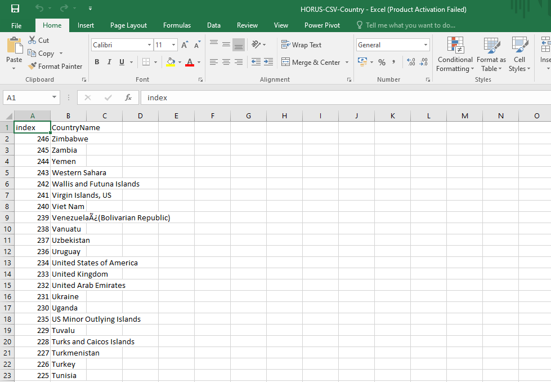

**B. Conversion from XML to HORUS format.**

**Code:**

import pandas as pd

import xml.etree.ElementTree as ET

def df2xml(data):

header = data.columns

root = ET.Element('root')

for row in range(data.shape[0]):

entry = ET.SubElement(root,'entry')

for index in range(data.shape[1]):

schild=str(header[index])

child = ET.SubElement(entry, schild)

if str(data[schild][row]) != 'nan':

child.text = str(data[schild][row])

else:

child.text = 'n/a'

entry.append(child)

result = ET.tostring(root)

return result

def xml2df(xml_data):

root = ET.XML(xml_data)

all_records = []

for i, child in enumerate(root):

record = {}

for subchild in child:

record[subchild.tag] = subchild.text

all_records.append(record)

return pd.DataFrame(all_records)

#=============================================================

# Input Agreement ============================================

#=============================================================

sInputFileName='C:/VKHCG/05-DS/9999-Data/Country_Code.xml'

InputData = open(sInputFileName).read()

print('=====================================================')

print('Input Data Values ===================================')

print('=====================================================')

print(InputData)

print('=====================================================')

# Processing Rules ===========================================

#=============================================================

ProcessDataXML=InputData

# XML to Data Frame

ProcessData=xml2df(ProcessDataXML)

# Remove columns ISO-2-Code and ISO-3-CODE

ProcessData.drop('ISO-2-CODE', axis=1,inplace=True)

ProcessData.drop('ISO-3-Code', axis=1,inplace=True)

# Rename Country and ISO-M49

ProcessData.rename(columns={'Country': 'CountryName'}, inplace=True)

ProcessData.rename(columns={'ISO-M49': 'CountryNumber'}, inplace=True)

# Set new Index

ProcessData.set_index('CountryNumber', inplace=True)

# Sort data by CurrencyNumber

ProcessData.sort_values('CountryName', axis=0, ascending=False, inplace=True)

print('=====================================================')

print('Process Data Values =================================')

print('=====================================================')

print(ProcessData)

print('=====================================================')

#=============================================================

# Output Agreement ===========================================

#=============================================================

OutputData=ProcessData

sOutputFileName='C:/VKHCG/05-DS/9999-Data/HORUS-XML-Country.csv'

OutputData.to_csv(sOutputFileName, index = False)

print('=====================================================')

print('UPGCM')

print('XML to HORUS - Done')

print('=====================================================')

# Utility done ===============================================

**Output:**

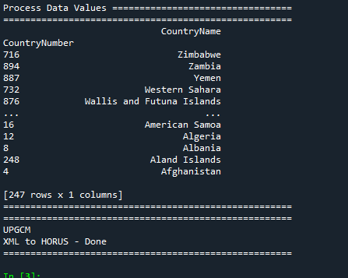

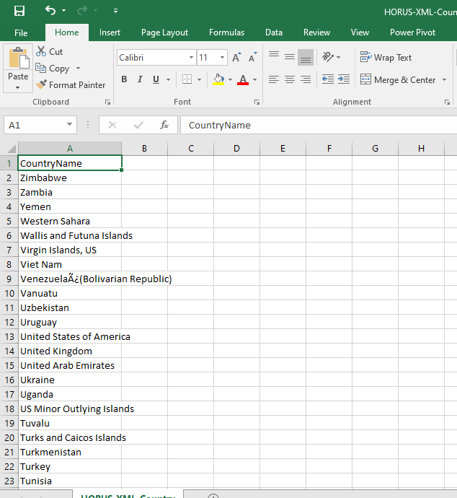

**C. Conversion from JSON to HORUS format.**

**Code:**

# Input Agreement ============================================

sInputFileName='C:/VKHCG/05-DS/9999-Data/Country_Code.json'

InputData=pd.read_json(sInputFileName,

orient='index',

encoding="latin-1")

print('Input Data Values ===================================')

print(InputData)

print('=====================================================')

# Processing Rules ===========================================

ProcessData=InputData

# Remove columns ISO-2-Code and ISO-3-CODE

ProcessData.drop('ISO-2-CODE', axis=1,inplace=True)

ProcessData.drop('ISO-3-Code', axis=1,inplace=True)

# Rename Country and ISO-M49

ProcessData.rename(columns={'Country': 'CountryName'}, inplace=True)

ProcessData.rename(columns={'ISO-M49': 'CountryNumber'}, inplace=True)

# Set new Index

ProcessData.set_index('CountryNumber', inplace=True)

# Sort data by CurrencyNumber

ProcessData.sort_values('CountryName', axis=0, ascending=False, inplace=True)

print('Process Data Values =================================')

print(ProcessData)

print('=====================================================')

# Output Agreement ===========================================

OutputData=ProcessData

sOutputFileName='C:/VKHCG/05-DS/9999-Data/HORUS-JSON-Country.csv'

OutputData.to_csv(sOutputFileName, index = False)

print('UPGCM')

print('JSON to HORUS - Done')

# Utility done ===============================================

**Output:**

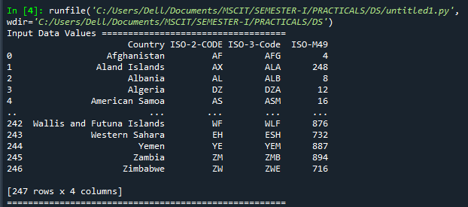

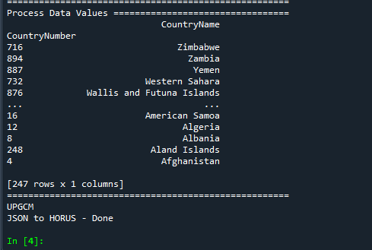

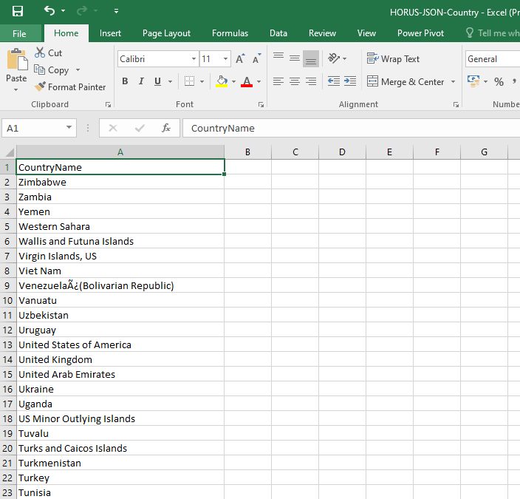

**D. Conversion from MYSQL database to HORUS format.**

**Code:**

#Utility Start Database to HORUS =================================

# Standard Tools

#=============================================================

import pandas as pd

import sqlite3 as sq

# Input Agreement ============================================

sInputFileName='C:/VKHCG/05-DS/9999-Data/utility.db'

sInputTable='Country_Code'

conn = sq.connect(sInputFileName)

sSQL='select * FROM ' + sInputTable + ';'

InputData=pd.read_sql_query(sSQL, conn)

print('Input Data Values ===================================')

print(InputData)

print('=====================================================')

# Processing Rules ===========================================

ProcessData=InputData

# Remove columns ISO-2-Code and ISO-3-CODE

ProcessData.drop('ISO-2-CODE', axis=1,inplace=True)

ProcessData.drop('ISO-3-Code', axis=1,inplace=True)

# Rename Country and ISO-M49

ProcessData.rename(columns={'Country': 'CountryName'}, inplace=True)

ProcessData.rename(columns={'ISO-M49': 'CountryNumber'}, inplace=True)

# Set new Index

ProcessData.set_index('CountryNumber', inplace=True)

# Sort data by CurrencyNumber

ProcessData.sort_values('CountryName', axis=0, ascending=False, inplace=True)

print('Process Data Values =================================')

print(ProcessData)

print('=====================================================')

# Output Agreement ===========================================

OutputData=ProcessData

sOutputFileName='C:/VKHCG/05-DS/9999-Data/HORUS-CSV-Country.csv'

OutputData.to_csv(sOutputFileName, index = False)

print('UPGCM')

print('Database to HORUS - Done')

# Utility done ===============================================

**Output:**

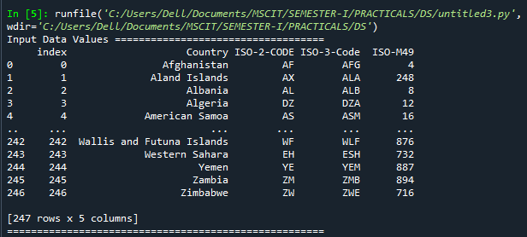

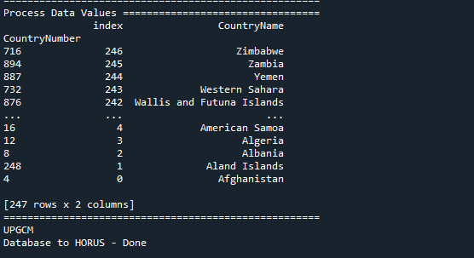

**E. Conversion from picture (jpeg) to HORUS format.**

**Code:**

# Utility Start Picture to HORUS =================================

# Standard Tools

#=============================================================

from scipy.misc import imread

import pandas as pd

import matplotlib.pyplot as plt

import numpy as np

# Input Agreement ============================================

sInputFileName='C:/VKHCG/05-DS/9999-Data/Angus.jpg'

InputData = imread(sInputFileName, flatten=False, mode='RGBA')

print('Input Data Values ===================================')

print('X: ',InputData.shape[0])

print('Y: ',InputData.shape[1])

print('RGBA: ', InputData.shape[2])

print('=====================================================')

# Processing Rules ===========================================

ProcessRawData=InputData.flatten()

y=InputData.shape[2] + 2

x=int(ProcessRawData.shape[0]/y)

ProcessData=pd.DataFrame(np.reshape(ProcessRawData, (x, y)))

sColumns= ['XAxis','YAxis','Red', 'Green', 'Blue','Alpha']

ProcessData.columns=sColumns

ProcessData.index.names =['ID']

print('Rows: ',ProcessData.shape[0])

print('Columns :',ProcessData.shape[1])

print('=====================================================')

print('Process Data Values =================================')

print('=====================================================')

plt.imshow(InputData)

plt.show()

print('=====================================================')

# Output Agreement ===========================================

OutputData=ProcessData

print('Storing File')

sOutputFileName='C:/VKHCG/05-DS/9999-Data/HORUS-Picture.csv'

OutputData.to_csv(sOutputFileName, index = False)

print('=====================================================')

print('UPGCM')

print('Picture to HORUS - Done')

print('=====================================================')

# Utility done ===============================================

**Output:**

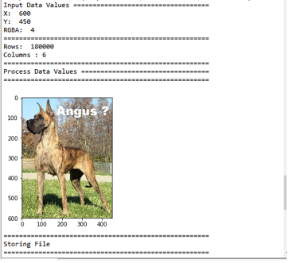

**F. Conversion from video to HORUS format.**

**Code:**

# Utility Start Movie to HORUS (Part 1) ======================

# Standard Tools

#=============================================================

import os

import shutil

import cv2

#=============================================================

sInputFileName='C:/VKHCG/05-DS/9999-Data/dog.mp4'

sDataBaseDir='C:/VKHCG/05-DS/9999-Data/temp'

if os.path.exists(sDataBaseDir):

shutil.rmtree(sDataBaseDir)

if not os.path.exists(sDataBaseDir):

os.makedirs(sDataBaseDir)

print('=====================================================')

print('Start Movie to Frames')

print('=====================================================')

vidcap = cv2.VideoCapture(sInputFileName)

success,image = vidcap.read()

count = 0

while success:

success,image = vidcap.read()

sFrame=sDataBaseDir + str('/dog-frame-' + str(format(count, '04d'))+ '.jpg')

print('Extracted: ', sFrame)

cv2.imwrite(sFrame, image)

if os.path.getsize(sFrame) == 0:

count += -1

os.remove(sFrame)

print('Removed: ', sFrame)

if cv2.waitKey(10) == 27: # exit if Escape is hit

break

count += 1

print('=====================================================')

print('Generated : ', count, ' Frames')

print('=====================================================')

print('Movie to Frames HORUS - Done')

print('=====================================================')

# Utility done ===============================================

**Output:**

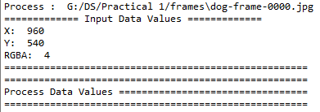

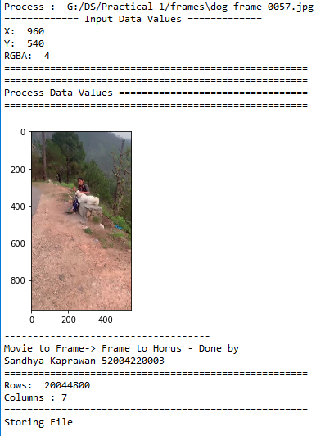

**G. Conversion from audio to HORUS format.**

**Code:**

#Utility Start Audio to HORUS ===============================

# Standard Tools

#=============================================================

from scipy.io import wavfile

import pandas as pd

import matplotlib.pyplot as plt

import numpy as np

#=============================================================

def show_info(aname, a,r):

print ('----------------')

print ("Audio:", aname)

print ('----------------')

print ("Rate:", r)

print ('----------------')

print ("shape:", a.shape)

print ("dtype:", a.dtype)

print ("min, max:", a.min(), a.max())

print ('----------------')

plot_info(aname, a,r)

#=============================================================

def plot_info(aname, a,r):

sTitle= 'Signal Wave - '+ aname + ' at ' + str(r) + 'hz'

plt.title(sTitle)

sLegend=[]

for c in range(a.shape[1]):

sLabel = 'Ch' + str(c+1)

sLegend=sLegend+[str(c+1)]

plt.plot(a[:,c], label=sLabel)

plt.legend(sLegend)

plt.show()

#=============================================================

sInputFileName='C:/VKHCG/05-DS/9999-Data/2ch-sound.wav'

print('=====================================================')

print('Processing : ', sInputFileName)

print('=====================================================')

InputRate, InputData = wavfile.read(sInputFileName)

show_info("2 channel", InputData,InputRate)

ProcessData=pd.DataFrame(InputData)

sColumns= ['Ch1','Ch2']

ProcessData.columns=sColumns

OutputData=ProcessData

sOutputFileName='C:/VKHCG/05-DS/9999-Data/HORUS-Audio-2ch.csv'

OutputData.to_csv(sOutputFileName, index = False)

#=============================================================

sInputFileName='C:/VKHCG/05-DS/9999-Data/4ch-sound.wav'

print('=====================================================')

print('Processing : ', sInputFileName)

print('=====================================================')

InputRate, InputData = wavfile.read(sInputFileName)

show_info("4 channel", InputData,InputRate)

ProcessData=pd.DataFrame(InputData)

sColumns= ['Ch1','Ch2','Ch3', 'Ch4']

ProcessData.columns=sColumns

OutputData=ProcessData

sOutputFileName='C:/VKHCG/05-DS/9999-Data/HORUS-Audio-4ch.csv'

OutputData.to_csv(sOutputFileName, index = False)

#=============================================================

sInputFileName='C:/VKHCG/05-DS/9999-Data/6ch-sound.wav'

print('=====================================================')

print('Processing : ', sInputFileName)

print('=====================================================')

InputRate, InputData = wavfile.read(sInputFileName)

show_info("6 channel", InputData,InputRate)

ProcessData=pd.DataFrame(InputData)

sColumns= ['Ch1','Ch2','Ch3', 'Ch4', 'Ch5','Ch6']

ProcessData.columns=sColumns

OutputData=ProcessData

sOutputFileName='C:/VKHCG/05-DS/9999-Data/HORUS-Audio-6ch.csv'

OutputData.to_csv(sOutputFileName, index = False)

#=============================================================

sInputFileName='C:/VKHCG/05-DS/9999-Data/8ch-sound.wav'

print('=====================================================')

print('Processing : ', sInputFileName)

print('=====================================================')

InputRate, InputData = wavfile.read(sInputFileName)

show_info("8 channel", InputData,InputRate)

ProcessData=pd.DataFrame(InputData)

sColumns= ['Ch1','Ch2','Ch3', 'Ch4', 'Ch5','Ch6','Ch7','Ch8']

ProcessData.columns=sColumns

OutputData=ProcessData

sOutputFileName='C:/VKHCG/05-DS/9999-Data/HORUS-Audio-8ch.csv'

OutputData.to_csv(sOutputFileName, index = False)

print('=====================================================')

print('UPGCM')

print('Audio to HORUS - Done')

print('=====================================================')

#=============================================================

# Utility done ===============================================

**Output:**

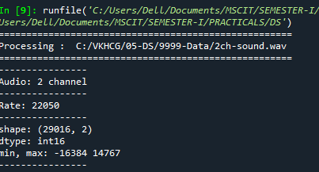

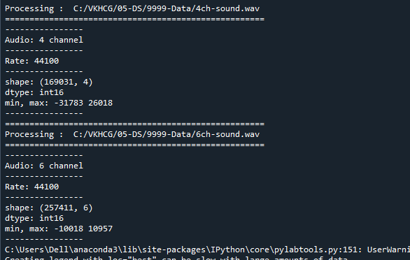

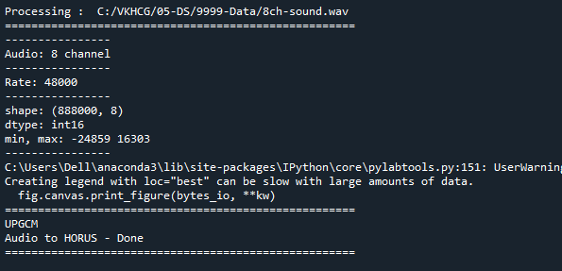

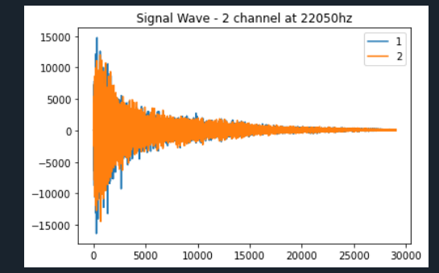

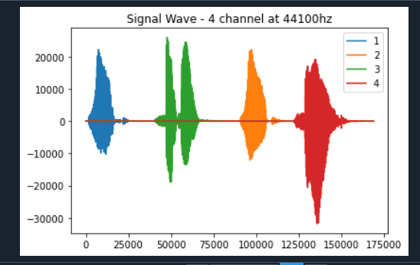

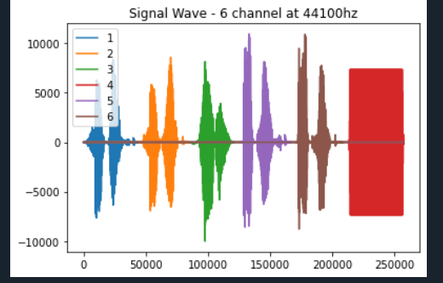

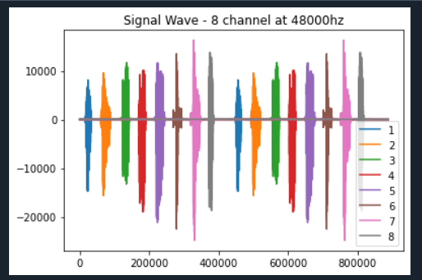

**Practical 2**

**AIM: Utilities and Auditing**

**Theory:**

Basic Utility Design

1. Load data as per input agreement.

2. Apply processing rules of utility.

3. Save data as per output agreement.

There are three types of utilities

• Data processing utilities

• Maintenance utilities

• Processing utility

Binning is a data preprocessing technique used to reduce the effects of minor observation errors. Statistical data binning is a way to group a number of more or less continuous values into a smaller number of “bins.”

The use of averaging of features value enables the reduction of data volumes in a control fashion to improve effective data processing.

Outliers are data that is so different from the rest of the data in the data set that it may be caused by an error in the data source. There is a technique called outlier detection that, with good data science, will identify these outliers.

1. **Fixer Utility**
2. **Removing leading or lagging spaces from a data entry**

**Code:**

import string

import datetime as dt

print( 1 Removing leading or lagging spaces from a data entry') ;

baddata = " Data Science with too many spaces is bad!! ! "

print('>',baddata,'<' )

cleandata=baddata.strip( )

print('>',cleandata,'<' )

print(‘UPGCM’)

**Output:**

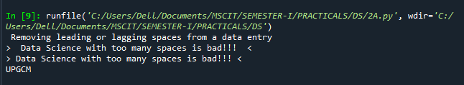

1. **Removing nonprintable characters from a data entry**

**Code:**

import string

import datetime as dt

print('2 Removing nonprintable characters from a data entry' )

printable = set(string.printable )

baddata = "Data\00Science with\0 2 funny characters is \10bad!!!"

cleandata=''.join(filter(lambda x : x in string.printable,baddata))

print('Bad Data : ',baddata) ;

print('Clean Data : ',cleandata )

print(‘UPGCM’)

**Output:**

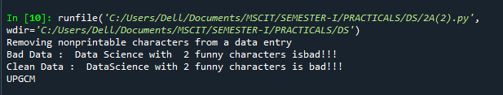

1. **Reformatting data entry to match specific formatting criteria.**

**Code:**

import string

import datetime as dt

print(' 3 Reformatting data entry to match specific formatting criteria.')

baddate = dt.date(2019 , 10 , 31 )

baddata = format(baddate,'%Y- %m-%d')

gooddate = dt.datetime.strptime(baddata,'%Y- %m-%d')

gooddata = format(gooddate,'%d%B%Y' )

print('Bad Data : ',baddata )

print('Good Data : ',gooddata )

print('UPGCM')

**Output:**

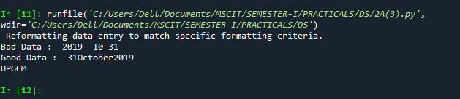

**B. Data Binning and Bucketing**

**Code:**

import numpy as np

import matplotlib.mlab as mlab

import matplotlib.pyplot as plt

import scipy.stats as stats

np.random.seed(0 )

# example data

mu = 90 # mean of distribution

sigma = 25 # standard deviation o f distribution

x = mu + sigma * np.random.randn(5000 )

num_bins = 25

fig , ax = plt.subplots( )

# the histogram of the data

n , bins , patches = ax.hist(x , num_bins , density=1 )

# add a 'best fit' line

y = stats.norm.pdf(bins , mu , sigma )

# mlab.normpdf(bins , mu , sigma )

ax.plot(bins , y,'--')

ax.set_xlabel('Example Data')

ax.set_ylabel('Probability density' )

sTitle=r'Histogram ' + str(len(x) ) + ' entries into' + str(num_bins ) + ' Bins : $\mu= ' + str(mu ) + '$ , $\sigma= ' + str(sigma ) + '$'

ax.set_title(sTitle )

fig.tight_layout( )

sPathFig='C:/VKHCG/05-DS/DU-Histogram.png'

fig.savefig(sPathFig )

print('UPGCM')

plt.show( )

**Output:**



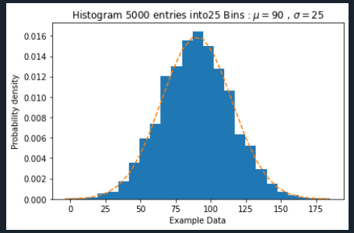

**C. Averaging of Data**

**Code:**

import pandas as pd

################################################################

InputFileName='IP_DATA_CORE.csv'

OutputFileName='Retrieve_Router_Location.csv'

################################################################

Base='C:/VKHCG'

print('################################')

print('Working Base :',Base)

print('################################')

################################################################

sFileName=Base + '/01-Vermeulen/00-RawData/' + InputFileName

print('Loading :',sFileName)

IP_DATA_ALL=pd.read_csv(sFileName,header=0,low_memory=False,

usecols=['Country','Place Name','Latitude','Longitude'], encoding="latin-1")

IP_DATA_ALL.rename(columns={'Place Name': 'Place_Name'}, inplace=True)

AllData=IP_DATA_ALL[['Country', 'Place_Name','Latitude']]

print(AllData)

MeanData=AllData.groupby(['Country', 'Place_Name'])['Latitude'].mean()

print(MeanData)

print('UPGCM')

**Output:**

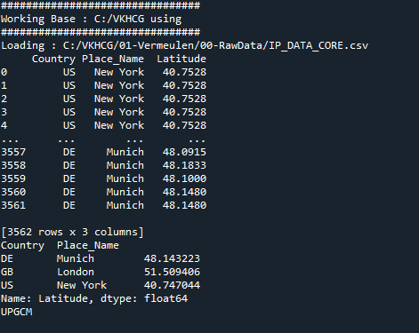

**D. Outlier Detection**

**Code:**

import pandas as pd

################################################################

InputFileName='IP_DATA_CORE.csv'

OutputFileName='Retrieve_Router_Location.csv'

################################################################

Base='C:/VKHCG'

print('################################')

print('UPGCM')

print('Working Base :',Base)

print('################################')

################################################################

sFileName=Base + '/01-Vermeulen/00-RawData/' + InputFileName

print('Loading :',sFileName)

IP_DATA_ALL=pd.read_csv(sFileName,header=0,low_memory=False,

usecols=['Country','Place Name','Latitude','Longitude'], encoding="latin-1")

IP_DATA_ALL.rename(columns={'Place Name': 'Place_Name'}, inplace=True)

AllData=IP_DATA_ALL[['Country', 'Place_Name','Latitude']]

print(AllData)

MeanData=AllData.groupby(['Country', 'Place_Name'])['Latitude'].mean()

print(MeanData)

print('UPGCM')

**Output:**

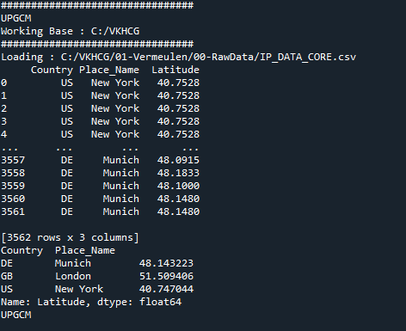

**E. Logging**

**Code:**

import sys

import os

import logging

import uuid

import shutil

import time

############################################################

if sys.platform == 'linux':

Base=os.path.expanduser('~') + '/VKHCG'

else:

Base='C:/VKHCG'

############################################################

sCompanies=['01-Vermeulen','02-Krennwallner','03-Hillman','04-Clark']

sLayers=['01-Retrieve','02-Assess','03-Process','04-Transform','05-Organise','06-Report']

sLevels=['debug','info','warning','error']

print('UPGCM')

for sCompany in sCompanies:

sFileDir=Base + '/' + sCompany

if not os.path.exists(sFileDir):

os.makedirs(sFileDir)

for sLayer in sLayers:

log = logging.getLogger() # root logger

for hdlr in log.handlers[:]: # remove all old handlers

log.removeHandler(hdlr)

############################################################

sFileDir=Base + '/' + sCompany + '/' + sLayer + '/Logging'

if os.path.exists(sFileDir):

shutil.rmtree(sFileDir)

time.sleep(2)

if not os.path.exists(sFileDir):

os.makedirs(sFileDir)

skey=str(uuid.uuid4())

sLogFile=Base + '/' + sCompany + '/' + sLayer + '/Logging/Logging_'+skey+'.log'

print('Set up:',sLogFile)

# set up logging to file - see previous section for more details

logging.basicConfig(level=logging.DEBUG,

format='%(asctime)s %(name)-12s %(levelname)-8s %(message)s',

datefmt='%m-%d %H:%M',

filename=sLogFile,

filemode='w')

# define a Handler which writes INFO messages or higher to the sys.stderr

console = logging.StreamHandler()

console.setLevel(logging.INFO)

# set a format which is simpler for console use

formatter = logging.Formatter('%(name)-12s: %(levelname)-8s %(message)s')

# tell the handler to use this format

console.setFormatter(formatter)

# add the handler to the root logger

logging.getLogger('').addHandler(console)

# Now, we can log to the root logger, or any other logger. First the root...

logging.info('Practical Data Science is fun!.')

for sLevel in sLevels:

sApp='Apllication-'+ sCompany + '-' + sLayer + '-' + sLevel

logger = logging.getLogger(sApp)

if sLevel == 'debug':

logger.debug('Practical Data Science logged a debugging message.')

if sLevel == 'info':

logger.info('Practical Data Science logged information message.')

if sLevel == 'warning':

logger.warning('Practical Data Science logged a warning message.')

if sLevel == 'error':

logger.error('Practical Data Science logged an error message.')

**Output:**

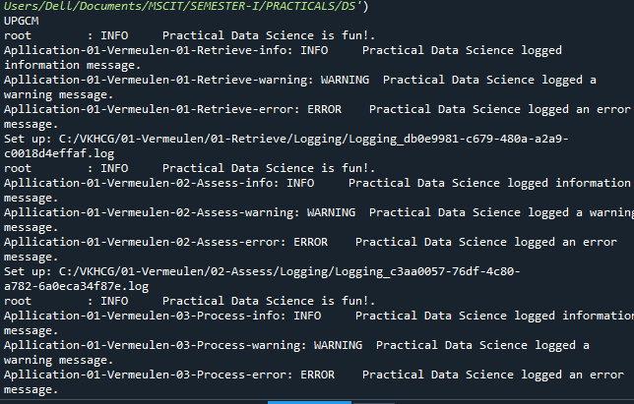

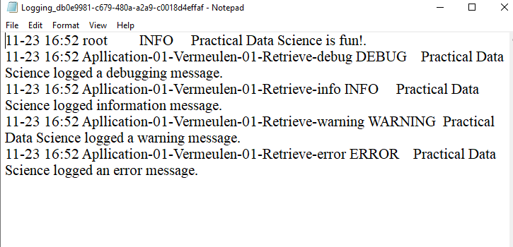

**Practical 3**

**AIM:** **Retrieving Data**

**Theory:**

The Retrieve superstep is a practical method for importing completely into the processing ecosystem a data lake consisting of various external data sources. The Retrieve superstep is the first contact between your data science and the source systems. I will guide you through a methodology of how to handle this discovery of the data up to the point you have all the data you need to evaluate the system you are working with, by deploying your data science skills. The successful retrieval of the data is a major stepping-stone to ensuring that you are performing good data science. Data lineage delivers the audit trail of the data elements at the lowest granular level, to ensure full data governance.

To determine a pattern of the data values, Replace all alphabet values with an uppercase case A, all numbers with an uppercase N, and replace any spaces with a lowercase letter b and all other unknown characters with a lowercase u. As a result, “Good Book 101” becomes “AAAAbAAAAbNNNu.”This pattern creation is beneficial for designing any specific assess rules. This pattern view of data is a quick way to identify common patterns or determine standard layouts.

This is a common use of patterns to separate common standards and structures. Pattern can be

loaded in separate retrieve procedures. If the same two patterns, NNNNuNNuNN and uuNNuNNuNN, are

found, you can send NNNNuNNuNN directly to be converted into a date, while uuNNuNNuNN goes through a quality-improvement process to then route back to the same queue as NNNNuNNuNN, once it complies.

1. **Perform the following data processing using R** .

**Code:**

>library(readr)

>IP_DATA_ALL<-read_csv("C:/VKHCG/01-Vermeulen/00RawData/IP_DATA_ALL.csv")

>View(IP_DATA_ALL)

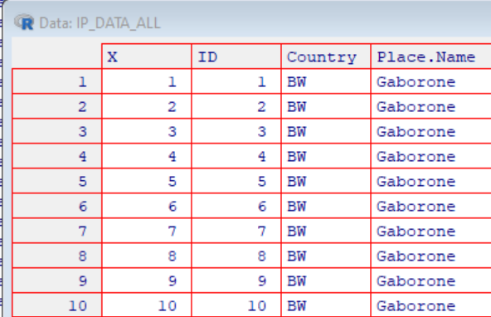

>spec(IP_DATA_ALL)

>library(tibble)

>set_tidy_names(IP_DATA_ALL , syntactic = TRUE , quiet = FALSE)

>IP_DATA_ALL_FIX=set_tidy_names(IP_DATA_ALL , syntactic = TRUE , quiet = TRUE)

>sapply(IP_DATA_ALL_FIX , typeof)

>library(data.table)

> hist_country=data.table(Country=unique(IP_DATA_ALL[is.na(IP_DATA_ALL ['Country'] )==0 ,]$Country))

>setorder(hist_country,'Country')

>hist_country_with_id=rowid_to_column(hist_country , va r = "RowIDCountry") >View(hist_country_with_id)

>IP_DATA_COUNTRY_FREQ=data.table(with(IP_DATA_ALL_FIX , table(Country)))

>View(IP_DATA_COUNTRY_FREQ)

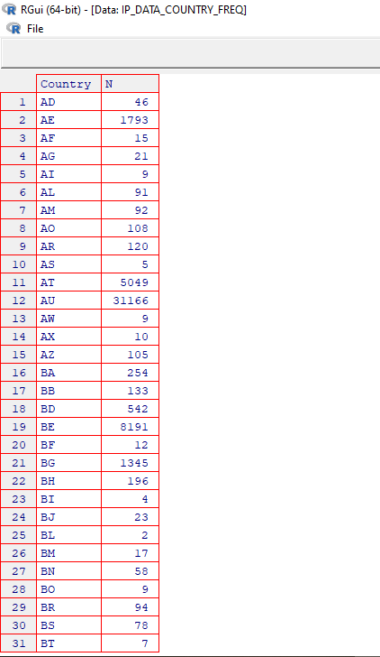

>hist_latitude =data.table(Latitude=unique(IP_DATA_ALL [is.na(IP_DATA_ALL['Latitude'] ) = = 0 , ]$Latitude))

>setkeyv(hist_latitude , 'Latitude' ) setorder(hist_latitude )

>hist_latitude_with_id=rowid_to_column(hist_latitude , var = "RowID" )

> View(hist_latitude_with_ id)

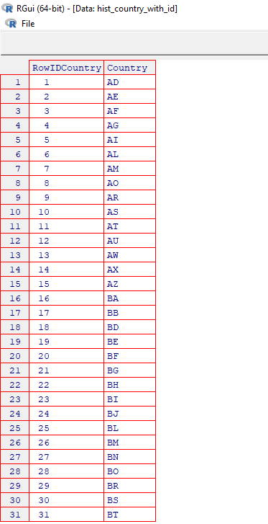

>IP_DATA_Latitude_FREQ=data.table(with(IP_DATA_ALL_FIX,table(Latitude)) ) >View(IP_DATA_Latitude_FREQ )

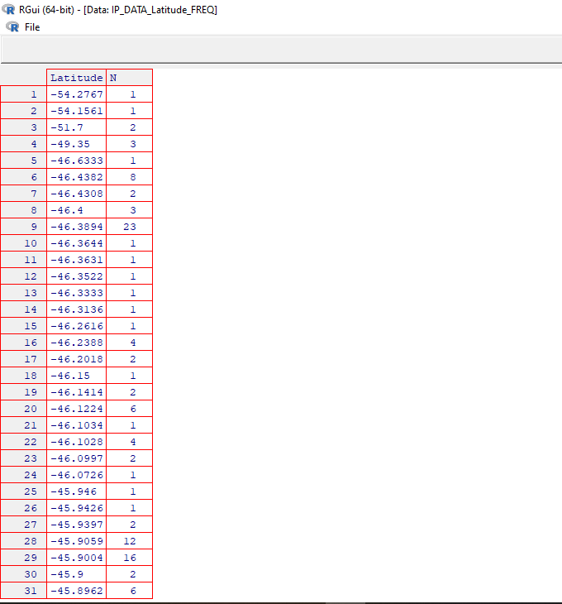

> sapply(IP_DATA_ALL_FIX[,'Latitude'] , min,na.rm=TRUE)

>sapply(IP_DATA_ALL_FIX[,'Country'] , min , na.rm=TRUE)

> sapply(IP_DATA_ALL_FIX[,'Latitude'] , max , na.rm=TRUE)

>sapply(IP_DATA_ALL_FIX[,'Country'], max , na.rm=TRUE )

> sapply(IP_DATA_ALL_FIX [,'Latitude'] , mean, na.rm=TRUE)

>sapply(IP_DATA_ALL_FIX [,'Latitude'] , median , na.rm=TRUE)

>sapply(IP_DATA_ALL_FIX [,'Latitude'] , range , na.rm=TRUE)

> sapply(IP_DATA_ALL_FIX [,'Latitude'] , quantile , na.rm=TRUE)

>sapply(IP_DATA_ALL_FIX [,'Latitude'] , sd , na.rm=TRUE)

>sapply(IP_DATA_ALL_FIX [,'Longitude'] , sd , na.rm=TRUE)

**Output:**

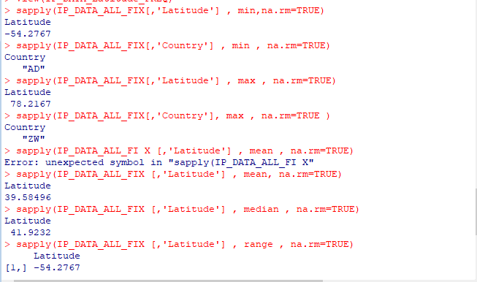

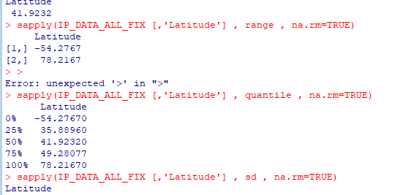

1. **Program to retrieve different attributes of data .**

**Code:**

import sys

import os

import pandas as pd

################################################################

if sys.platform == 'linux':

Base=os.path.expanduser('~') + '/VKHCG'

else:

Base='C:/VKHCG'

################################################################

sFileName=Base + '/01-Vermeulen/00-RawData/IP_DATA_ALL.csv'

print('Loading :',sFileName)

IP_DATA_ALL=pd.read_csv(sFileName,header=0,low_memory=False, encoding="latin-1")

################################################################

sFileDir=Base + '/01-Vermeulen/01-Retrieve/01-EDS/02-Python'

if not os.path.exists(sFileDir):

os.makedirs(sFileDir)

print('Rows:', IP_DATA_ALL.shape[0])

print('Columns:', IP_DATA_ALL.shape[1])

print('### Raw Data Set #####################################')

for i in range(0,len(IP_DATA_ALL.columns)):

print(IP_DATA_ALL.columns[i],type(IP_DATA_ALL.columns[i]))

print('### Fixed Data Set ###################################')

IP_DATA_ALL_FIX=IP_DATA_ALL

for i in range(0,len(IP_DATA_ALL.columns)):

cNameOld=IP_DATA_ALL_FIX.columns[i] + ' '

cNameNew=cNameOld.strip().replace(" ", ".")

IP_DATA_ALL_FIX.columns.values[i] = cNameNew

print(IP_DATA_ALL.columns[i],type(IP_DATA_ALL.columns[i]))

################################################################

#print(IP_DATA_ALL_FIX.head())

################################################################

print('Fixed Data Set with ID')

IP_DATA_ALL_with_ID=IP_DATA_ALL_FIX

IP_DATA_ALL_with_ID.index.names = ['RowID']

#print(IP_DATA_ALL_with_ID.head())

sFileName2=sFileDir + '/Retrieve_IP_DATA.csv'

IP_DATA_ALL_with_ID.to_csv(sFileName2, index = True, encoding="latin-1")

################################################################

print('### Done!! ############################################')

print('UPGCM')

################################################################

**Output:**

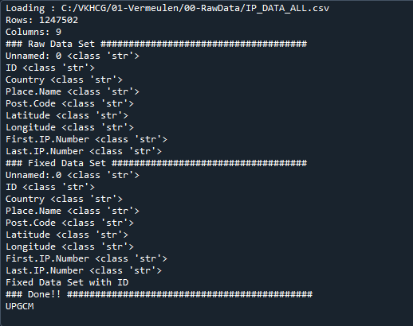

1. **Data Pattern**

**Example 1:**

**Code:**

library(readr)

library(data.table)

FileName=paste0('c:/VKHCG/01-Vermeulen/00-RawData/IP_DATA_ALL.csv') IP_DATA_ALL <- read_csv(FileName )

hist_country=data.table(Country=unique(IP_DATA_ALL$Country)) pattern_country=data.table(Country=hist_country$Country,

PatternCountry=hist_country$Country)

oldchar=c(letters,LETTERS )

newchar=replicate(length(oldchar),"A")

for ( r in seq(nrow(pattern_country))) {

s=pattern_country[r,]$PatternCountry ;

for ( c in seq(length(oldchar))) {

s=chartr(oldchar[c],newchar[c],s ) } ;

for ( n i n seq(0,9,1)) {

s=chartr(as.character(n),"N",s ) } ;

s=chartr( " ","b",s ) s=chartr(".","u",s )

pattern_country[r,]$PatternCountry=s ; } ;

View(pattern_country )

**Output:**

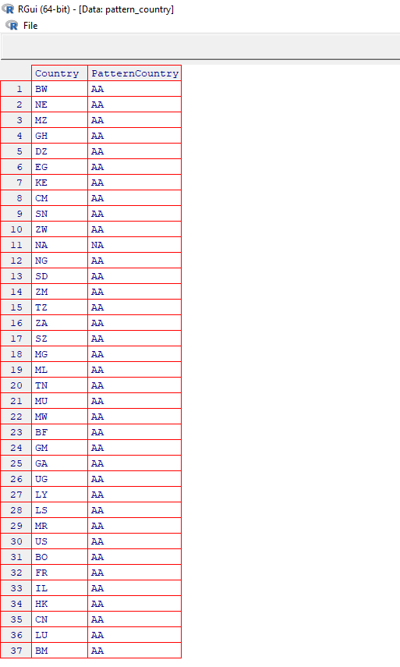

**Example 2:**

**Code:**

library(readr )

library(data.table )

Base='C:/VKHCG '

FileName=paste0(Base,'/01-Vermeulen/00-RawData/IP_DATA_ALL.csv')

IP_DATA_ALL<- read_csv(FileName)

hist_latitude=data.table(Latitude=unique(IP_DATA_ALL$Latitude)) pattern_latitude=data.table(latitude=hist_latitude$Latitude ,

Patternlatitude=as.character(hist_latitude$Latitude)) oldchar=c(letters,LETTERS )

newchar=replicate(length(oldchar),"A")

for ( r in seq(nrow(pattern_latitude))){

s=pattern_latitude[r,]$Patternlatitude;

for ( c in seq(length(oldchar))) {

s=chartr(oldchar[c],newchar[c],s ) } ;

for ( n in seq(0,9,1)) {

s=chartr(as.character(n),"N",s ) } ;

s=chartr( " ","b",s )

s=chartr("+","u",s )

s=chartr( "","u",s)

s=chartr(".","u",s )

pattern_latitude[r,]$Patternlatitude=s ; } ;

setorder(pattern_latitude,latitude )

View(pattern_latitude[1:3] )

**Output:**

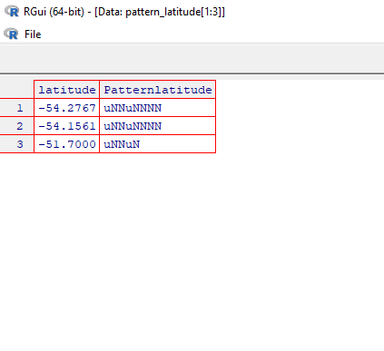

1. **Loading IP_DATA_ALL**

**Haversine distance calculation using Vermeulen dataset**

**Code:**

import sys

import os

import pandas as pd

from math import radians, cos, sin, asin, sqrt

def haversine(lon1, lat1, lon2, lat2,stype):

"""

Calculate the great circle distance between two points

on the earth (specified in decimal degrees)

"""

# convert decimal degrees to radians

lon1, lat1, lon2, lat2 = map(radians, [lon1, lat1, lon2, lat2])

# haversine formula

dlon = lon2 - lon1

dlat = lat2 - lat1

a = sin(dlat/2)**2 + cos(lat1) * cos(lat2) * sin(dlon/2)**2

c = 2 * asin(sqrt(a))

if stype == 'km':

r = 6371 # Radius of earth in kilometers

else:

r = 3956 # Radius of earth in miles

d=round(c * r,3)

return d

if sys.platform == 'linux':

Base=os.path.expanduser('~') + '/VKHCG'

else:

Base='C:/VKHCG'

sFileName=Base + '/01-Vermeulen/00-RawData/IP_DATA_CORE.csv'

print('Loading :',sFileName)

IP_DATA_ALL=pd.read_csv(sFileName,header=0,low_memory=False,

usecols=['Country','Place Name','Latitude','Longitude'], encoding="latin-1")

sFileDir=Base + '/01-Vermeulen/01-Retrieve/01-EDS/02-Python'

if not os.path.exists(sFileDir):

os.makedirs(sFileDir)

IP_DATA = IP_DATA_ALL.drop_duplicates(subset=None, keep='first', inplace=False)

IP_DATA.rename(columns={'Place Name': 'Place_Name'}, inplace=True)

IP_DATA1 = IP_DATA

IP_DATA1.insert(0, 'K', 1)

IP_DATA2 = IP_DATA1

print(IP_DATA1.shape)

IP_CROSS=pd.merge(right=IP_DATA1,left=IP_DATA2,on='K')

IP_CROSS.drop('K', axis=1, inplace=True)

IP_CROSS.rename(columns={'Longitude_x': 'Longitude_from', 'Longitude_y': 'Longitude_to'}, inplace=True)

IP_CROSS.rename(columns={'Latitude_x': 'Latitude_from', 'Latitude_y': 'Latitude_to'}, inplace=True)

IP_CROSS.rename(columns={'Place_Name_x': 'Place_Name_from', 'Place_Name_y': 'Place_Name_to'}, inplace=True)

IP_CROSS.rename(columns={'Country_x': 'Country_from', 'Country_y': 'Country_to'}, inplace=True)

IP_CROSS['DistanceBetweenKilometers'] = IP_CROSS.apply(lambda row:

haversine(

row['Longitude_from'],

row['Latitude_from'],

row['Longitude_to'],

row['Latitude_to'],

'km')

,axis=1)

IP_CROSS['DistanceBetweenMiles'] = IP_CROSS.apply(lambda row:

haversine(

row['Longitude_from'],

row['Latitude_from'],

row['Longitude_to'],

row['Latitude_to'],

'miles')

,axis=1)

print(IP_CROSS.shape)

sFileName2=sFileDir + '/Retrieve_IP_Routing.csv'

IP_CROSS.to_csv(sFileName2, index = False, encoding="latin-1")

print('### Done!! ############################################')

print(‘UPGCM’)

**Output:**

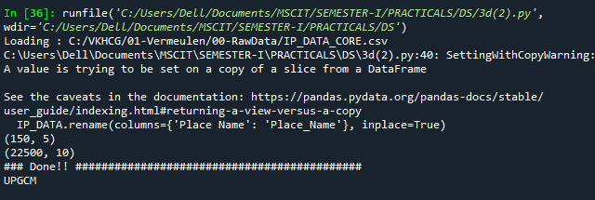

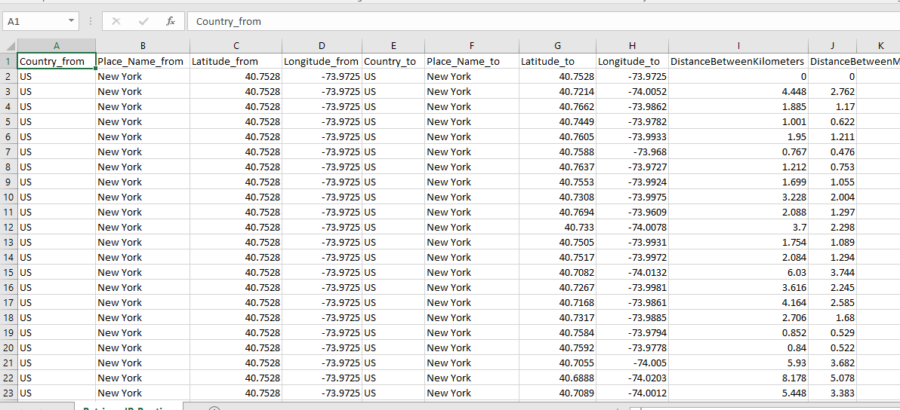

**E. Building a Diagram for the Scheduling of Jobs**

**Code:**

import sys

import os

import pandas as pd

InputFileName='IP_DATA_CORE.csv'

OutputFileName='Retrieve_Router_Location.csv'

if sys.platform == 'linux':

Base=os.path.expanduser('~') + '/VKHCG'

else:

Base='C:/VKHCG'

sFileName=Base + '/01-Vermeulen/00-RawData/' + InputFileName

print('Loading :',sFileName)

IP_DATA_ALL=pd.read_csv(sFileName,header=0,low_memory=False,

usecols=['Country','Place Name','Latitude','Longitude'], encoding="latin-1")

################################################################

IP_DATA_ALL.rename(columns={'Place Name': 'Place_Name'}, inplace=True)

################################################################

sFileDir=Base + '/01-Vermeulen/01-Retrieve/01-EDS/02-Python'

if not os.path.exists(sFileDir):

os.makedirs(sFileDir)

ROUTERLOC = IP_DATA_ALL.drop_duplicates(subset=None, keep='first', inplace=False)

print('Rows :',ROUTERLOC.shape[0])

print('Columns :',ROUTERLOC.shape[1])

sFileName2=sFileDir + '/' + OutputFileName

ROUTERLOC.to_csv(sFileName2, index = False, encoding="latin-1")

################################################################

print('### Done!! ############################################')

print('UPGCM')

**Output:**

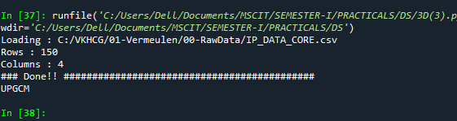

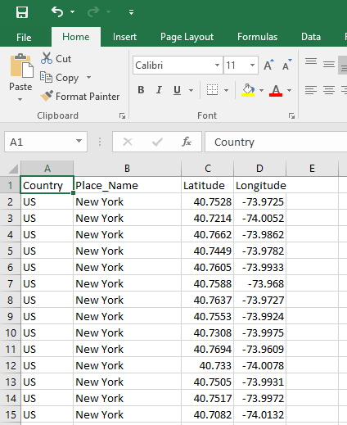

**F)** **Picking Content for Billboards**

**Code:**

import sys

import os

import pandas as pd

################################################################

InputFileName='DE_Billboard_Locations.csv'

OutputFileName='Retrieve_DE_Billboard_Locations.csv'

Company='02-Krennwallner'

################################################################

if sys.platform == 'linux':

Base=os.path.expanduser('~') + '/VKHCG'

else:

Base='C:/VKHCG'

print('################################')

print('Working Base :',Base, ' using ', sys.platform)

print('################################')

################################################################

Base='C:/VKHCG'

sFileName=Base + '/' + Company + '/00-RawData/' + InputFileName

print('Loading :',sFileName)

IP_DATA_ALL=pd.read_csv(sFileName,header=0,low_memory=False,

usecols=['Country','PlaceName','Latitude','Longitude'])

IP_DATA_ALL.rename(columns={'PlaceName': 'Place_Name'}, inplace=True)

################################################################

sFileDir=Base + '/' + Company + '/01-Retrieve/01-EDS/02-Python'

if not os.path.exists(sFileDir):

os.makedirs(sFileDir)

ROUTERLOC = IP_DATA_ALL.drop_duplicates(subset=None, keep='first', inplace=False)

print('Rows :',ROUTERLOC.shape[0])

print('Columns :',ROUTERLOC.shape[1])

sFileName2=sFileDir + '/' + OutputFileName

ROUTERLOC.to_csv(sFileName2, index = False)

################################################################

print('### Done!! ############################################')

print('UPGCM')

**Output:**

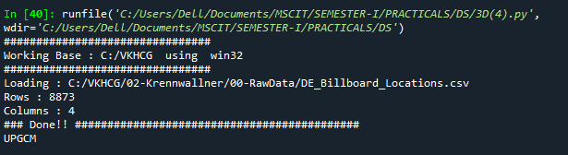

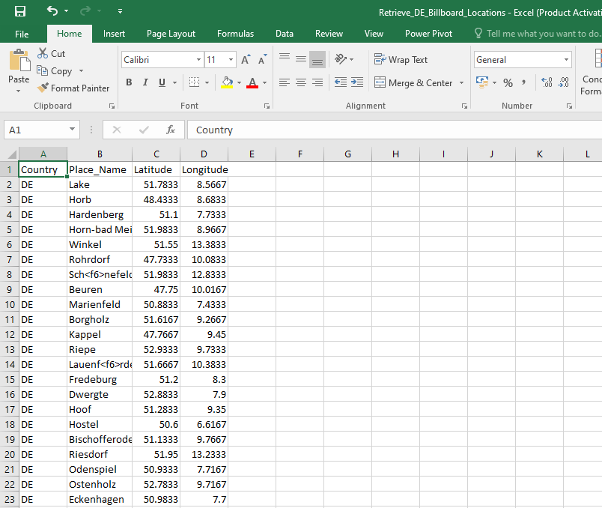

**Practical 4**

**AIM:** **Assessing Data**

**Theory:** Data quality refers to the condition of a set of quantitative or qualitative variables. Dataquality is a multidimensional measurement of the acceptability of specific data sets. Inbusiness, data quality is measured to determine whether data can be used as a basis forreliable intelligence extraction for supporting organizational decisions. Data profiling involves observing in your data source all the viewpoints that the information offers. The main goal is to determine if individual viewpoints are accurate complete. The Assess superstep determines what additional processing to apply to the entries that are noncompliant.

Errors

Typically, one of four things can be done with an error to the data

1. Accept the Error
2. Reject the Error
3. Correct the Error
4. Create a Default Value
5. **Perform error management on the given data using pandas package.**

**1 . Drop the Columns Where All Elements Are Missing Values**

**Code:**

import sys

import os

import pandas as pd

################################################################

if sys.platform == 'linux':

Base=os.path.expanduser('~') + 'VKHCG'

else:

Base='C:/VKHCG'

################################################################

print('################################')

print('Working Base :',Base, ' using ', sys.platform)

print('################################')

################################################################

sInputFileName='Good-or-Bad.csv'

sOutputFileName='Good-or-Bad-01.csv'

Company='01-Vermeulen'

################################################################

Base='C:/VKHCG'

################################################################

sFileDir=Base + '/' + Company + '/02-Assess/01-EDS/02-Python'

if not os.path.exists(sFileDir):

os.makedirs(sFileDir)

################################################################

### Import Warehouse

################################################################

sFileName=Base + '/' + Company + '/00-RawData/' + sInputFileName

print('Loading :',sFileName)

RawData=pd.read_csv(sFileName,header=0)

print('################################')

print('## Raw Data Values')

print('################################')

print(RawData)

print('################################')

print('## Data Profile')

print('################################')

print('Rows :',RawData.shape[0])

print('Columns :',RawData.shape[1])

print('################################')

################################################################

sFileName=sFileDir + '/' + sInputFileName

RawData.to_csv(sFileName, index = False)

################################################################

TestData=RawData.dropna(axis=1, how='all')

################################################################

print('################################')

print('## Test Data Values')

print('################################')

print(TestData)

print('################################')

print('## Data Profile')

print('################################')

print('Rows :',TestData.shape[0])

print('Columns :',TestData.shape[1])

print('################################')

################################################################

sFileName=sFileDir + '/' + sOutputFileName

TestData.to_csv(sFileName, index = False)

################################################################

print('################################')

print('UPGCM')

print('### Done!! #####################')

print('################################')

################################################################

**Output:**

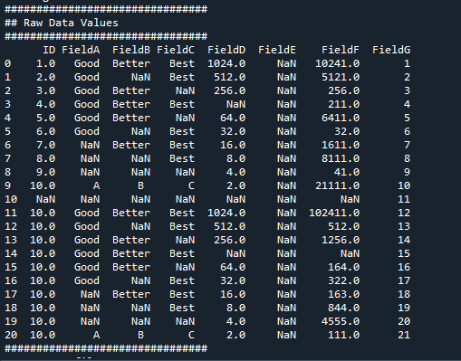

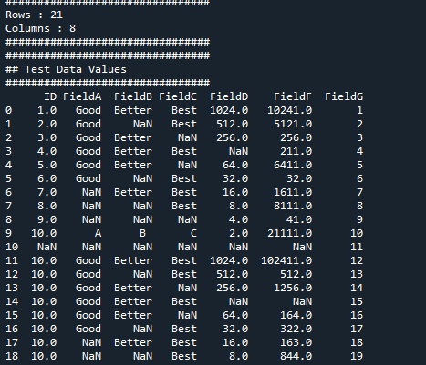

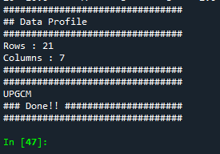

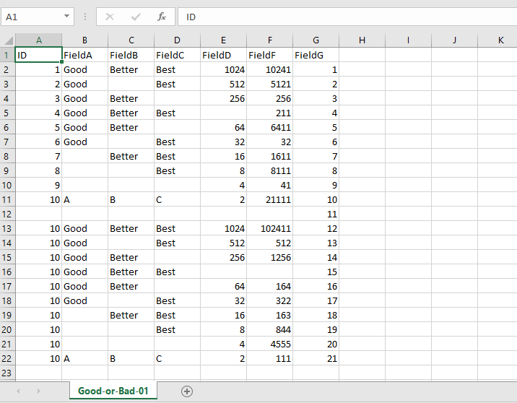

**2. Drop the Columns Where Any of the Elements Is Missing Values**

**Code:**

import sys

import os

import pandas as pd

################################################################

Base='C:/VKHCG'

sInputFileName='Good-or-Bad.csv'

sOutputFileName='Good-or-Bad-02.csv'

Company='01-Vermeulen'

################################################################

if sys.platform == 'linux':

Base=os.path.expanduser('~') + 'VKHCG'

else:

Base='C:/VKHCG'

################################################################

print('################################')

print('Working Base :',Base, ' using ', sys.platform)

print('################################')

################################################################

sFileDir=Base + '/' + Company + '/02-Assess/01-EDS/02-Python'

if not os.path.exists(sFileDir):

os.makedirs(sFileDir)

################################################################

### Import Warehouse

################################################################

sFileName=Base + '/' + Company + '/00-RawData/' + sInputFileName

print('Loading :',sFileName)

RawData=pd.read_csv(sFileName,header=0)

print('################################')

print('## Raw Data Values')

print('################################')

print(RawData)

print('################################')

print('## Data Profile')

print('################################')

print('Rows :',RawData.shape[0])

print('Columns :',RawData.shape[1])

print('################################')

################################################################

sFileName=sFileDir + '/' + sInputFileName

RawData.to_csv(sFileName, index = False)

################################################################

TestData=RawData.dropna(axis=1, how='any')

################################################################

print('################################')

print('## Test Data Values')

print('################################')

print(TestData)

print('################################')

print('## Data Profile')

print('################################')

print('Rows :',TestData.shape[0])

print('Columns :',TestData.shape[1])

print('################################')

################################################################

sFileName=sFileDir + '/' + sOutputFileName

TestData.to_csv(sFileName, index = False)

################################################################

print('################################')

print('### Done!! #####################')

print('################################')

**Output:**

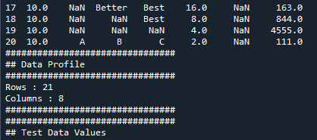

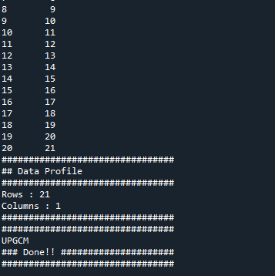

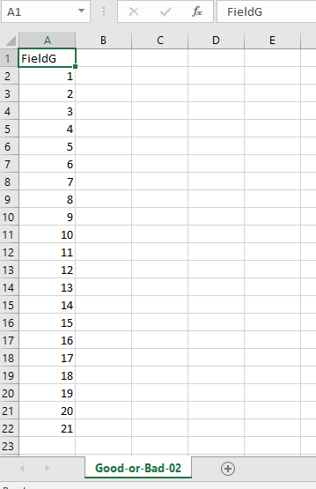

**3. Keep Only the Rows That Contain a Maximum of Two Missing Values**

**Code:**

import sys

import os

import pandas as pd

################################################################

if sys.platform == 'linux':

Base=os.path.expanduser('~') + 'VKHCG'

else:

Base='C:/VKHCG'

################################################################

print('################################')

print('Working Base :',Base, ' using ', sys.platform)

print('################################')

################################################################

sInputFileName='Good-or-Bad.csv'

sOutputFileName='Good-or-Bad-03.csv'

Company='01-Vermeulen'

sFileDir=Base + '/' + Company + '/02-Assess/01-EDS/02-Python'

if not os.path.exists(sFileDir):

os.makedirs(sFileDir)

################################################################

### Import Warehouse

################################################################

sFileName=Base + '/' + Company + '/00-RawData/' + sInputFileName

print('Loading :',sFileName)

RawData=pd.read_csv(sFileName,header=0)

print('################################')

print('## Raw Data Values')

print('################################')

print(RawData)

print('################################')

print('## Data Profile')

print('################################')

print('Rows :',RawData.shape[0])

print('Columns :',RawData.shape[1])

print('################################')

################################################################

sFileName=sFileDir + '/' + sInputFileName

RawData.to_csv(sFileName, index = False)

################################################################

TestData=RawData.dropna(thresh=2)

################################################################

print('################################')

print('## Test Data Values')

print('################################')

print(TestData)

print('################################')

print('## Data Profile')

print('################################')

print('Rows :',TestData.shape[0])

print('Columns :',TestData.shape[1])

print('################################')

################################################################

sFileName=sFileDir + '/' + sOutputFileName

TestData.to_csv(sFileName, index = False)

################################################################

print('################################')

print('### Done!! #####################')

print(‘UPGCM’)

print('################################')

**Output:**

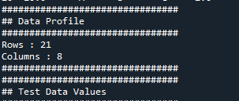

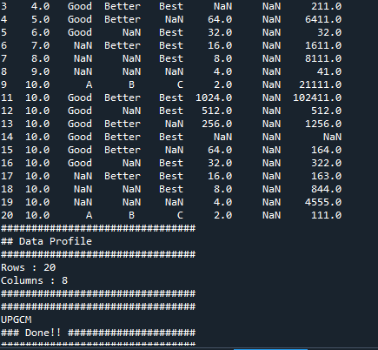

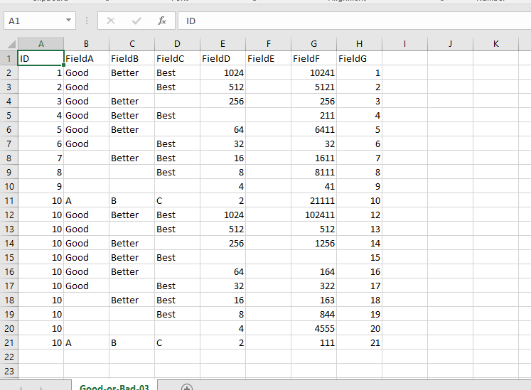

**4.Fill All Missing Values with the Mean, Median, Mode, Minimum, and Maximum of the Particular Numeric Column**

**Code:**

import sys

import os

import pandas as pd

Base='C:/VKHCG'

print('AIM: Fill all the missing values with Mean Median Mode Minimum Maximum of numeric column\n ')

print('Working Base :',Base, ' using ',sys.platform)

print(' ')

sInputFileName='Good-or-Bad.csv'

sOutputFileNameA='Good-or-Bad-04-A.csv' #MEAN

sOutputFileNameB='Good-or-Bad-04-B.csv' #MEDIAN

sOutputFileNameC='Good-or-Bad-04-C.csv' #MODE

sOutputFileNameD='Good-or-Bad-04-D.csv' #MIN

sOutputFileNameE='Good-or-Bad-04-E.csv' #MAX

Company='01-Vermeulen'

Base='C:/VKHCG'

sFileDir=Base + '/' + Company + '/02-Assess/01-EDS/02-Python'

if not os.path.exists(sFileDir):

os.makedirs(sFileDir)

sFileName=Base + '/' + Company + '/00-RawData/' + sInputFileName

print('Loading :',sFileName)

RawData=pd.read_csv(sFileName,header=0)

print(' ')

print('Raw Data Values')

print(RawData)

print(' ')

print('Data Profile')

print(' ')

print('R-ows :',RawData.shape[0])

print('Columns :',RawData.shape[1])

sFileName=sFileDir + '/' + sInputFileName

RawData.to_csv(sFileName, index = False)

TestData=RawData.fillna(RawData.mean())

print(' ')

print('## Test Data Values')

print(TestData)

print(' ')

print('## Data Profile')

print(' ')

print('Rows :',TestData.shape[0])

print('Columns :',TestData.shape[1])

sFileName=sFileDir + '/' + sOutputFileNameA

TestData.to_csv(sFileName, index = False)

TestData=RawData.fillna(RawData.median())

print(' ')

print('## Test Data Values')

print(TestData)

print(' ')

print('## Data Profile')

print(' ')

print('Rows :',TestData.shape[0])

print('Columns :',TestData.shape[1])

sFileName=sFileDir + '/' + sOutputFileNameB

TestData.to_csv(sFileName, index = False)

TestData=RawData.fillna(RawData.mode())

print(' ')

print('## Test Data Values')

print(TestData)

print(' ')

print('## Data Profile')

print(' ')

print('Rows :',TestData.shape[0])

print('Columns:',TestData.shape[1])

print(' ')

sFileName=sFileDir + '/' + sOutputFileNameC

TestData.to_csv(sFileName, index = False)

TestData=RawData.fillna(RawData.min())

print(' ')

print('## Test Data Values')

print(TestData)

print(' ')

print('## Data Profile')

print(' ')

print('Rows :',TestData.shape[0])

print('Columns:',TestData.shape[1])

print(' ')

sFileName=sFileDir + '/' + sOutputFileNameD

TestData.to_csv(sFileName, index = False)

TestData=RawData.fillna(RawData.max())

print(' ')

print('## Test Data Values')

print(TestData)

print(' ')

print('## Data Profile')

print(' ')

print('Rows :',TestData.shape[0])

print('Columns:',TestData.shape[1])

print(' ')

sFileName=sFileDir + '/' + sOutputFileNameE

TestData.to_csv(sFileName, index = False)

print('UPGCM')

print('Done!!!!!')

print(' ')

**Output:**

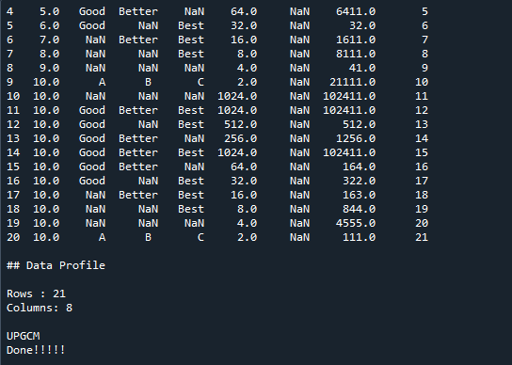

**B.Write Python / R program to create the network routing diagram from the given data**

**onrouters in assess superstep..**

**Code:**

################################################################

import sys

import os

import pandas as pd

################################################################

pd.options.mode.chained_assignment = None

################################################################

if sys.platform == 'linux':

Base=os.path.expanduser('~') + 'VKHCG'

else:

Base='C:/VKHCG'

################################################################

print('################################')

print('Working Base :',Base, ' using ', sys.platform)

print('################################')

################################################################

sInputFileName1='01-Retrieve/01-EDS/02-Python/Retrieve_Country_Code.csv'

sInputFileName2='01-Retrieve/01-EDS/02-Python/Retrieve_Router_Location.csv'

sInputFileName3='01-Retrieve/01-EDS/02-Python/Retrieve_IP_DATA.csv'

################################################################

sOutputFileName='Assess-Network-Routing-Company.csv'

Company='01-Vermeulen'

################################################################

################################################################

### Import Country Data

################################################################

sFileName=Base + '/' + Company + '/' + sInputFileName1

print('################################')

print('Loading :',sFileName)

print('################################')

CountryData=pd.read_csv(sFileName,header=0,low_memory=False, encoding="latin-1")

print('Loaded Country:',CountryData.columns.values)

print('################################')

################################################################

## Assess Country Data

################################################################

print('################################')

print('Changed :',CountryData.columns.values)

CountryData.rename(columns={'Country': 'Country_Name'}, inplace=True)

CountryData.rename(columns={'ISO-2-CODE': 'Country_Code'}, inplace=True)

CountryData.drop('ISO-M49', axis=1, inplace=True)

CountryData.drop('ISO-3-Code', axis=1, inplace=True)

CountryData.drop('RowID', axis=1, inplace=True)

print('To :',CountryData.columns.values)

print('################################')

################################################################

################################################################

### Import Company Data

################################################################

sFileName=Base + '/' + Company + '/' + sInputFileName2

print('################################')

print('Loading :',sFileName)

print('################################')

CompanyData=pd.read_csv(sFileName,header=0,low_memory=False, encoding="latin-1")

print('Loaded Company :',CompanyData.columns.values)

print('################################')

################################################################

## Assess Company Data

################################################################

print('################################')

print('Changed :',CompanyData.columns.values)

CompanyData.rename(columns={'Country': 'Country_Code'}, inplace=True)

print('To :',CompanyData.columns.values)

print('################################')

################################################################

################################################################

### Import Customer Data

################################################################

sFileName=Base + '/' + Company + '/' + sInputFileName3

print('################################')

print('Loading :',sFileName)

print('################################')

CustomerRawData=pd.read_csv(sFileName,header=0,low_memory=False, encoding="latin-1")

print('################################')

print('Loaded Customer :',CustomerRawData.columns.values)

print('################################')

################################################################

CustomerData=CustomerRawData.dropna(axis=0, how='any')

print('################################')

print('Remove Blank Country Code')

print('Reduce Rows from', CustomerRawData.shape[0],' to ', CustomerData.shape[0])

print('################################')

################################################################

print('################################')

print('Changed :',CustomerData.columns.values)

CustomerData.rename(columns={'Country': 'Country_Code'}, inplace=True)

print('To :',CustomerData.columns.values)

print('################################')

################################################################

print('################################')

print('Merge Company and Country Data')

print('################################')

CompanyNetworkData=pd.merge(

CompanyData,

CountryData,

how='inner',

on='Country_Code'

)

################################################################

print('################################')

print('Change ',CompanyNetworkData.columns.values)

for i in CompanyNetworkData.columns.values:

j='Company_'+i

CompanyNetworkData.rename(columns={i: j}, inplace=True)

print('To ', CompanyNetworkData.columns.values)

print('################################')

################################################################

################################################################

sFileDir=Base + '/' + Company + '/02-Assess/01-EDS/02-Python'

if not os.path.exists(sFileDir):

os.makedirs(sFileDir)

################################################################

sFileName=sFileDir + '/' + sOutputFileName

print('################################')

print('Storing :', sFileName)

print('################################')

CompanyNetworkData.to_csv(sFileName, index = False, encoding="latin-1")

################################################################

################################################################

print('################################')

print('### Done!! #####################')

print('UPGCM')

print('################################')

################################################################

**Output:**

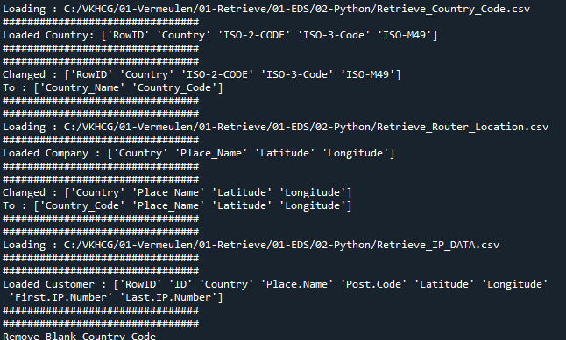

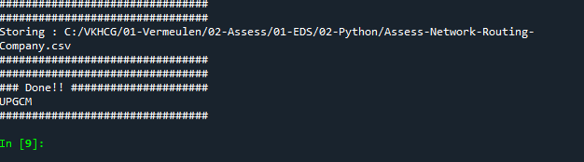

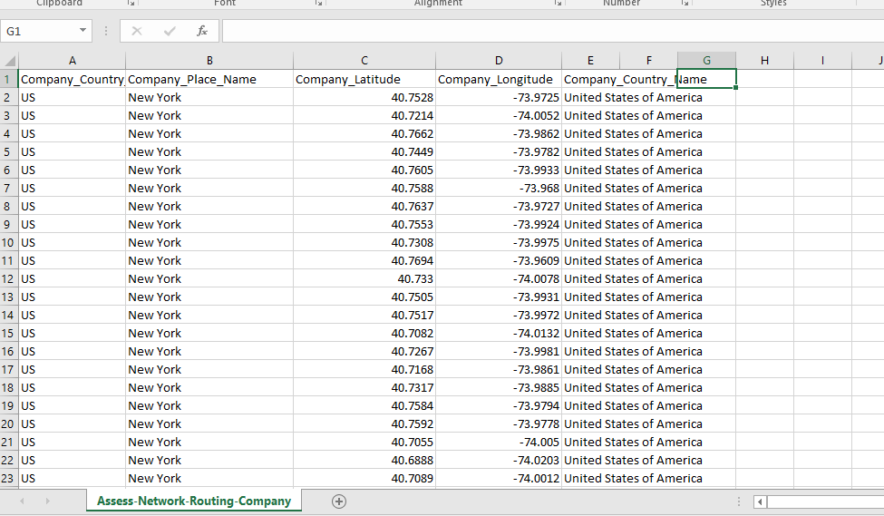

**C.Write python/R program to build directed acyclic graph.**

**Example 1: Company location DAG**

**Code:**

################################################################

import networkx as nx

import matplotlib.pyplot as plt

import sys

import os

import pandas as pd

################################################################

if sys.platform == 'linux':

Base=os.path.expanduser('~') + 'VKHCG'

else:

Base='C:/VKHCG'

################################################################

print('################################')

print('Working Base :',Base, ' using ', sys.platform)

print('################################')

################################################################

sInputFileName='01-Retrieve/01-EDS/02-Python/Retrieve_Router_Location.csv'

sOutputFileName1='Assess-DAG-Company-Country.png'

sOutputFileName2='Assess-DAG-Company-Country-Place.png'

Company='01-Vermeulen'

################################################################

### Import Company Data

################################################################

sFileName=Base + '/' + Company + '/' + sInputFileName

print('################################')

print('Loading :',sFileName)

print('################################')

CompanyData=pd.read_csv(sFileName,header=0,low_memory=False, encoding="latin-1")

print('Loaded Company :',CompanyData.columns.values)

print('################################')

################################################################

print(CompanyData)

print('################################')

print('Rows : ',CompanyData.shape[0])

print('################################')

################################################################

G1=nx.DiGraph()

G2=nx.DiGraph()

################################################################

for i in range(CompanyData.shape[0]):

G1.add_node(CompanyData['Country'][i])

sPlaceName= CompanyData['Place_Name'][i] + '-' + CompanyData['Country'][i]

G2.add_node(sPlaceName)

print('################################')

for n1 in G1.nodes():

for n2 in G1.nodes():

if n1 != n2:

print('Link :',n1,' to ', n2)

G1.add_edge(n1,n2)

print('################################')

print('################################')

print("Nodes of graph: ")

print(G1.nodes())

print("Edges of graph: ")

print(G1.edges())

print('################################')

################################################################

sFileDir=Base + '/' + Company + '/02-Assess/01-EDS/02-Python'

if not os.path.exists(sFileDir):

os.makedirs(sFileDir)

################################################################

sFileName=sFileDir + '/' + sOutputFileName1

print('################################')

print('Storing :', sFileName)

print('################################')

nx.draw(G1,pos=nx.spectral_layout(G1),nodecolor='r',edge_color='g',with_labels=True,node_size=8000,font_size=12)

plt.savefig(sFileName) # save as png

plt.show() # display

################################################################

print('################################')

for n1 in G2.nodes():

for n2 in G2.nodes():

if n1 != n2:

print('Link :',n1,' to ', n2)

G2.add_edge(n1,n2)

print('################################')

print('################################')

print("Nodes of graph: ")

print(G2.nodes())

print("Edges of graph: ")

print(G2.edges())

print('################################')

################################################################

sFileDir=Base + '/' + Company + '/02-Assess/01-EDS/02-Python'

if not os.path.exists(sFileDir):

os.makedirs(sFileDir)

################################################################

sFileName=sFileDir + '/' + sOutputFileName2

print('################################')

print('Storing :', sFileName)

print('################################')

nx.draw(G2,pos=nx.spectral_layout(G2),

nodecolor='r',edge_color='b',

with_labels=True,node_size=8000,

font_size=12)

plt.savefig(sFileName) # save as png

plt.show() # display

################################################################

**Output:**

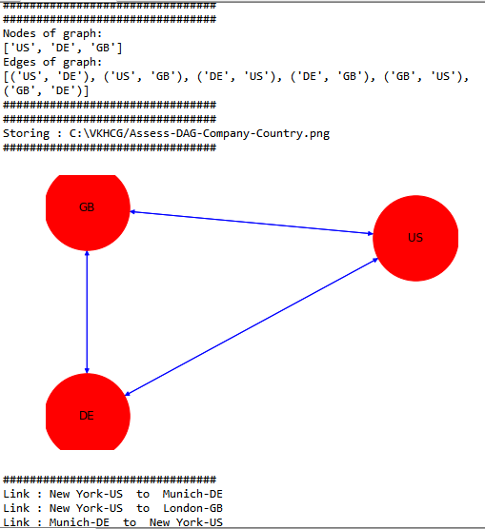

**Example 2: Customer location DAG**

**Code:**

import networkx as nx

import matplotlib.pyplot as plt

import sys

import os

import pandas as pd

################################################################

if sys.platform == 'linux':

Base=os.path.expanduser('~') + 'VKHCG'

else:

Base='C:/VKHCG'

################################################################

print('################################')

print('Working Base :',Base, ' using ', sys.platform)

print('################################')

################################################################

sInputFileName='01-Retrieve/01-EDS/02-Python/Retrieve_Router_Location.csv'

sOutputFileName1='Assess-DAG-Company-Country.png'

sOutputFileName2='Assess-DAG-Company-Country-Place.png'

Company='01-Vermeulen'

################################################################

### Import Company Data

################################################################

sFileName=Base + '/' + Company + '/' + sInputFileName

print('################################')

print('Loading :',sFileName)

print('################################')

CompanyData=pd.read_csv(sFileName,header=0,low_memory=False, encoding="latin-1")

print('Loaded Company :',CompanyData.columns.values)

print('################################')

################################################################

print(CompanyData)

print('################################')

print('Rows : ',CompanyData.shape[0])

print('################################')

################################################################

G1=nx.DiGraph()

G2=nx.DiGraph()

################################################################

for i in range(CompanyData.shape[0]):

G1.add_node(CompanyData['Country'][i])

sPlaceName= CompanyData['Place_Name'][i] + '-' + CompanyData['Country'][i]

G2.add_node(sPlaceName)

print('################################')

for n1 in G1.nodes():

for n2 in G1.nodes():

if n1 != n2:

print('Link :',n1,' to ', n2)

G1.add_edge(n1,n2)

print('################################')

print('################################')

print("Nodes of graph: ")

print(G1.nodes())

print("Edges of graph: ")

print(G1.edges())

print('################################')

################################################################

sFileDir=Base + '/' + Company + '/02-Assess/01-EDS/02-Python'

if not os.path.exists(sFileDir):

os.makedirs(sFileDir)

################################################################

sFileName=sFileDir + '/' + sOutputFileName1

print('################################')

print('Storing :', sFileName)

print('################################')

nx.draw(G1,pos=nx.spectral_layout(G1),nodecolor='r',edge_color='g',with_labels=True,node_size=8000,font_size=12)

plt.savefig(sFileName) # save as png

plt.show() # display

################################################################

print('################################')

for n1 in G2.nodes():

for n2 in G2.nodes():

if n1 != n2:

print('Link :',n1,' to ', n2)

G2.add_edge(n1,n2)

print('################################')

print('################################')

print("Nodes of graph: ")

print(G2.nodes())

print("Edges of graph: ")

print(G2.edges())

print('################################')

################################################################

sFileDir=Base + '/' + Company + '/02-Assess/01-EDS/02-Python'

if not os.path.exists(sFileDir):

os.makedirs(sFileDir)

################################################################

sFileName=sFileDir + '/' + sOutputFileName2

print('################################')

print('Storing :', sFileName)

print('################################')

nx.draw(G2,pos=nx.spectral_layout(G2),nodecolor='r',edge_color='b',with_labels=True,node_size=8000,font_size=12)

plt.savefig(sFileName) # save as png

plt.show() # display

################################################################

**Output:**

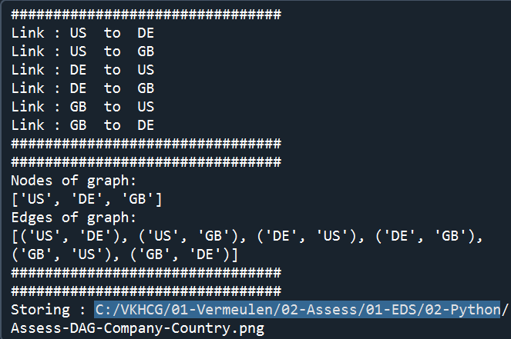

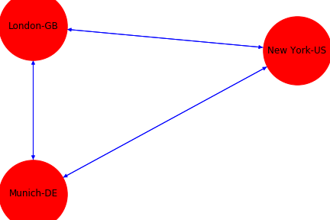

**Example 3: DAG using GPS data**

**Code:**

################################################################

import networkx as nx

import matplotlib.pyplot as plt

import sys

import os

import pandas as pd

################################################################

if sys.platform == 'linux':

Base=os.path.expanduser('~') + 'VKHCG'

else:

Base='C:/VKHCG'

print('################################')

print('Working Base :',Base, ' using ', sys.platform)

print('################################')

################################################################

sInputFileName='01-Retrieve/01-EDS/02-Python/Retrieve_Router_Location.csv'

sOutputFileName='Assess-DAG-Company-GPS.png'

Company='01-Vermeulen'

################################################################

### Import Company Data

################################################################

sFileName=Base + '/' + Company + '/' + sInputFileName

print('################################')

print('Loading :',sFileName)

print('################################')

CompanyData=pd.read_csv(sFileName,header=0,low_memory=False, encoding="latin-1")

print('Loaded Company :',CompanyData.columns.values)

print('################################')

################################################################

print(CompanyData)

print('################################')

print('Rows : ',CompanyData.shape[0])

print('################################')

################################################################

G=nx.Graph()

################################################################

for i in range(CompanyData.shape[0]):

nLatitude=round(CompanyData['Latitude'][i],1)

nLongitude=round(CompanyData['Longitude'][i],1)

if nLatitude < 0:

sLatitude = str(nLatitude*-1) + ' S'

else:

sLatitude = str(nLatitude) + ' N'

if nLongitude < 0:

sLongitude = str(nLongitude*-1) + ' W'

else:

sLongitude = str(nLongitude) + ' E'

sGPS= sLatitude + '-' + sLongitude

G.add_node(sGPS)

print('################################')

for n1 in G.nodes():

for n2 in G.nodes():

if n1 != n2:

print('Link :',n1,' to ', n2)

G.add_edge(n1,n2)

print('################################')

print('################################')

print("Nodes of graph: ")

print(G.nodes())

print("Edges of graph: ")

print(G.edges())

print('################################')

################################################################

sFileDir=Base + '/' + Company + '/02-Assess/01-EDS/02-Python'

if not os.path.exists(sFileDir):

os.makedirs(sFileDir)

################################################################

sFileName=sFileDir + '/' + sOutputFileName

print('################################')

print('Storing :', sFileName)

print('################################')

pos=nx.circular_layout(G,dim=1, scale=2)

nx.draw(G,pos=pos,

nodecolor='r',edge_color='b',

with_labels=True,node_size=4000,

font_size=9)

plt.savefig(sFileName) # save as png

plt.show() # display

print('Practical Done by UPG Student')

**Output:**

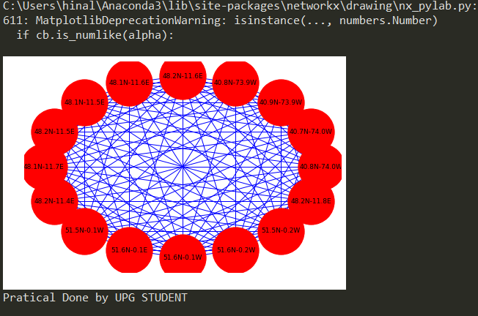

**D.** **Write python/R program to pick the content for Billboards for the given data**.

**Code:**

import sys

import os

import sqlite3 as sq

import pandas as pd

################################################################

Base='C:/VKHCG'

print('################################')

print('Working Base :',Base, ' using ', sys.platform)

print('UPGCM')

print('################################')

################################################################

sInputFileName1='01-Retrieve/01-EDS/02-Python/Retrieve_DE_Billboard_Locations.csv'

sInputFileName2='01-Retrieve/01-EDS/02-Python/Retrieve_Online_Visitor.csv'

sOutputFileName='Assess-DE-Billboard-Visitor.csv'

Company='02-Krennwallner'

################################################################

sDataBaseDir=Base + '/' + Company + '/02-Assess/SQLite'

if not os.path.exists(sDataBaseDir):

os.makedirs(sDataBaseDir)

################################################################

sDatabaseName=sDataBaseDir + '/krennwallner.db'

conn = sq.connect(sDatabaseName)

################################################################

### Import Billboard Data

################################################################

sFileName=Base + '/' + Company + '/' + sInputFileName1

print('################################')

print('Loading :',sFileName)

print('################################')

BillboardRawData=pd.read_csv(sFileName,header=0,low_memory=False, encoding="latin-1")

BillboardRawData.drop_duplicates(subset=None, keep='first', inplace=True)

BillboardData=BillboardRawData

print('Loaded Company :',BillboardData.columns.values)

print('################################')

################################################################

print('################')

sTable='Assess_BillboardData'

print('Storing :',sDatabaseName,' Table:',sTable)

BillboardData.to_sql(sTable, conn, if_exists="replace")

print('################')

################################################################

print(BillboardData.head())

print('################################')

print('Rows : ',BillboardData.shape[0])

print('################################')

################################################################

### Import Billboard Data

################################################################

sFileName=Base + '/' + Company + '/' + sInputFileName2

print('################################')

print('Loading :',sFileName)

print('################################')

VisitorRawData=pd.read_csv(sFileName,header=0,low_memory=False, encoding="latin-1")

VisitorRawData.drop_duplicates(subset=None, keep='first', inplace=True)

VisitorData=VisitorRawData[VisitorRawData.Country=='DE']

print('Loaded Company :',VisitorData.columns.values)

print('################################')

################################################################

print('################')

sTable='Assess_VisitorData'

print('Storing :',sDatabaseName,' Table:',sTable)

VisitorData.to_sql(sTable, conn, if_exists="replace")

print('################')

################################################################

print(VisitorData.head())

print('################################')

print('Rows : ',VisitorData.shape[0])

print('################################')

################################################################

print('################')

sTable='Assess_BillboardVisitorData'

print('Loading :',sDatabaseName,' Table:',sTable)

sSQL="select distinct"

sSQL=sSQL+ " A.Country AS BillboardCountry,"

sSQL=sSQL+ " A.Place_Name AS BillboardPlaceName,"

sSQL=sSQL+ " A.Latitude AS BillboardLatitude, "

sSQL=sSQL+ " A.Longitude AS BillboardLongitude,"

sSQL=sSQL+ " B.Country AS VisitorCountry,"

sSQL=sSQL+ " B.Place_Name AS VisitorPlaceName,"

sSQL=sSQL+ " B.Latitude AS VisitorLatitude, "

sSQL=sSQL+ " B.Longitude AS VisitorLongitude,"

sSQL=sSQL+ " (B.Last_IP_Number - B.First_IP_Number) * 365.25 * 24 * 12 AS VisitorYearRate"

sSQL=sSQL+ " from"

sSQL=sSQL+ " Assess_BillboardData as A"

sSQL=sSQL+ " JOIN "

sSQL=sSQL+ " Assess_VisitorData as B"

sSQL=sSQL+ " ON "

sSQL=sSQL+ " A.Country = B.Country"

sSQL=sSQL+ " AND "

sSQL=sSQL+ " A.Place_Name = B.Place_Name;"

BillboardVistorsData=pd.read_sql_query(sSQL, conn)

print('################')

################################################################

print('################')

sTable='Assess_BillboardVistorsData'

print('Storing :',sDatabaseName,' Table:',sTable)

BillboardVistorsData.to_sql(sTable, conn, if_exists="replace")

print('################')

################################################################

print(BillboardVistorsData.head())

print('################################')

print('Rows : ',BillboardVistorsData.shape[0])

print('################################')

################################################################

sFileDir=Base + '/' + Company + '/02-Assess/01-EDS/02-Python'

if not os.path.exists(sFileDir):

os.makedirs(sFileDir)

################################################################

print('################################')

print('Storing :', sFileName)

print('################################')

sFileName=sFileDir + '/' + sOutputFileName

BillboardVistorsData.to_csv(sFileName, index = False)

print('################################')

################################################################

print('### Done!! ############################################')

################################################################

**Output:**

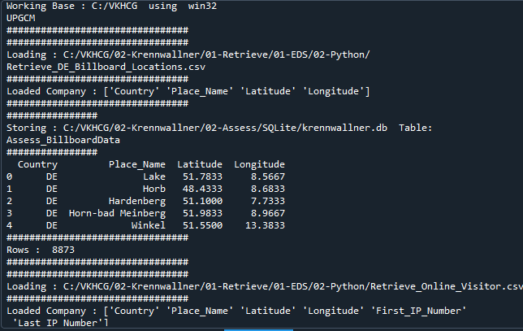

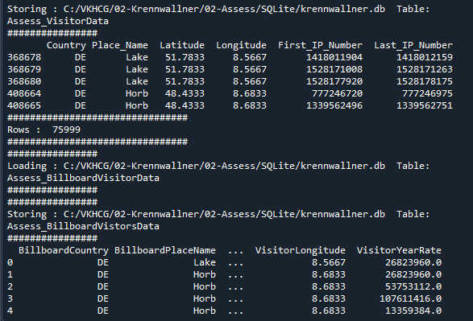

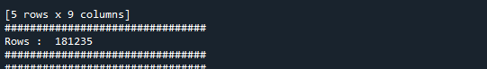

**Practical 5**

**AIM: Processing Data**

**Theory:**

**Hubs** are the containers for business keys. They are the most important facets of the data vault methodology. The more successfully one is able to identify business keys the less refining of the model will follow.

**Links** stores the intersection of business keys (HUBS). Links can be considered the glue that holds the data vault model together. These tables allow for the data model to elegantly change over time because they can come and go as required by the business.

**Satellites** add all the color and description to the business keys (hubs) and relationships (links) in the data vault environment. Satellites contain all the descriptive information, tracking change by start and end dates over time, to let one know the information in effect at any point in time.

A golden nominal record is a single person’s record, with distinctive references for use by all systems. This gives the system a single view of the person. I use first name, other names, last name, and birth date as my golden nominal. The data we have in the assess directory requires a birth date to become a golden nominal. The program will generate a golden nominal using our sample data set

Vehicles:

The international classification of vehicles is a complex process. There are standards, but these are not universally applied or similar between groups or countries

Human interactions:

The interaction of humans with their environment is a major relationship that guides people’s behavior and the characteristics of the location. Activities such as mining and other industries, roads, and landscaping at a location create both positive and negative effects on the environment, but also on humans. A location earmarked as a green belt, to assist in reducing the carbon footprint, or a new interstate change its current and future characteristics. The location is a main data source for the data science, and, normally, we find unknown or unexpected effects on the data insights

1. **Build the time hub, links and satellites**.

**Code:**

import sys

import os

from datetime import datetime

from datetime import timedelta

from pytz import timezone, all_timezones

import pandas as pd

import sqlite3 as sq

from pandas.io import sql

import uuid

pd.options.mode.chained_assignment = None

if sys.platform == 'linux':

Base=os.path.expanduser('~') + '/VKHCG'

else:

Base='C:/VKHCG'

print('################################')

print('Working Base :',Base, ' using ', sys.platform)

print('################################')

Company='01-Vermeulen'

InputDir='00-RawData'

InputFileName='VehicleData.csv'

sDataBaseDir=Base + '/' + Company + '/03-Process/SQLite'

if not os.path.exists(sDataBaseDir):

os.makedirs(sDataBaseDir)

sDatabaseName=sDataBaseDir + '/Hillman.db'

conn1 = sq.connect(sDatabaseName)

sDataVaultDir=Base + '/88-DV'

if not os.path.exists(sDataBaseDir):

os.makedirs(sDataBaseDir)

sDatabaseName=sDataVaultDir + '/datavault.db'

conn2 = sq.connect(sDatabaseName)

base = datetime(2018,1,1,0,0,0)

numUnits=1000

date_list = [base - timedelta(hours=x) for x in range(0, numUnits)]

t=0

for i in date_list:

now_utc=i.replace(tzinfo=timezone('UTC'))

sDateTime=now_utc.strftime("%Y-%m-%d %H:%M:%S")

print(sDateTime)

sDateTimeKey=sDateTime.replace(' ','-').replace(':','-')

t+=1

IDNumber=str(uuid.uuid4())

TimeLine=[('ZoneBaseKey', ['UTC']),('IDNumber', [IDNumber]),('nDateTimeValue', [now_utc]),('DateTimeValue', [sDateTime]),('DateTimeKey', [sDateTimeKey])]

if t==1:

TimeFrame = pd.DataFrame.from_items(TimeLine)

else:

TimeRow = pd.DataFrame.from_items(TimeLine)

TimeFrame = TimeFrame.append(TimeRow)

TimeHub=TimeFrame[['IDNumber','ZoneBaseKey','DateTimeKey','DateTimeValue']]

TimeHubIndex=TimeHub.set_index(['IDNumber'],inplace=False)

TimeFrame.set_index(['IDNumber'],inplace=True)

sTable = 'Process-Time'

print('Storing :',sDatabaseName,' Table:',sTable)

TimeHubIndex.to_sql(sTable, conn1, if_exists="replace")

################################################################

sTable = 'Hub-Time'

print('Storing :',sDatabaseName,' Table:',sTable)

TimeHubIndex.to_sql(sTable, conn2, if_exists="replace")

################################################################

active_timezones=all_timezones

z=0

for zone in active_timezones:

t=0

for j in range(TimeFrame.shape[0]):

now_date=TimeFrame['nDateTimeValue'][j]

DateTimeKey=TimeFrame['DateTimeKey'][j]

now_utc=now_date.replace(tzinfo=timezone('UTC'))

sDateTime=now_utc.strftime("%Y-%m-%d %H:%M:%S")

now_zone = now_utc.astimezone(timezone(zone))

sZoneDateTime=now_zone.strftime("%Y-%m-%d %H:%M:%S")

print(sZoneDateTime)

t+=1

z+=1

IDZoneNumber=str(uuid.uuid4())

TimeZoneLine=[('ZoneBaseKey', ['UTC']),

('IDZoneNumber', [IDZoneNumber]),

('DateTimeKey', [DateTimeKey]),

('UTCDateTimeValue', [sDateTime]),

('Zone', [zone]),

('DateTimeValue', [sZoneDateTime])]

if t==1:

TimeZoneFrame = pd.DataFrame.from_items(TimeZoneLine)

else:

TimeZoneRow = pd.DataFrame.from_items(TimeZoneLine)

TimeZoneFrame = TimeZoneFrame.append(TimeZoneRow)

TimeZoneFrameIndex=TimeZoneFrame.set_index(['IDZoneNumber'],inplace=False)

sZone=zone.replace('/','-').replace(' ','')

#############################################################

sTable = 'Process-Time-'+sZone

print('Storing :',sDatabaseName,' Table:',sTable)

TimeZoneFrameIndex.to_sql(sTable, conn1, if_exists="replace")

#################################################################

#############################################################

sTable = 'Satellite-Time-'+sZone

print('Storing :',sDatabaseName,' Table:',sTable)

TimeZoneFrameIndex.to_sql(sTable, conn2, if_exists="replace")

#################################################################

print('################')

print('Vacuum Databases')

sSQL="VACUUM;"

sql.execute(sSQL,conn1)

sql.execute(sSQL,conn2)

print('################')

#################################################################

print('### Done!! ############################################')

#################################################################

**Output:**

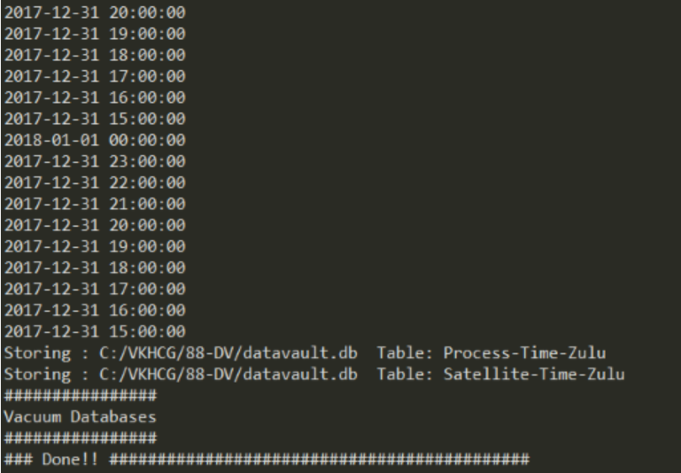

1. **Golden Nominal**

**Code:**

import sys

import os

import sqlite3 as sq

import pandas as pd

from pandas.io import sql

from datetime import datetime, timedelta

from pytz import timezone, all_timezones

from random import randint

import uuid

################################################################

if sys.platform == 'linux':

Base=os.path.expanduser('~') + '/VKHCG'

else:

Base='C:/VKHCG'

print('################################')

print('Working Base :',Base, ' using ', sys.platform)

print('################################')

################################################################

Company='04-Clark'

sInputFileName='02-Assess/01-EDS/02-Python/Assess_People.csv'

################################################################

sDataBaseDir=Base + '/' + Company + '/03-Process/SQLite'

if not os.path.exists(sDataBaseDir):

os.makedirs(sDataBaseDir)

################################################################

sDatabaseName=sDataBaseDir + '/clark.db'

conn1 = sq.connect(sDatabaseName)

################################################################

sDataVaultDir=Base + '/88-DV'

if not os.path.exists(sDataBaseDir):

os.makedirs(sDataBaseDir)

################################################################

sDatabaseName=sDataVaultDir + '/datavault.db'

conn2 = sq.connect(sDatabaseName)

################################################################

### Import Female Data

################################################################

sFileName=Base + '/' + Company + '/' + sInputFileName

print('################################')

print('Loading :',sFileName)

print('################################')

print(sFileName)

RawData=pd.read_csv(sFileName,header=0,low_memory=False, encoding="latin-1")

RawData.drop_duplicates(subset=None, keep='first', inplace=True)

start_date = datetime(1900,1,1,0,0,0)

start_date_utc=start_date.replace(tzinfo=timezone('UTC'))

HoursBirth=100*365*24

RawData['BirthDateUTC']=RawData.apply(lambda row:

(start_date_utc + timedelta(hours=randint(0, HoursBirth)))

,axis=1)

zonemax=len(all_timezones)-1

RawData['TimeZone']=RawData.apply(lambda row:

(all_timezones[randint(0, zonemax)])

,axis=1)

RawData['BirthDateISO']=RawData.apply(lambda row:

row["BirthDateUTC"].astimezone(timezone(row['TimeZone']))

,axis=1)

RawData['BirthDateKey']=RawData.apply(lambda row:

row["BirthDateUTC"].strftime("%Y-%m-%d %H:%M:%S")

,axis=1)

RawData['BirthDate']=RawData.apply(lambda row:

row["BirthDateISO"].strftime("%Y-%m-%d %H:%M:%S")

,axis=1)

RawData['PersonID']=RawData.apply(lambda row:

str(uuid.uuid4())

,axis=1)

################################################################

Data=RawData.copy()

Data.drop('BirthDateUTC', axis=1,inplace=True)

Data.drop('BirthDateISO', axis=1,inplace=True)

indexed_data = Data.set_index(['PersonID'])

print('################################')

#################################################################

print('################')

sTable='Process_Person'

print('Storing :',sDatabaseName,' Table:',sTable)

indexed_data.to_sql(sTable, conn1, if_exists="replace")

print('################')

################################################################

PersonHubRaw=Data[['PersonID','FirstName','SecondName','LastName','BirthDateKey']]

PersonHubRaw['PersonHubID']=RawData.apply(lambda row:

str(uuid.uuid4())

,axis=1)

PersonHub=PersonHubRaw.drop_duplicates(subset=None, \

keep='first',\

inplace=False)

indexed_PersonHub = PersonHub.set_index(['PersonHubID'])

sTable = 'Hub-Person'

print('Storing :',sDatabaseName,' Table:',sTable)

indexed_PersonHub.to_sql(sTable, conn2, if_exists="replace")

PersonSatelliteGenderRaw=Data[['PersonID','FirstName','SecondName','LastName'\

,'BirthDateKey','Gender']]

PersonSatelliteGenderRaw['PersonSatelliteID']=RawData.apply(lambda row:

str(uuid.uuid4())

,axis=1)

PersonSatelliteGender=PersonSatelliteGenderRaw.drop_duplicates(subset=None, \

keep='first', \

inplace=False)

indexed_PersonSatelliteGender = PersonSatelliteGender.set_index(['PersonSatelliteID'])

sTable = 'Satellite-Person-Gender'

print('Storing :',sDatabaseName,' Table:',sTable)

indexed_PersonSatelliteGender.to_sql(sTable, conn2, if_exists="replace")

################################################################

PersonSatelliteBirthdayRaw=Data[['PersonID','FirstName','SecondName','LastName',\

'BirthDateKey','TimeZone','BirthDate']]

PersonSatelliteBirthdayRaw['PersonSatelliteID']=RawData.apply(lambda row:

str(uuid.uuid4())

,axis=1)

PersonSatelliteBirthday=PersonSatelliteBirthdayRaw.drop_duplicates(subset=None, \

keep='first',\

inplace=False)

indexed_PersonSatelliteBirthday = PersonSatelliteBirthday.set_index(['PersonSatelliteID'])

sTable = 'Satellite-Person-Names'

print('Storing :',sDatabaseName,' Table:',sTable)

indexed_PersonSatelliteBirthday.to_sql(sTable, conn2, if_exists="replace")

################################################################

sFileDir=Base + '/' + Company + '/03-Process/01-EDS/02-Python'

if not os.path.exists(sFileDir):

os.makedirs(sFileDir)

################################################################

sOutputFileName = sTable + '.csv'

sFileName=sFileDir + '/' + sOutputFileName

print('################################')

print('Storing :', sFileName)

print('################################')

RawData.to_csv(sFileName, index = False)

print('################################')

#################################################################

print('################')

print('Vacuum Databases')

sSQL="VACUUM;"

sql.execute(sSQL,conn1)

sql.execute(sSQL,conn2)

print('################')

#################################################################

print('### Done!! ############################################')

**Output:**

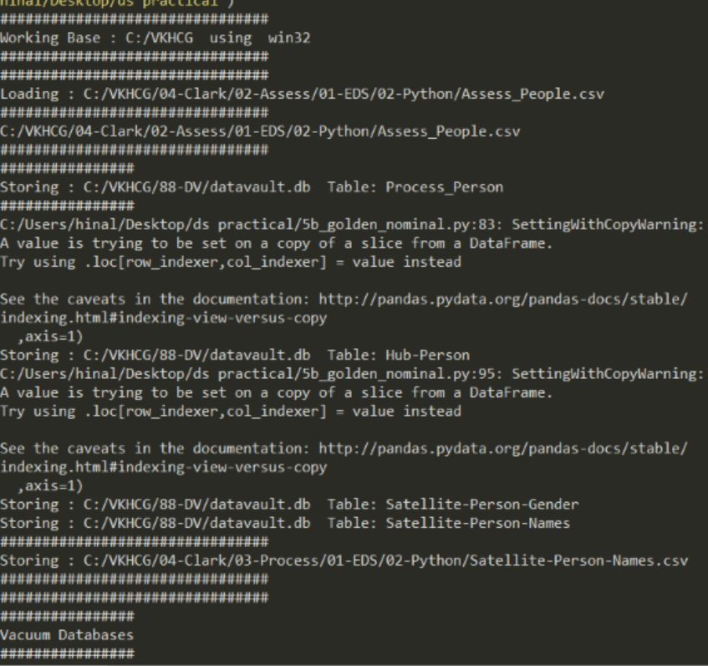

**C. Vehicles as object hub and satellite using python and SQLite.**

**Code:**

#import sys

import os

import pandas as pd

import sqlite3 as sq

from pandas.io import sql

import uuid

pd.options.mode.chained_assignment = None

################################################################

if sys.platform == 'windows':

Base=os.path.expanduser('~') + '/VKHCG'

else:

Base='C:/VKHCG'

print('################################')

print('Working Base :',Base, ' using ', sys.platform)

print('################################')

################################################################

Company='03-Hillman'

InputDir='00-RawData'

InputFileName='VehicleData.csv'

################################################################

sDataBaseDir=Base + '/' + Company + '/03-Process/SQLite'

if not os.path.exists(sDataBaseDir):

os.makedirs(sDataBaseDir)

################################################################

sDatabaseName=sDataBaseDir + '/Hillman.db'

conn1 = sq.connect(sDatabaseName)

################################################################

sDataVaultDir=Base + '/88-DV'

if not os.path.exists(sDataBaseDir):

os.makedirs(sDataBaseDir)

################################################################

sDatabaseName=sDataVaultDir + '/datavault.db'

conn2 = sq.connect(sDatabaseName)

################################################################

sFileName=Base + '/' + Company + '/' + InputDir + '/' + InputFileName

print('###########')

print('Loading :',sFileName)

VehicleRaw=pd.read_csv(sFileName,header=0,low_memory=False, encoding="latin-1")

################################################################

sTable='Process_Vehicles'

print('Storing :',sDatabaseName,' Table:',sTable)

VehicleRaw.to_sql(sTable, conn1, if_exists="replace")

################################################################

VehicleRawKey=VehicleRaw[['Make','Model']].copy()

VehicleKey=VehicleRawKey.drop_duplicates()

################################################################

VehicleKey['ObjectKey']=VehicleKey.apply(lambda row:

str('('+ str(row['Make']).strip().replace(' ', '-').replace('/', '-').lower() +

')-(' + (str(row['Model']).strip().replace(' ', '-').replace(' ', '-').lower())

+')')

,axis=1)

################################################################

VehicleKey['ObjectType']=VehicleKey.apply(lambda row:

'vehicle'

,axis=1)

################################################################

VehicleKey['ObjectUUID']=VehicleKey.apply(lambda row:

str(uuid.uuid4())

,axis=1)

################################################################

### Vehicle Hub

################################################################

VehicleHub=VehicleKey[['ObjectType','ObjectKey','ObjectUUID']].copy()

VehicleHub.index.name='ObjectHubID'

sTable = 'Hub-Object-Vehicle'

print('Storing :',sDatabaseName,' Table:',sTable)

VehicleHub.to_sql(sTable, conn2, if_exists="replace")

################################################################

### Vehicle Satellite

################################################################

#

VehicleSatellite=VehicleKey[['ObjectType','ObjectKey','ObjectUUID','Make','Model']].copy()

VehicleSatellite.index.name='ObjectSatelliteID'

sTable = 'Satellite-Object-Make-Model'

print('Storing :',sDatabaseName,' Table:',sTable)

VehicleSatellite.to_sql(sTable, conn2, if_exists="replace")

################################################################

### Vehicle Dimension

################################################################

sView='Dim-Object'

print('Storing :',sDatabaseName,' View:',sView)

sSQL="CREATE VIEW IF NOT EXISTS [" + sView + "] AS"

sSQL=sSQL+ " SELECT DISTINCT"

sSQL=sSQL+ " H.ObjectType,"

sSQL=sSQL+ " H.ObjectKey AS VehicleKey,"

sSQL=sSQL+ " TRIM(S.Make) AS VehicleMake,"

sSQL=sSQL+ " TRIM(S.Model) AS VehicleModel"

sSQL=sSQL+ " FROM"

sSQL=sSQL+ " [Hub-Object-Vehicle] AS H"

sSQL=sSQL+ " JOIN"

sSQL=sSQL+ " [Satellite-Object-Make-Model] AS S"

sSQL=sSQL+ " ON"

sSQL=sSQL+ " H.ObjectType=S.ObjectType"

sSQL=sSQL+ " AND"

sSQL=sSQL+ " H.ObjectUUID=S.ObjectUUID;"

sql.execute(sSQL,conn2)

print('################')

print('Loading :',sDatabaseName,' Table:',sView)

sSQL=" SELECT DISTINCT"

sSQL=sSQL+ " VehicleMake,"

sSQL=sSQL+ " VehicleModel"

sSQL=sSQL+ " FROM"

sSQL=sSQL+ " [" + sView + "]"

sSQL=sSQL+ " ORDER BY"

sSQL=sSQL+ " VehicleMake"

sSQL=sSQL+ " AND"

sSQL=sSQL+ " VehicleMake;"

DimObjectData=pd.read_sql_query(sSQL, conn2)

DimObjectData.index.name='ObjectDimID'

DimObjectData.sort_values(['VehicleMake','VehicleModel'],inplace=True, ascending=True)

print('################')

print(DimObjectData)

#################################################################

print('################')

print('Vacuum Databases')

sSQL="VACUUM;"

sql.execute(sSQL,conn1)

sql.execute(sSQL,conn2)

print('################')

#################################################################

conn1.close()

conn2.close()

#################################################################

#print('### Done!! ############################################')

###############################################################

**Output:**

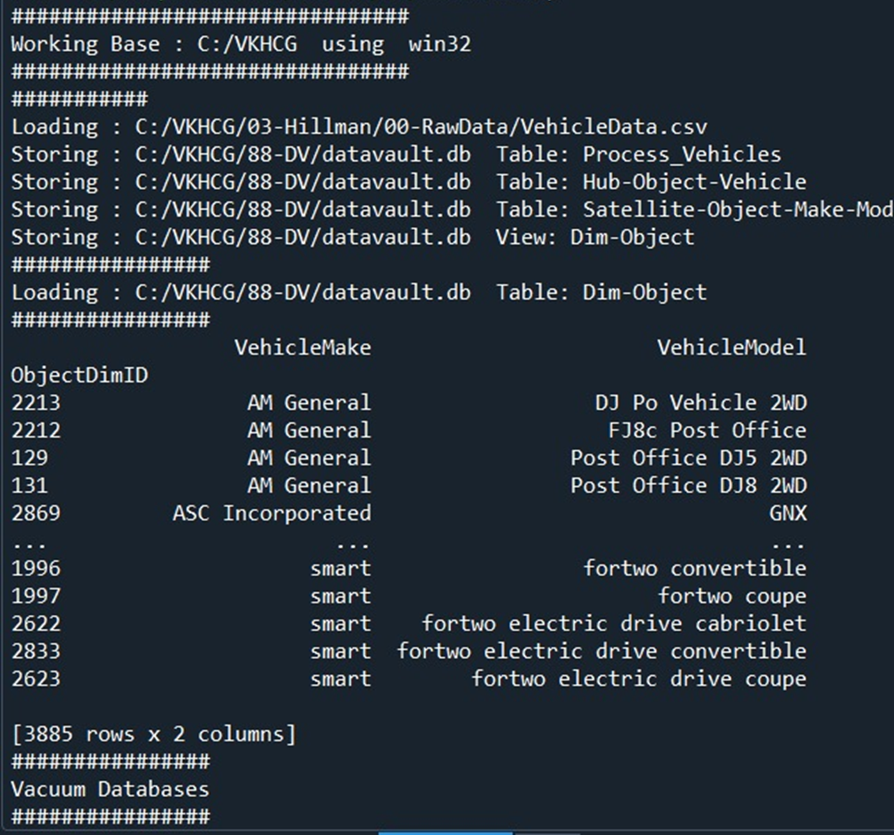

**D. Human-Environment interaction**

**Code:**

import sys

import os

import pandas as pd

import sqlite3 as sq

from pandas.io import sql

import uuid

################################################################

Base='C:/VKHCG'

print('################################')

print('Working Base :',Base, ' using ', sys.platform)

print('################################')

################################################################

Company='01-Vermeulen'

InputAssessGraphName='Assess_All_Animals.gml'

EDSAssessDir='02-Assess/01-EDS'

InputAssessDir=EDSAssessDir + '/02-Python'

################################################################

sFileAssessDir=Base + '/' + Company + '/' + InputAssessDir

if not os.path.exists(sFileAssessDir):

os.makedirs(sFileAssessDir)

################################################################

sDataBaseDir=Base + '/' + Company + '/03-Process/SQLite'

if not os.path.exists(sDataBaseDir):

os.makedirs(sDataBaseDir)

################################################################

sDatabaseName=sDataBaseDir + '/Vermeulen.db'

conn1 = sq.connect(sDatabaseName)

################################################################

sDataVaultDir=Base + '/88-DV'

if not os.path.exists(sDataBaseDir):

os.makedirs(sDataBaseDir)

################################################################

sDatabaseName=sDataVaultDir + '/datavault.db'

conn2 = sq.connect(sDatabaseName)

t=0

tMax=360*180

################################################################

for Longitude in range(-180,180,10):

for Latitude in range(-90,90,10):

t+=1

IDNumber=str(uuid.uuid4())

LocationName='L'+format(round(Longitude,3)*1000, '+07d') +\

'-'+format(round(Latitude,3)*1000, '+07d')

print('Create:',t,' of ',tMax,':',LocationName)

LocationLine=[('ObjectBaseKey', ['GPS']),

('IDNumber', [IDNumber]),

('LocationNumber', [str(t)]),

('LocationName', [LocationName]),

('Longitude', [Longitude]),

('Latitude', [Latitude])]

if t==1:

LocationFrame = pd.DataFrame.from_items(LocationLine)

else:

LocationRow = pd.DataFrame.from_items(LocationLine)

LocationFrame = LocationFrame.append(LocationRow)

################################################################

LocationHubIndex=LocationFrame.set_index(['IDNumber'],inplace=False)

################################################################

sTable = 'Process-Location'

print('Storing :',sDatabaseName,' Table:',sTable)

LocationHubIndex.to_sql(sTable, conn1, if_exists="replace")

#################################################################

sTable = 'Hub-Location'

print('Storing :',sDatabaseName,' Table:',sTable)

LocationHubIndex.to_sql(sTable, conn2, if_exists="replace")

#################################################################

print('################')

print('Vacuum Databases')

sSQL="VACUUM;"

sql.execute(sSQL,conn1)

sql.execute(sSQL,conn2)

print('################')

################################################################

print('### Done!! ############################################’)

**Output:**

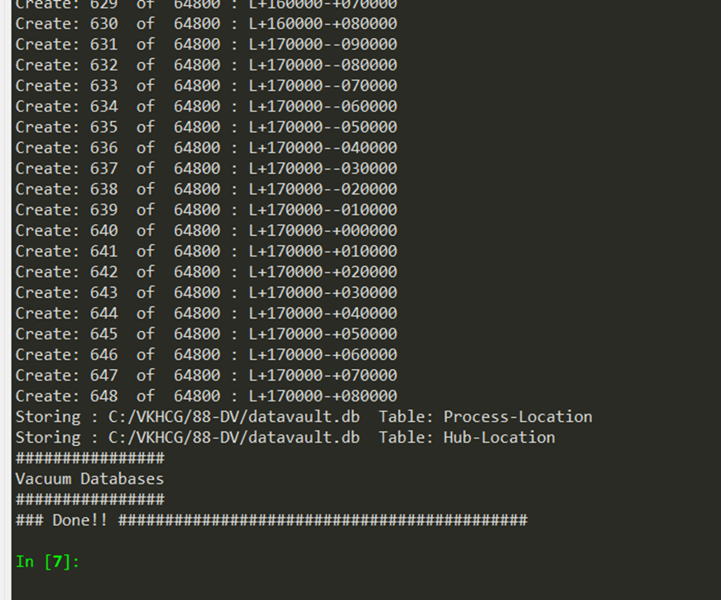

**Practical 6**

**AIM: Transforming Data**

**Theory:**

The Transform superstep allows you, as a data scientist, to take data from the data vault and formulate answers to questions raised by your investigations. The transformation step is the data science process that converts results into insights. It takes standard data science techniques and methods to attain insight and knowledge about the data that then can be transformed into actionable decisions, which, through storytelling, you can explain to non-data scientists what you have discovered in the data lake.

Simple Linear Regression

Linear regression is used if there is a relationship or significant association between the

variables. This can be checked by scatterplots. If no linear association appears between

the variables, fitting a linear regression model to the data will not provide a useful model.

A linear regression line has equations in the following form:

Y = a + bX,

Where, X = explanatory variable and

Y = dependent variable

b = slope of the line

a = intercept (the value of y when x = 0)

**A. Program to show the details of hub: person being born.**

**Code:**

import sys

import os

from datetime import datetime

from pytz import timezone

import pandas as pd

import sqlite3 as sq

import uuid

pd.options.mode.chained_assignment = None

################################################################

Base='C:/VKHCG'

print('################################')

print('Working Base :',Base, ' using ', sys.platform)

print('################################')

################################################################

Company='01-Vermeulen'

InputDir='00-RawData'

InputFileName='VehicleData.csv'

################################################################

sDataBaseDir=Base + '/' + Company + '/04-Transform/SQLite'

if not os.path.exists(sDataBaseDir):

os.makedirs(sDataBaseDir)

################################################################

sDatabaseName=sDataBaseDir + '/Vermeulen.db'

conn1 = sq.connect(sDatabaseName)

################################################################

sDataVaultDir=Base + '/88-DV'

if not os.path.exists(sDataVaultDir):

os.makedirs(sDataVaultDir)

################################################################

sDatabaseName=sDataVaultDir + '/datavault.db'

conn2 = sq.connect(sDatabaseName)

################################################################

sDataWarehouseDir=Base + '/99-DW'

if not os.path.exists(sDataWarehouseDir):

os.makedirs(sDataWarehouseDir)

################################################################

sDatabaseName=sDataWarehouseDir + '/datawarehouse.db'

conn3 = sq.connect(sDatabaseName)

################################################################

print('\n#################################')

print('Time Category')

print('UTC Time')

BirthDateUTC = datetime(1960,12,20,10,15,0)

BirthDateZoneUTC=BirthDateUTC.replace(tzinfo=timezone('UTC'))

BirthDateZoneStr=BirthDateZoneUTC.strftime("%Y-%m-%d %H:%M:%S")

BirthDateZoneUTCStr=BirthDateZoneUTC.strftime("%Y-%m-%d %H:%M:%S (%Z) (%z)")

print(BirthDateZoneUTCStr)

print('#################################')

print('Birth Date in Reykjavik :')

BirthZone = 'Atlantic/Reykjavik'

BirthDate = BirthDateZoneUTC.astimezone(timezone(BirthZone))

BirthDateStr=BirthDate.strftime("%Y-%m-%d %H:%M:%S (%Z) (%z)")

BirthDateLocal=BirthDate.strftime("%Y-%m-%d %H:%M:%S")

print(BirthDateStr)

print('#################################')

################################################################

IDZoneNumber=str(uuid.uuid4())

sDateTimeKey=BirthDateZoneStr.replace(' ','-').replace(':','-')

TimeLine=[('ZoneBaseKey', ['UTC']),

('IDNumber', [IDZoneNumber]),

('DateTimeKey', [sDateTimeKey]),

('UTCDateTimeValue', [BirthDateZoneUTC]),

('Zone', [BirthZone]),

('DateTimeValue', [BirthDateStr])]

TimeFrame = pd.DataFrame.from_items(TimeLine)

################################################################

TimeHub=TimeFrame[['IDNumber','ZoneBaseKey','DateTimeKey','DateTimeValue']]

TimeHubIndex=TimeHub.set_index(['IDNumber'],inplace=False)

################################################################

sTable = 'Hub-Time-Gunnarsson'

print('\n#################################')

print('Storing :',sDatabaseName,'\n Table:',sTable)

print('\n#################################')

TimeHubIndex.to_sql(sTable, conn2, if_exists="replace")

sTable = 'Dim-Time-Gunnarsson'

TimeHubIndex.to_sql(sTable, conn3, if_exists="replace")

################################################################

TimeSatellite=TimeFrame[['IDNumber','DateTimeKey','Zone','DateTimeValue']]

TimeSatelliteIndex=TimeSatellite.set_index(['IDNumber'],inplace=False)

################################################################

BirthZoneFix=BirthZone.replace(' ','-').replace('/','-')

sTable = 'Satellite-Time-' + BirthZoneFix + '-Gunnarsson'

print('\n#################################')

print('Storing :',sDatabaseName,'\n Table:',sTable)

print('\n#################################')

TimeSatelliteIndex.to_sql(sTable, conn2, if_exists="replace")

sTable = 'Dim-Time-' + BirthZoneFix + '-Gunnarsson'

TimeSatelliteIndex.to_sql(sTable, conn3, if_exists="replace")

################################################################

print('\n#################################')

print('Person Category')

FirstName = 'Guðmundur'

LastName = 'Gunnarsson'

print('Name:',FirstName,LastName)

print('Birth Date:',BirthDateLocal)

print('Birth Zone:',BirthZone)

print('UTC Birth Date:',BirthDateZoneStr)

print('#################################')

###############################################################

IDPersonNumber=str(uuid.uuid4())

PersonLine=[('IDNumber', [IDPersonNumber]),

('FirstName', [FirstName]),

('LastName', [LastName]),

('Zone', ['UTC']),

('DateTimeValue', [BirthDateZoneStr])]

PersonFrame = pd.DataFrame.from_items(PersonLine)

################################################################

TimeHub=PersonFrame

TimeHubIndex=TimeHub.set_index(['IDNumber'],inplace=False)

################################################################

sTable = 'Hub-Person-Gunnarsson'

print('\n#################################')

print('Storing :',sDatabaseName,'\n Table:',sTable)

print('\n#################################')

TimeHubIndex.to_sql(sTable, conn2, if_exists="replace")

sTable = 'Dim-Person-Gunnarsson'

TimeHubIndex.to_sql(sTable, conn3, if_exists="replace")

**Output:**

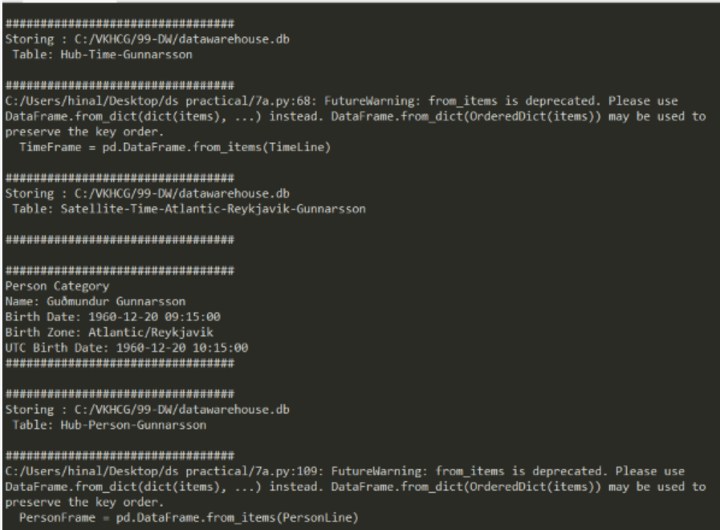

**B. Building dimension Person, Time and fact PersonBornAtTime**

**Code:**

import sys

import os

from datetime import datetime

from pytz import timezone

import pandas as pd

import sqlite3 as sq

import uuid

pd.options.mode.chained_assignment = None

################################################################

if sys.platform == 'linux':

Base=os.path.expanduser('~') + '/VKHCG'

else:

Base='C:/VKHCG'

print('################################')

print('Working Base :',Base, ' using ', sys.platform)

print('################################')

################################################################

Company='01-Vermeulen'

################################################################

sDataBaseDir=Base + '/' + Company + '/04-Transform/SQLite'

if not os.path.exists(sDataBaseDir):

os.makedirs(sDataBaseDir)

################################################################

sDatabaseName=sDataBaseDir + '/Vermeulen.db'

conn1 = sq.connect(sDatabaseName)

################################################################

sDataWarehousetDir=Base + '/99-DW'

if not os.path.exists(sDataWarehousetDir):

os.makedirs(sDataWarehousetDir)

################################################################

sDatabaseName=sDataWarehousetDir + '/datawarehouse.db'

conn2 = sq.connect(sDatabaseName)

################################################################

print('\n#################################')

print('Time Dimension')

BirthZone = 'Atlantic/Reykjavik'

BirthDateUTC = datetime(1960,12,20,10,15,0)

BirthDateZoneUTC=BirthDateUTC.replace(tzinfo=timezone('UTC'))

BirthDateZoneStr=BirthDateZoneUTC.strftime("%Y-%m-%d %H:%M:%S")

BirthDateZoneUTCStr=BirthDateZoneUTC.strftime("%Y-%m-%d %H:%M:%S (%Z) (%z)")

BirthDate = BirthDateZoneUTC.astimezone(timezone(BirthZone))

BirthDateStr=BirthDate.strftime("%Y-%m-%d %H:%M:%S (%Z) (%z)")

BirthDateLocal=BirthDate.strftime("%Y-%m-%d %H:%M:%S")

################################################################

IDTimeNumber=str(uuid.uuid4())

TimeLine=[('TimeID', [IDTimeNumber]),

('UTCDate', [BirthDateZoneStr]),

('LocalTime', [BirthDateLocal]),

('TimeZone', [BirthZone])]

TimeFrame = pd.DataFrame.from_items(TimeLine)

################################################################

DimTime=TimeFrame

DimTimeIndex=DimTime.set_index(['TimeID'],inplace=False)

################################################################

sTable = 'Dim-Time'

print('\n#################################')

print('Storing :',sDatabaseName,'\n Table:',sTable)

print('\n#################################')

DimTimeIndex.to_sql(sTable, conn1, if_exists="replace")

DimTimeIndex.to_sql(sTable, conn2, if_exists="replace")

################################################################

print('\n#################################')

print('Dimension Person')

print('\n#################################')

FirstName = 'Guðmundur'

LastName = 'Gunnarsson'

###############################################################

IDPersonNumber=str(uuid.uuid4())

PersonLine=[('PersonID', [IDPersonNumber]),

('FirstName', [FirstName]),

('LastName', [LastName]),

('Zone', ['UTC']),

('DateTimeValue', [BirthDateZoneStr])]

PersonFrame = pd.DataFrame.from_items(PersonLine)

################################################################

DimPerson=PersonFrame

DimPersonIndex=DimPerson.set_index(['PersonID'],inplace=False)

################################################################

sTable = 'Dim-Person'

print('\n#################################')

print('Storing :',sDatabaseName,'\n Table:',sTable)

print('\n#################################')

DimPersonIndex.to_sql(sTable, conn1, if_exists="replace")

DimPersonIndex.to_sql(sTable, conn2, if_exists="replace")

################################################################

print('\n#################################')

print('Fact - Person - time')

print('\n#################################')

IDFactNumber=str(uuid.uuid4())

PersonTimeLine=[('IDNumber', [IDFactNumber]),

('IDPersonNumber', [IDPersonNumber]),

('IDTimeNumber', [IDTimeNumber])]

PersonTimeFrame = pd.DataFrame.from_items(PersonTimeLine)

################################################################

FctPersonTime=PersonTimeFrame

FctPersonTimeIndex=FctPersonTime.set_index(['IDNumber'],inplace=False)

################################################################

sTable = 'Fact-Person-Time'

print('\n#################################')

print('Storing :',sDatabaseName,'\n Table:',sTable)

print('\n#################################')

FctPersonTimeIndex.to_sql(sTable, conn1, if_exists="replace")

FctPersonTimeIndex.to_sql(sTable, conn2, if_exists="replace")

################################################################

**Output:**

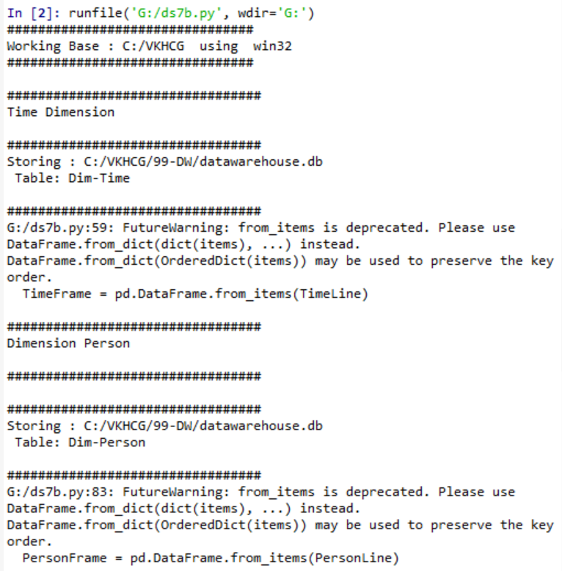

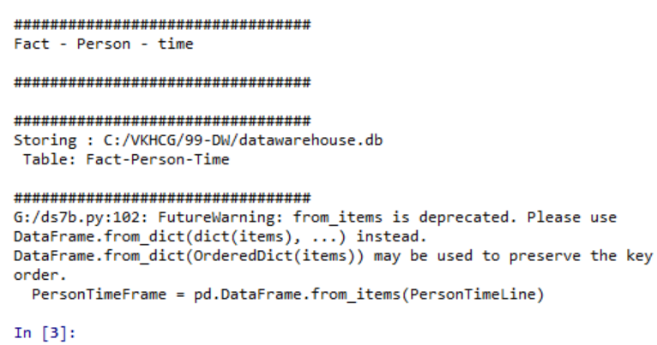

**C. Building a Data warehouse for transform superstep.**

**Code:**

import sys

import os

from datetime import datetime

from pytz import timezone

import pandas as pd

import sqlite3 as sq

import uuid

pd.options.mode.chained_assignment = None

################################################################

if sys.platform == 'linux':

Base=os.path.expanduser('~') + '/VKHCG'

else:

Base='C:/VKHCG'

print('################################')

print('Working Base :',Base, ' using ', sys.platform)

print('################################')

################################################################

Company='01-Vermeulen'

################################################################

sDataBaseDir=Base + '/' + Company + '/04-Transform/SQLite'

if not os.path.exists(sDataBaseDir):

os.makedirs(sDataBaseDir)

################################################################

sDatabaseName=sDataBaseDir + '/Vermeulen.db'

conn1 = sq.connect(sDatabaseName)

################################################################

sDataVaultDir=Base + '/88-DV'

if not os.path.exists(sDataVaultDir):

os.makedirs(sDataVaultDir)

################################################################

sDatabaseName=sDataVaultDir + '/datavault.db'

conn2 = sq.connect(sDatabaseName)

################################################################

sDataWarehouseDir=Base + '/99-DW'

if not os.path.exists(sDataWarehouseDir):

os.makedirs(sDataWarehouseDir)

################################################################

sDatabaseName=sDataWarehouseDir + '/datawarehouse.db'

conn3 = sq.connect(sDatabaseName)

################################################################

sSQL=" SELECT DateTimeValue FROM [Hub-Time];"

DateDataRaw=pd.read_sql_query(sSQL, conn2)

DateData=DateDataRaw.head(1000)

print(DateData)

################################################################

print('\n#################################')

print('Time Dimension')

print('\n#################################')

t=0

mt=DateData.shape[0]

for i in range(mt):

BirthZone = ('Atlantic/Reykjavik','Europe/London','UCT')

for j in range(len(BirthZone)):

t+=1

print(t,mt*3)

BirthDateUTC = datetime.strptime(DateData['DateTimeValue'][i],"%Y-%m-%d %H:%M:%S")

BirthDateZoneUTC=BirthDateUTC.replace(tzinfo=timezone('UTC'))

BirthDateZoneStr=BirthDateZoneUTC.strftime("%Y-%m-%d %H:%M:%S")

BirthDateZoneUTCStr=BirthDateZoneUTC.strftime("%Y-%m-%d %H:%M:%S (%Z) (%z)")

BirthDate = BirthDateZoneUTC.astimezone(timezone(BirthZone[j]))

BirthDateStr=BirthDate.strftime("%Y-%m-%d %H:%M:%S (%Z) (%z)")

BirthDateLocal=BirthDate.strftime("%Y-%m-%d %H:%M:%S")

################################################################

IDTimeNumber=str(uuid.uuid4())

TimeLine=[('TimeID', [str(IDTimeNumber)]),

('UTCDate', [str(BirthDateZoneStr)]),

('LocalTime', [str(BirthDateLocal)]),

('TimeZone', [str(BirthZone)])]

if t==1:

TimeFrame = pd.DataFrame.from_items(TimeLine)

else:

TimeRow = pd.DataFrame.from_items(TimeLine)

TimeFrame=TimeFrame.append(TimeRow)

################################################################

DimTime=TimeFrame

DimTimeIndex=DimTime.set_index(['TimeID'],inplace=False)

################################################################

sTable = 'Dim-Time'

print('\n#################################')

print('Storing :',sDatabaseName,'\n Table:',sTable)

print('\n#################################')

DimTimeIndex.to_sql(sTable, conn1, if_exists="replace")

DimTimeIndex.to_sql(sTable, conn3, if_exists="replace")

################################################################

sSQL=" SELECT " + \

" FirstName," + \

" SecondName," + \

" LastName," + \

" BirthDateKey " + \

" FROM [Hub-Person];"

PersonDataRaw=pd.read_sql_query(sSQL, conn2)

PersonData=PersonDataRaw.head(1000)

################################################################

print('\n#################################')

print('Dimension Person')

print('\n#################################')

t=0

mt=DateData.shape[0]

for i in range(mt):

t+=1

print(t,mt)

FirstName = str(PersonData["FirstName"])

SecondName = str(PersonData["SecondName"])

if len(SecondName) > 0:

SecondName=""

LastName = str(PersonData["LastName"])

BirthDateKey = str(PersonData["BirthDateKey"])

###############################################################

IDPersonNumber=str(uuid.uuid4())

PersonLine=[('PersonID', [str(IDPersonNumber)]),

('FirstName', [FirstName]),

('SecondName', [SecondName]),

('LastName', [LastName]),

('Zone', [str('UTC')]),

('BirthDate', [BirthDateKey])]

if t==1:

PersonFrame = pd.DataFrame.from_items(PersonLine)

else:

PersonRow = pd.DataFrame.from_items(PersonLine)

PersonFrame = PersonFrame.append(PersonRow)

################################################################

DimPerson=PersonFrame

print(DimPerson)

DimPersonIndex=DimPerson.set_index(['PersonID'],inplace=False)

################################################################

sTable = 'Dim-Person'

print('\n#################################')

print('Storing :',sDatabaseName,'\n Table:',sTable)

print('\n#################################')

DimPersonIndex.to_sql(sTable, conn1, if_exists="replace")

DimPersonIndex.to_sql(sTable, conn3, if_exists="replace")

###############################################################

**Output:**

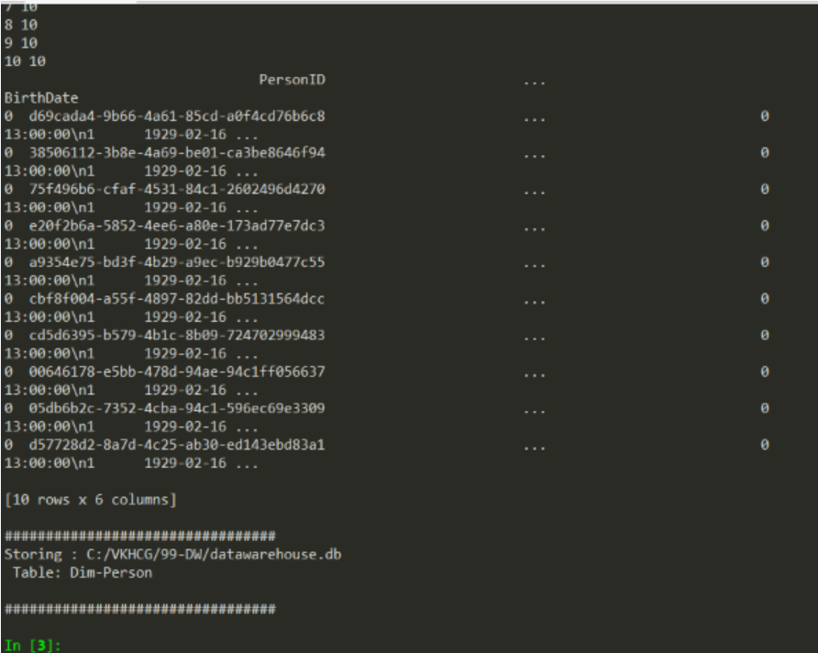

**D. Write python program to demonstrate Simple Linear Regression.**

**Code:**

import sys

import os

import pandas as pd

import sqlite3 as sq

import matplotlib.pyplot as plt

import numpy as np

from sklearn import datasets, linear_model

from sklearn.metrics import mean_squared_error, r2_score

################################################################

Base='C:/VKHCG'

print('################################')

print('Working Base :',Base, ' using ', sys.platform)

print('################################')

################################################################

################################################################

Company='01-Vermeulen'

################################################################

sDataBaseDir=Base + '/' + Company + '/04-Transform/SQLite'

if not os.path.exists(sDataBaseDir):

os.makedirs(sDataBaseDir)

################################################################

sDatabaseName=sDataBaseDir + '/Vermeulen.db'

conn1 = sq.connect(sDatabaseName)

################################################################

sDataVaultDir=Base + '/88-DV'

if not os.path.exists(sDataVaultDir):

os.makedirs(sDataVaultDir)

################################################################

sDatabaseName=sDataVaultDir + '/datavault.db'

conn2 = sq.connect(sDatabaseName)

################################################################

sDataWarehouseDir=Base + '/99-DW'

if not os.path.exists(sDataWarehouseDir):

os.makedirs(sDataWarehouseDir)

################################################################

sDatabaseName=sDataWarehouseDir + '/datawarehouse.db'

conn3 = sq.connect(sDatabaseName)

################################################################

t=0

tMax=((300-100)/10)*((300-30)/5)

for heightSelect in range(100,300,10):

for weightSelect in range(30,300,5):

height = round(heightSelect/100,3)

weight = int(weightSelect)

bmi = weight/(height*height)

if bmi <= 18.5:

BMI_Result=1

elif bmi > 18.5 and bmi < 25:

BMI_Result=2

elif bmi > 25 and bmi < 30:

BMI_Result=3

elif bmi > 30:

BMI_Result=4

else:

BMI_Result=0

PersonLine=[('PersonID', [str(t)]),

('Height', [height]),

('Weight', [weight]),

('bmi', [bmi]),

('Indicator', [BMI_Result])]

t+=1

print('Row:',t,'of',tMax)

if t==1:

PersonFrame = pd.DataFrame.from_items(PersonLine)

else:

PersonRow = pd.DataFrame.from_items(PersonLine)

PersonFrame = PersonFrame.append(PersonRow)

################################################################

DimPerson=PersonFrame

DimPersonIndex=DimPerson.set_index(['PersonID'],inplace=False)

################################################################

sTable = 'Transform-BMI'

print('\n#################################')

print('Storing :',sDatabaseName,'\n Table:',sTable)

print('\n#################################')

DimPersonIndex.to_sql(sTable, conn1, if_exists="replace")

################################################################

################################################################

sTable = 'Person-Satellite-BMI'

print('\n#################################')

print('Storing :',sDatabaseName,'\n Table:',sTable)

print('\n#################################')

DimPersonIndex.to_sql(sTable, conn2, if_exists="replace")

################################################################

################################################################

sTable = 'Dim-BMI'

print('\n#################################')

print('Storing :',sDatabaseName,'\n Table:',sTable)

print('\n#################################')

DimPersonIndex.to_sql(sTable, conn3, if_exists="replace")

################################################################

fig = plt.figure()

PlotPerson=DimPerson[DimPerson['Indicator']==1]

x=PlotPerson['Height']

y=PlotPerson['Weight']

plt.plot(x, y, ".")

PlotPerson=DimPerson[DimPerson['Indicator']==2]

x=PlotPerson['Height']

y=PlotPerson['Weight']

plt.plot(x, y, "o")

PlotPerson=DimPerson[DimPerson['Indicator']==3]

x=PlotPerson['Height']

y=PlotPerson['Weight']

plt.plot(x, y, "+")

PlotPerson=DimPerson[DimPerson['Indicator']==4]

x=PlotPerson['Height']

y=PlotPerson['Weight']

plt.plot(x, y, "^")

plt.axis('tight')

plt.title("BMI Curve")

plt.xlabel("Height(meters)")

plt.ylabel("Weight(kg)")

plt.plot()

# Load the diabetes dataset

diabetes = datasets.load_diabetes()

# Use only one feature

diabetes_X = diabetes.data[:, np.newaxis, 2]

diabetes_X_train = diabetes_X[:-30]

diabetes_X_test = diabetes_X[-50:]

diabetes_y_train = diabetes.target[:-30]

diabetes_y_test = diabetes.target[-50:]

regr = linear_model.LinearRegression()

regr.fit(diabetes_X_train, diabetes_y_train)

diabetes_y_pred = regr.predict(diabetes_X_test)

print('Coefficients: \n', regr.coef_)

print("Mean squared error: %.2f"% mean_squared_error(diabetes_y_test, diabetes_y_pred))

print('Variance score: %.2f' % r2_score(diabetes_y_test, diabetes_y_pred))

plt.scatter(diabetes_X_test, diabetes_y_test, color='black')

plt.plot(diabetes_X_test, diabetes_y_pred, color='blue', linewidth=3)

plt.xticks(())

plt.yticks(())

plt.axis('tight')

plt.title("Diabetes")

plt.xlabel("BMI")

plt.ylabel("Age")

plt.show()

**Output:**

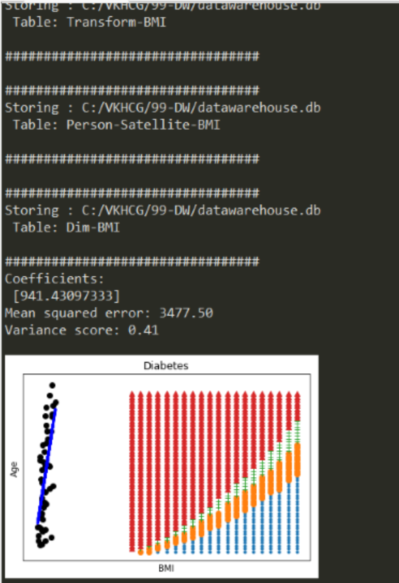

**Practical 7**

**AIM: Organizing Data**

**Theory:**

**Organize Superstep**

The Organize superstep takes the complete data warehouse you built at the end of the Transform superstep and subsections it into business-specific data marts. A data mart is the access layer of the data warehouse environment built to expose data to the users. The data mart is a subset of the data warehouse and is generally oriented to a specific business group.

**Horizontal Style**

Performing horizontal-style slicing or subsetting of the data warehouse is achieved by applying a filter technique that forces the data warehouse to show only the data for a specific preselected set of filtered outcomes against the data population. The horizontal-style slicing selects the subset of rows from the population while preserving the columns. That is, the data science tool can see the complete record for the records in the subset of records

**Vertical Style**

Performing vertical-style slicing or subsetting of the data warehouse is achieved by applying a filter technique that forces the data warehouse to show only the data for specific preselected filtered outcomes against the data population. The vertical-style slicing selects the subset of columns from the population, while preserving the rows. That is, the data science tool can see only the preselected columns from a record for all the records in the population.

**Island Style:**

Performing island style slicing or subsetting of the data warehouse is achieved by applying a combination of horizontal and vertical style slicing. This generates asubset of specific rows and specific columns reduced at the same time.

**Secure Vault Style:**

The secure vault is a version of one of the horizontal,vertical or,island slicing techniques,but the outcome is also attached t the person who perform the query. This is common in multi-security environments, where different users are allowed to see different data sets.

This process works well,if you use a role-based access control (RBAC) approach to restricting system access to authorized users.The security is applied against the “role” and a person canthen,by the security system,simply be added or removed from the role,to enable or disable access.

1. **Write python/R program to perform the horizontal style subset or slice of the data warehouse data**

**Code:**

import sys

import os

import pandas as pd

import sqlite3 as sq

################################################################

if sys.platform == 'linux':

Base=os.path.expanduser('~') + '/VKHCG'

else:

Base='C:/VKHCG'

print('################################')

print('Working Base :',Base, ' using ', sys.platform)

print('################################')

################################################################

################################################################

Company='01-Vermeulen'

################################################################

sDataWarehouseDir=Base + '/99-DW'

if not os.path.exists(sDataWarehouseDir):

os.makedirs(sDataWarehouseDir)

################################################################

sDatabaseName=sDataWarehouseDir + '/datawarehouse.db'

conn1 = sq.connect(sDatabaseName)

################################################################

sDatabaseName=sDataWarehouseDir + '/datamart.db'

conn2 = sq.connect(sDatabaseName)

################################################################

print('################')

sTable = 'Dim-BMI'

print('Loading :',sDatabaseName,' Table:',sTable)

sSQL="SELECT * FROM [Dim-BMI];"

PersonFrame0=pd.read_sql_query(sSQL, conn1)

################################################################

print('################################')

sTable = 'Dim-BMI'

print('Loading :',sDatabaseName,' Table:',sTable)

print('################################')

sSQL="SELECT PersonID,\

Height,\

Weight,\

bmi,\

Indicator\

FROM [Dim-BMI]\

WHERE \

Height > 1.5 \

and Indicator = 1\

ORDER BY \

Height,\

Weight;"

PersonFrame1=pd.read_sql_query(sSQL, conn1)

################################################################

DimPerson=PersonFrame1

DimPersonIndex=DimPerson.set_index(['PersonID'],inplace=False)

################################################################

sTable = 'Dim-BMI-Horizontal'

print('\n#################################')

print('Storing :',sDatabaseName,'\n Table:',sTable)

print('\n#################################')

DimPersonIndex.to_sql(sTable, conn2, if_exists="replace")

################################################################

print('################################')

sTable = 'Dim-BMI-Horizontal'

print('Loading :',sDatabaseName,' Table:',sTable)

print('################################')

sSQL="SELECT * FROM [Dim-BMI];"

PersonFrame2=pd.read_sql_query(sSQL, conn2)

################################################################

print('################################')

print('Full Data Set (Rows):', PersonFrame0.shape[0])

print('Full Data Set (Columns):', PersonFrame0.shape[1])

print('################################')

print('Horizontal Data Set (Rows):', PersonFrame2.shape[0])

print('Horizontal Data Set (Columns):', PersonFrame2.shape[1])

print('################################')

**Output:**

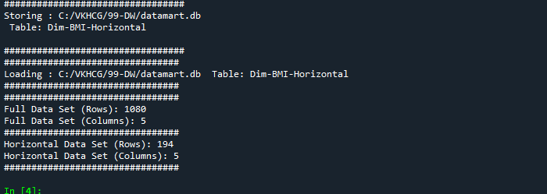

**B. Write python/R program to perform the vertical style subset or slice of the data warehouse data.**

**Code:**

import sys

import os

import pandas as pd

import sqlite3 as sq

################################################################

if sys.platform == 'linux':

Base=os.path.expanduser('~') + '/VKHCG'

else:

Base='C:/VKHCG'

print('################################')

print('Working Base :',Base, ' using ', sys.platform)

print('################################')

################################################################

################################################################

Company='01-Vermeulen'

################################################################

sDataWarehouseDir=Base + '/99-DW'

if not os.path.exists(sDataWarehouseDir):

os.makedirs(sDataWarehouseDir)

################################################################

sDatabaseName=sDataWarehouseDir + '/datawarehouse.db'

conn1 = sq.connect(sDatabaseName)

################################################################

sDatabaseName=sDataWarehouseDir + '/datamart.db'

conn2 = sq.connect(sDatabaseName)

################################################################

print('################################')

sTable = 'Dim-BMI'

print('Loading :',sDatabaseName,' Table:',sTable)

sSQL="SELECT * FROM [Dim-BMI];"

PersonFrame0=pd.read_sql_query(sSQL, conn1)

################################################################

print('################################')

sTable = 'Dim-BMI'

print('Loading :',sDatabaseName,' Table:',sTable)

print('################################')

sSQL="SELECT \

Height,\

Weight,\

Indicator\

FROM [Dim-BMI];"

PersonFrame1=pd.read_sql_query(sSQL, conn1)

################################################################

DimPerson=PersonFrame1

DimPersonIndex=DimPerson.set_index(['Indicator'],inplace=False)

################################################################

sTable = 'Dim-BMI-Vertical'

print('\n#################################')

print('Storing :',sDatabaseName,'\n Table:',sTable)

print('\n#################################')

DimPersonIndex.to_sql(sTable, conn2, if_exists="replace")

################################################################

print('################')

sTable = 'Dim-BMI-Vertical'

print('Loading :',sDatabaseName,' Table:',sTable)

sSQL="SELECT * FROM [Dim-BMI-Vertical];"

PersonFrame2=pd.read_sql_query(sSQL, conn2)

################################################################

print('################################')

print('Full Data Set (Rows):', PersonFrame0.shape[0])

print('Full Data Set (Columns):', PersonFrame0.shape[1])

print('################################')

print('Horizontal Data Set (Rows):', PersonFrame2.shape[0])

print('Horizontal Data Set (Columns):', PersonFrame2.shape[1])

print('################################')

**Output:**

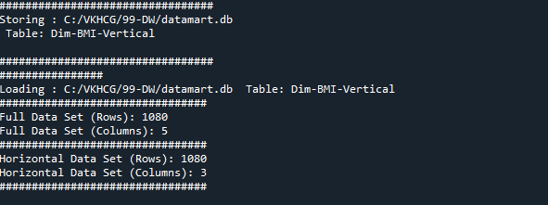

**C. Write python/R program to perform the island style subset or slice of the data warehouse data.**

**Code:**

import sys

import os

import pandas as pd

import sqlite3 as sq

################################################################

if sys.platform == 'linux':

Base=os.path.expanduser('~') + '/VKHCG'

else:

Base='C:/VKHCG'

print('################################')

print('Working Base :',Base, ' using ', sys.platform)

print('################################')

################################################################

################################################################

Company='01-Vermeulen'

################################################################

sDataWarehouseDir=Base + '/99-DW'

if not os.path.exists(sDataWarehouseDir):

os.makedirs(sDataWarehouseDir)

################################################################

sDatabaseName=sDataWarehouseDir + '/datawarehouse.db'

conn1 = sq.connect(sDatabaseName)

################################################################

sDatabaseName=sDataWarehouseDir + '/datamart.db'

conn2 = sq.connect(sDatabaseName)

################################################################

print('################')

sTable = 'Dim-BMI'

print('Loading :',sDatabaseName,' Table:',sTable)

sSQL="SELECT * FROM [Dim-BMI];"

PersonFrame0=pd.read_sql_query(sSQL, conn1)

################################################################

print('################')

sTable = 'Dim-BMI'

print('Loading :',sDatabaseName,' Table:',sTable)

sSQL="SELECT \

Height,\

Weight,\

Indicator\

FROM [Dim-BMI]\

WHERE Indicator > 2\

ORDER BY \

Height,\

Weight;"

PersonFrame1=pd.read_sql_query(sSQL, conn1)

################################################################

DimPerson=PersonFrame1

DimPersonIndex=DimPerson.set_index(['Indicator'],inplace=False)

################################################################

sTable = 'Dim-BMI-Vertical'

print('\n#################################')

print('Storing :',sDatabaseName,'\n Table:',sTable)

print('\n#################################')

DimPersonIndex.to_sql(sTable, conn2, if_exists="replace")

################################################################

print('################################')

sTable = 'Dim-BMI-Vertical'

print('Loading :',sDatabaseName,' Table:',sTable)

print('################################')

sSQL="SELECT * FROM [Dim-BMI-Vertical];"

PersonFrame2=pd.read_sql_query(sSQL, conn2)

################################################################

print('################################')

print('Full Data Set (Rows):', PersonFrame0.shape[0])

print('Full Data Set (Columns):', PersonFrame0.shape[1])

print('################################')

print('Horizontal Data Set (Rows):', PersonFrame2.shape[0])

print('Horizontal Data Set (Columns):', PersonFrame2.shape[1])

print('################################')

**Output:**

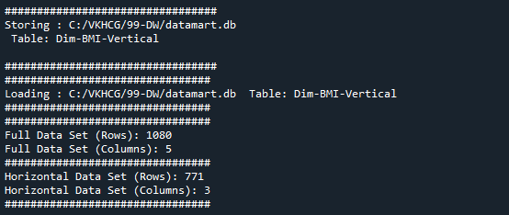

**D. Write python/R program to perform the secure vault style subset or slice of the data warehouse data and attach the result to the person who performs the query.**

**Code:**

import sys

import os

import pandas as pd

import sqlite3 as sq

################################################################

if sys.platform == 'linux':

Base=os.path.expanduser('~') + '/VKHCG'

else:

Base='C:/VKHCG'

print('################################')

print('Working Base :',Base, ' using ', sys.platform)

print('################################')

################################################################

################################################################

Company='01-Vermeulen'

################################################################

sDataWarehouseDir=Base + '/99-DW'

if not os.path.exists(sDataWarehouseDir):

os.makedirs(sDataWarehouseDir)

################################################################

sDatabaseName=sDataWarehouseDir + '/datawarehouse.db'

conn1 = sq.connect(sDatabaseName)

################################################################

sDatabaseName=sDataWarehouseDir + '/datamart.db'

conn2 = sq.connect(sDatabaseName)

################################################################

print('################')

sTable = 'Dim-BMI'

print('Loading :',sDatabaseName,' Table:',sTable)

sSQL="SELECT * FROM [Dim-BMI];"

PersonFrame0=pd.read_sql_query(sSQL, conn1)

################################################################

print('################')

sTable = 'Dim-BMI'

print('Loading :',sDatabaseName,' Table:',sTable)

sSQL="SELECT \

Height,\

Weight,\

Indicator,\

CASE Indicator\

WHEN 1 THEN 'Pip'\

WHEN 2 THEN 'Norman'\

WHEN 3 THEN 'Grant'\

ELSE 'Sam'\

END AS Name\

FROM [Dim-BMI]\

WHERE Indicator > 2\

ORDER BY \

Height,\

Weight;"

PersonFrame1=pd.read_sql_query(sSQL, conn1)

################################################################

DimPerson=PersonFrame1

DimPersonIndex=DimPerson.set_index(['Indicator'],inplace=False)

################################################################

sTable = 'Dim-BMI-Secure'

print('\n#################################')

print('Storing :',sDatabaseName,'\n Table:',sTable)

print('\n#################################')

DimPersonIndex.to_sql(sTable, conn2, if_exists="replace")

################################################################

print('################################')

sTable = 'Dim-BMI-Secure'

print('Loading :',sDatabaseName,' Table:',sTable)

print('################################')

sSQL="SELECT * FROM [Dim-BMI-Secure] WHERE Name = 'Sam';"

PersonFrame2=pd.read_sql_query(sSQL, conn2)

################################################################

print('################################')

print('Full Data Set (Rows):', PersonFrame0.shape[0])

print('Full Data Set (Columns):', PersonFrame0.shape[1])

print('################################')

print('Horizontal Data Set (Rows):', PersonFrame2.shape[0])

print('Horizontal Data Set (Columns):', PersonFrame2.shape[1])

print('Only Sam Data')

print(PersonFrame2.head())

print('################################')

**Output:**

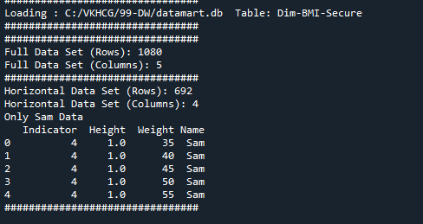

**E. Write python program to demonstrate Association rule mining.**

**Code:**

import sys

import os

import pandas as pd

from mlxtend.frequent_patterns import apriori

from mlxtend.frequent_patterns import association_rules

################################################################

if sys.platform == 'linux':

Base=os.path.expanduser('~') + '/VKHCG'

else:

Base='C:/VKHCG'

print('################################')

print('Working Base :',Base, ' using ', sys.platform)

print('################################')

################################################################

Company='01-Vermeulen'

InputFileName='Online-Retail-Billboard.xlsx'

EDSAssessDir='02-Assess/01-EDS'

InputAssessDir=EDSAssessDir + '/02-Python'

################################################################

sFileAssessDir=Base + '/' + Company + '/' + InputAssessDir

if not os.path.exists(sFileAssessDir):

os.makedirs(sFileAssessDir)

################################################################

sFileName=Base+'/'+ Company + '/00-RawData/' + InputFileName

################################################################

df = pd.read_excel(sFileName)

print(df.shape)

################################################################

df['Description'] = df['Description'].str.strip()

df.dropna(axis=0, subset=['InvoiceNo'], inplace=True)

df['InvoiceNo'] = df['InvoiceNo'].astype('str')

df = df[~df['InvoiceNo'].str.contains('C')]

basket = (df[df['Country'] =="France"]

.groupby(['InvoiceNo', 'Description'])['Quantity']

.sum().unstack().reset_index().fillna(0)

.set_index('InvoiceNo'))

################################################################

def encode_units(x):

if x <= 0:

return 0

if x >= 1:

return 1

################################################################

basket_sets = basket.applymap(encode_units)

basket_sets.drop('POSTAGE', inplace=True, axis=1)

frequent_itemsets = apriori(basket_sets, min_support=0.07, use_colnames=True)

rules = association_rules(frequent_itemsets, metric="lift", min_threshold=1)

print(rules.head())

rules[ (rules['lift'] >= 6) &

(rules['confidence'] >= 0.8) ]

################################################################

sProduct1='ALARM CLOCK BAKELIKE GREEN'

print(sProduct1)

print(basket[sProduct1].sum())

sProduct2='ALARM CLOCK BAKELIKE RED'

print(sProduct2)

print(basket[sProduct2].sum())

################################################################

basket2 = (df[df['Country'] =="Germany"]

.groupby(['InvoiceNo', 'Description'])['Quantity']

.sum().unstack().reset_index().fillna(0)

.set_index('InvoiceNo'))

basket_sets2 = basket2.applymap(encode_units)

basket_sets2.drop('POSTAGE', inplace=True, axis=1)

frequent_itemsets2 = apriori(basket_sets2, min_support=0.05, use_colnames=True)

rules2 = association_rules(frequent_itemsets2, metric="lift", min_threshold=1)

print(rules2[ (rules2['lift'] >= 4) &

(rules2['confidence'] >= 0.5)])

################################################################

print('### Done!! ############################################')

print('UPGCM')

**Output:**

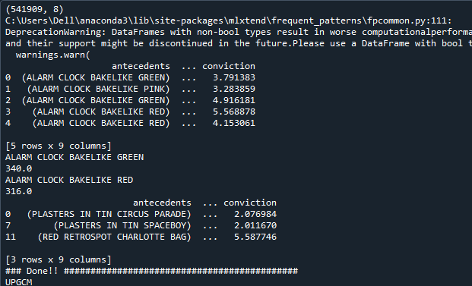

**F. Write python program to create network routing diagram in organizing superstep.**

**Code:**

import sys

import os

import pandas as pd

import networkx as nx

import matplotlib.pyplot as plt

################################################################

pd.options.mode.chained_assignment = None

################################################################

if sys.platform == 'linux':

Base=os.path.expanduser('~') + 'VKHCG'

else:

Base='C:/VKHCG'

################################################################

print('################################')

print('UPGCM')

print('Working Base :',Base, ' using ', sys.platform)

print('################################')

################################################################

sInputFileName='02-Assess/01-EDS/02-Python/Assess-Network-Routing-Company.csv'

################################################################

sOutputFileName1='05-Organise/01-EDS/02-Python/Organise-Network-Routing-Company.gml'

sOutputFileName2='05-Organise/01-EDS/02-Python/Organise-Network-Routing-Company.png'

Company='01-Vermeulen'

################################################################

################################################################

### Import Country Data

################################################################

sFileName=Base + '/' + Company + '/' + sInputFileName

print('################################')

print('Loading :',sFileName)

print('################################')

CompanyData=pd.read_csv(sFileName,header=0,low_memory=False, encoding="latin-1")

print('################################')

################################################################

print(CompanyData.head())

print(CompanyData.shape)

################################################################

G=nx.Graph()

for i in range(CompanyData.shape[0]):

for j in range(CompanyData.shape[0]):

Node0=CompanyData['Company_Country_Name'][i]

Node1=CompanyData['Company_Country_Name'][j]

if Node0 != Node1:

G.add_edge(Node0,Node1)

for i in range(CompanyData.shape[0]):

Node0=CompanyData['Company_Country_Name'][i]

Node1=CompanyData['Company_Place_Name'][i] + '('+ CompanyData['Company_Country_Name'][i] + ')'

if Node0 != Node1:

G.add_edge(Node0,Node1)

print('Nodes:', G.number_of_nodes())

print('Edges:', G.number_of_edges())

################################################################

sFileName=Base + '/' + Company + '/' + sOutputFileName1

print('################################')

print('Storing :',sFileName)

print('################################')

nx.write_gml(G, sFileName)

################################################################

sFileName=Base + '/' + Company + '/' + sOutputFileName2

print('################################')

print('Storing Graph Image:',sFileName)

print('################################')

plt.figure(figsize=(15, 15))

pos=nx.spectral_layout(G,dim=2)

nx.draw_networkx_nodes(G,pos, node_color='k', node_size=10, alpha=0.8)

nx.draw_networkx_edges(G, pos,edge_color='r', arrows=False, style='dashed')

nx.draw_networkx_labels(G,pos,font_size=12,font_family='sans-serif',font_color='b')

plt.axis('off')

plt.savefig(sFileName,dpi=600)

plt.show()

################################################################

print('################################')

print('### Done!! #####################')

print('################################')

**Output:**

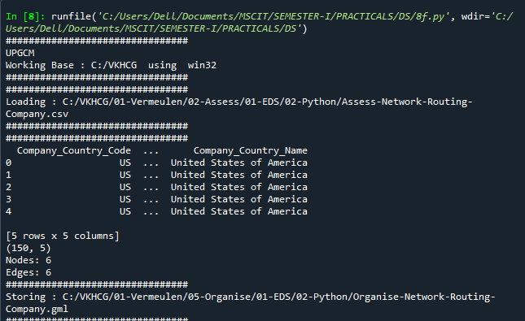

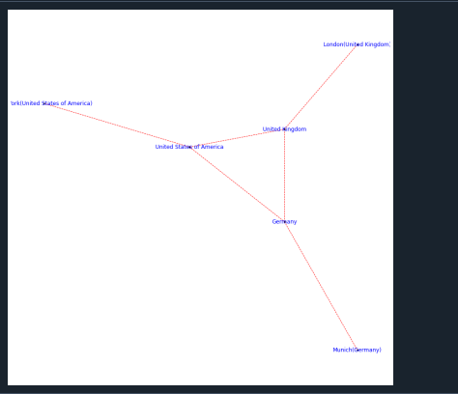

**Practical 8**

**AIM:** **GeneratingData**

**Theory:**

**Report Superstep**

The Report superstep is the step in the ecosystem that enhances the data science findings with the art of

storytelling and data visualization. You can perform the best data science, but if you cannot execute a

respectable and trustworthy Report step by turning your data science into actionable business insights, you have achieved no advantage for your business.

**Graphics**

This section will now guide you through a number of visualizations that particularly useful in presenting data to my customers.

**A. Write a python program to perform data visualization to create following graphs using profit data.**

**1.Pie Graph**

**Code:**

import sys

import os

import pandas as pd

import matplotlib as ml

from matplotlib import pyplot as plt

from google.colab import files

ml.style.use('ggplot')

data=[

['London', 29.2, 17.4],

['Glasgow', 18.8, 11.3],

['Cape Town', 15.3, 9.0],

['Houston', 22.0, 7.8],

['Perth', 18.0, 23.7],

['San Francisco', 11.4, 33.3]

]

os_new=pd.DataFrame(data)

pd.Index(['Item', 'Value', 'Value Percent', 'Conversions', 'Conversion Percent','URL', 'Stats URL'],dtype='object')

os_new.rename(columns = {0 : "Warehouse Location"}, inplace=True)

os_new.rename(columns = {1 : "Profit 2016"}, inplace=True)

os_new.rename(columns = {2 : "Profit 2017"}, inplace=True)

explode = (0, 0, 0, 0, 0, 0.1)

labels=os_new['Warehouse Location']

colors_mine = ['yellowgreen', 'gold', 'lightskyblue', 'lightcoral',

'lightcyan','lightblue']

os_new.plot(figsize=(10, 10),kind="pie", y="Profit 2017",autopct='%.2f%%', shadow=True, explode=explode, legend = False, colors = colors_mine,labels=labels, fontsize=20)

sPicNameOut1='pie_explode.png'

plt.savefig(sPicNameOut1,dpi=600)

files.download('pie_explode.png')

**Output:**

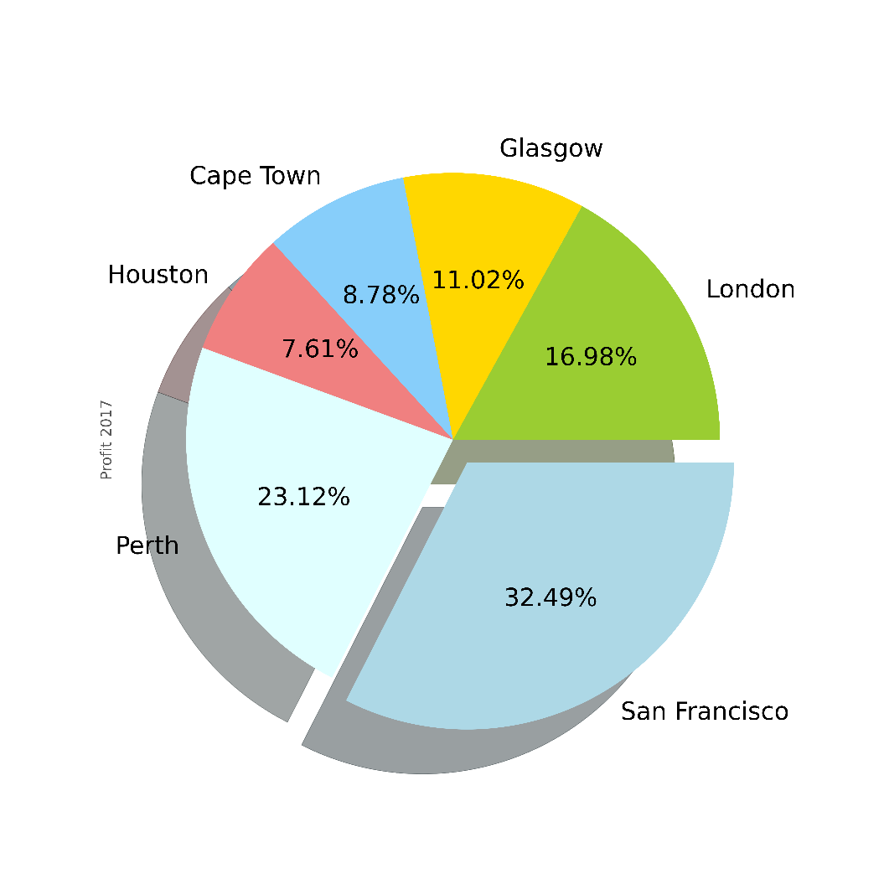

**2. Double Pie Graph**

**Code:**

import sys

import os

import pandas as pd

import matplotlib as ml

from matplotlib import pyplot as plt

if sys.platform == 'linux' or sys.platform == ' darwin':

Base=os.path.expanduser('~') + '/VKHCG'

else:

Base='C:/VKHCG'

print('################################')

print('Working Base :',Base, ' using ', sys.platform)

print('################################')

################################################################

GBase = Base+'/01-Vermeulen/06-Report/01-EDS/02-Python/'

ml.style.use('ggplot')

data=[

['London', 29.2, 17.4],

['Glasgow', 18.8, 11.3],

['Cape Town', 15.3, 9.0],

['Houston', 22.0, 7.8],

['Perth', 18.0, 23.7],

['San Francisco', 11.4, 33.3]

]

os_new=pd.DataFrame(data)

pd.Index(['Item', 'Value', 'Value Percent', 'Conversions', 'ConversionPercent','URL', 'Stats URL'],dtype='object')

os_new.rename(columns = {0 : "Warehouse Location"}, inplace=True)

os_new.rename(columns = {1 : "Profit 2016"}, inplace=True)

os_new.rename(columns = {2 : "Profit 2017"}, inplace=True)

explode = (0, 0, 0, 0, 0, 0)

colors_mine = ['yellowgreen', 'gold', 'lightskyblue', 'lightcoral','lightcyan','lightblue']

os_new.plot(figsize=(10, 5),kind="pie", y=['Profit 2016','Profit 2017'],autopct='%.2f%%', \

shadow=True, explode=explode, legend = False,colors =

colors_mine,\

subplots=True, labels=labels, fontsize=10)

sPicNameOut2=GBase+'pie.png'

plt.savefig(sPicNameOut2,dpi=600)

**Output:**

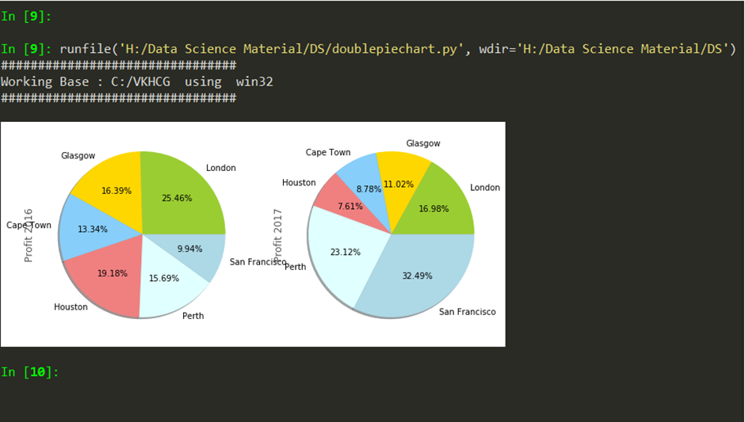

**3. Line Graph**

**Code:**

import sys

import os

import pandas as pd

import matplotlib as ml

from matplotlib import pyplot as plt

from google.colab import files

ml.style.use('ggplot')

data=[

['London', 29.2, 17.4],

['Glasgow', 18.8, 11.3],

['Cape Town', 15.3, 9.0],

['Houston', 22.0, 7.8],

['Perth', 18.0, 23.7],

['San Francisco', 11.4, 33.3]

]

os_new=pd.DataFrame(data)

pd.Index(['Item', 'Value', 'Value Percent', 'Conversions', 'Conversion Percent','URL', 'Stats URL'],dtype='object')

os_new.rename(columns = {0 : "Warehouse Location"}, inplace=True)

os_new.rename(columns = {1 : "Profit 2016"}, inplace=True)

os_new.rename(columns = {2 : "Profit 2017"}, inplace=True)

os_new.iloc[:5].plot(figsize=(10, 10),kind='line',x='Warehouse Location',y=['Profit 2016','Profit 2017']);

sPicNameOut3='line.png'

plt.savefig(sPicNameOut3,dpi=600)

files.download('line.png')

**Output:**

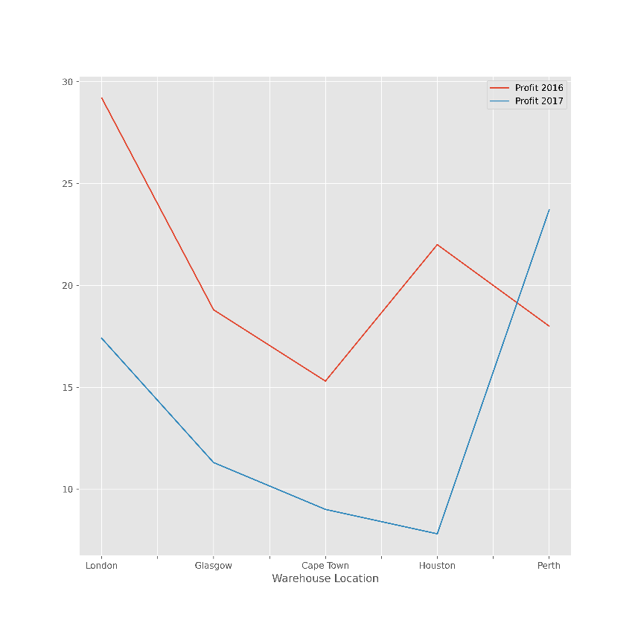

**4. Vertical Bar Graph**

**Code:**

import sys

import os

import pandas as pd

import matplotlib as ml

from matplotlib import pyplot as plt

from google.colab import files

ml.style.use('ggplot')

data=[

['London', 29.2, 17.4],

['Glasgow', 18.8, 11.3],

['Cape Town', 15.3, 9.0],

['Houston', 22.0, 7.8],

['Perth', 18.0, 23.7],

['San Francisco', 11.4, 33.3]

]

os_new=pd.DataFrame(data)

pd.Index(['Item', 'Value', 'Value Percent', 'Conversions', 'Conversion Percent','URL', 'Stats URL'],dtype='object')

os_new.rename(columns = {0 : "Warehouse Location"}, inplace=True)

os_new.rename(columns = {1 : "Profit 2016"}, inplace=True)

os_new.rename(columns = {2 : "Profit 2017"}, inplace=True)

os_new.iloc[:5].plot(figsize=(10, 10),kind='bar',x='Warehouse Location', y=['Profit 2016','Profit 2017']);

sPicNameOut4='bar.png'

plt.savefig(sPicNameOut4,dpi=600)

files.download('bar.png')

**Output:**

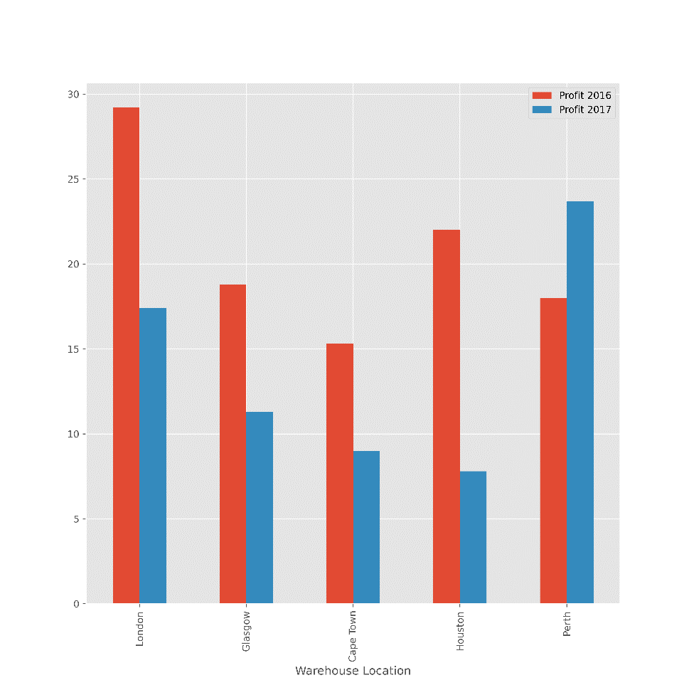

**5. Horizontal Bar Graph**

**Code:**

import sys

import os

import pandas as pd

import matplotlib as ml

from matplotlib import pyplot as plt

from google.colab import files

ml.style.use('ggplot')

data=[

['London', 29.2, 17.4],

['Glasgow', 18.8, 11.3],

['Cape Town', 15.3, 9.0],

['Houston', 22.0, 7.8],

['Perth', 18.0, 23.7],

['San Francisco', 11.4, 33.3]

]

os_new=pd.DataFrame(data)

pd.Index(['Item', 'Value', 'Value Percent', 'Conversions', 'Conversion Percent','URL', 'Stats URL'],dtype='object')

os_new.rename(columns = {0 : "Warehouse Location"}, inplace=True)

os_new.rename(columns = {1 : "Profit 2016"}, inplace=True)

os_new.rename(columns = {2 : "Profit 2017"}, inplace=True)

os_new.iloc[:5].plot(figsize=(10, 10),kind='barh',x='Warehouse Location',y=['Profit 2016','Profit 2017']);

sPicNameOut='hbar.png'

plt.savefig(sPicNameOut,dpi=600)

files.download('hbar.png')

**Output:**

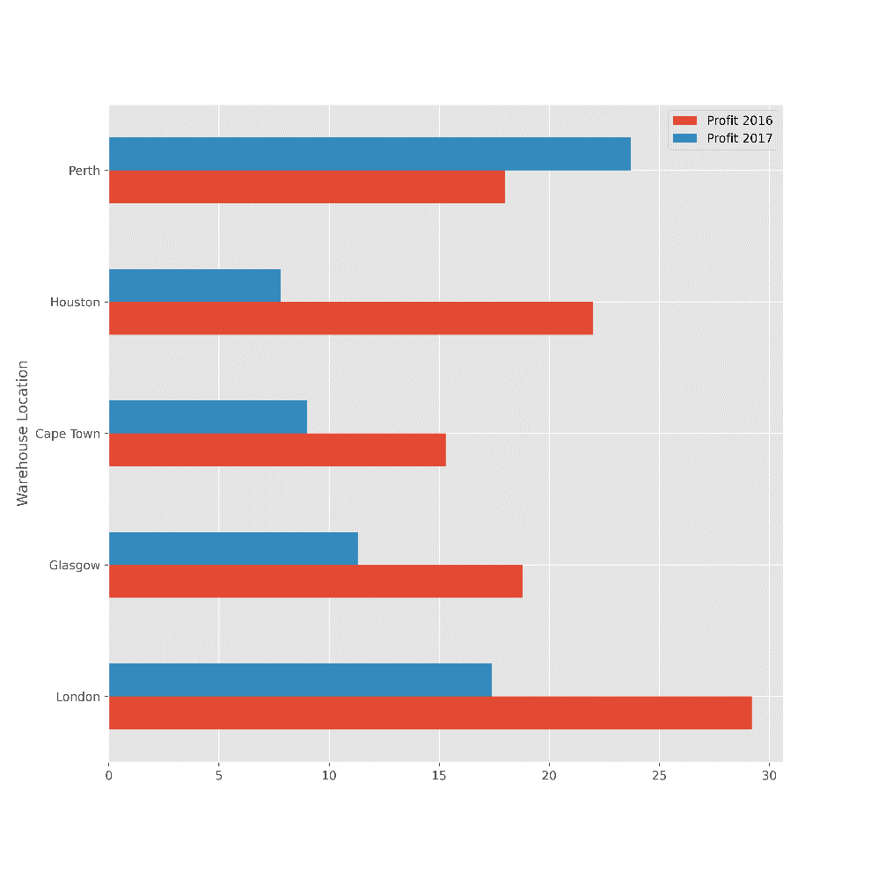

**6. Area Graph**

**Code:**

import sys

import os

import pandas as pd

import matplotlib as ml

from matplotlib import pyplot as plt

from google.colab import files

ml.style.use('ggplot')

data=[

['London', 29.2, 17.4],

['Glasgow', 18.8, 11.3],

['Cape Town', 15.3, 9.0],

['Houston', 22.0, 7.8],

['Perth', 18.0, 23.7],

['San Francisco', 11.4, 33.3]

]

os_new=pd.DataFrame(data)

pd.Index(['Item', 'Value', 'Value Percent', 'Conversions', 'Conversion Percent','URL', 'Stats URL'],dtype='object')

os_new.rename(columns = {0 : "Warehouse Location"}, inplace=True)

os_new.rename(columns = {1 : "Profit 2016"}, inplace=True)

os_new.rename(columns = {2 : "Profit 2017"}, inplace=True)

os_new.iloc[:5].plot(figsize=(10, 10),kind='area',x='Warehouse Location',y=['Profit 2016','Profit 2017'],stacked=False);

sPicNameOut6='area1.png'

plt.savefig(sPicNameOut6,dpi=600)

files.download('area1.png')

**Output:**

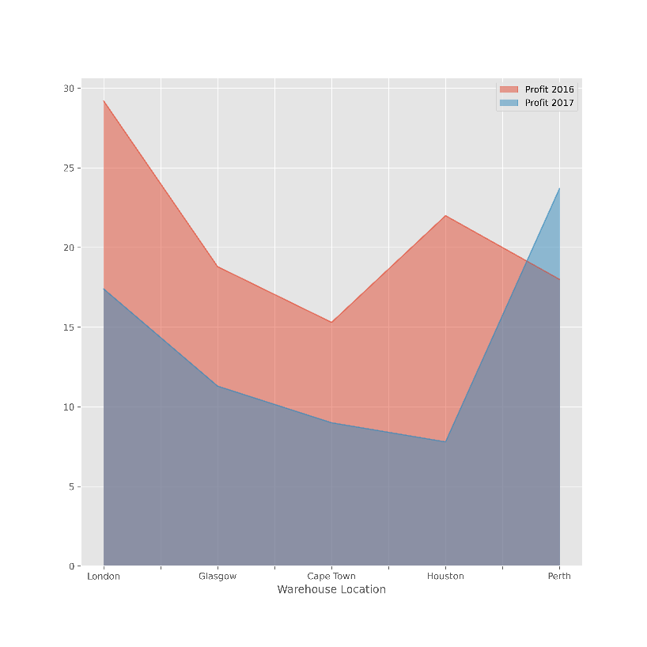

**7. Scatter Graph**

**Code:**

import sys

import os

import pandas as pd

import matplotlib as ml

from matplotlib import pyplot as plt

from google.colab import files

ml.style.use('ggplot')

data=[

['London', 29.2, 17.4],

['Glasgow', 18.8, 11.3],

['Cape Town', 15.3, 9.0],

['Houston', 22.0, 7.8],

['Perth', 18.0, 23.7],

['San Francisco', 11.4, 33.3]

]

os_new=pd.DataFrame(data)

pd.Index(['Item', 'Value', 'Value Percent', 'Conversions', 'Conversion Percent','URL', 'Stats URL'],dtype='object')

os_new.rename(columns = {0 : "Warehouse Location"}, inplace=True)

os_new.rename(columns = {1 : "Profit 2016"}, inplace=True)

os_new.rename(columns = {2 : "Profit 2017"}, inplace=True)

os_new.iloc[:5].plot(figsize=(10, 10),kind='scatter',x='Profit 2016',y='Profit 2017',color='DarkBlue',marker='o');

sPicNameOut7='scatter.png'

plt.savefig(sPicNameOut7,dpi=600)

files.download('scatter.png')

**Output:**

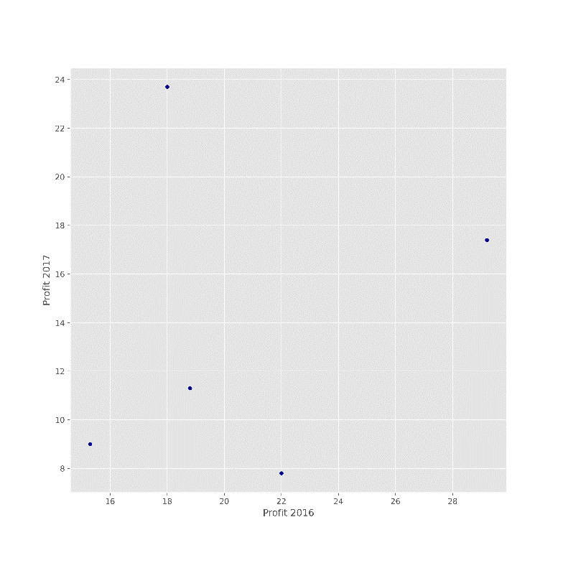

**8. Hex Bin Graph**

**Code:**

import sys

import os

import pandas as pd

import matplotlib as ml

from matplotlib import pyplot as plt

from google.colab import files

ml.style.use('ggplot')

data=[

['London', 29.2, 17.4],

['Glasgow', 18.8, 11.3],

['Cape Town', 15.3, 9.0],

['Houston', 22.0, 7.8],

['Perth', 18.0, 23.7],

['San Francisco', 11.4, 33.3]

]

os_new=pd.DataFrame(data)

pd.Index(['Item', 'Value', 'Value Percent', 'Conversions', 'Conversion Percent','URL', 'Stats URL'],dtype='object')

os_new.rename(columns = {0 : "Warehouse Location"}, inplace=True)

os_new.rename(columns = {1 : "Profit 2016"}, inplace=True)

os_new.rename(columns = {2 : "Profit 2017"}, inplace=True)

os_new.iloc[:5].plot(figsize=(13, 10),kind='hexbin',x='Profit 2016',y='Profit 2017', gridsize=25);

sPicNameOut8='hexbin.png'

plt.savefig(sPicNameOut8,dpi=600)

files.download('hexbin.png')

**Output:**

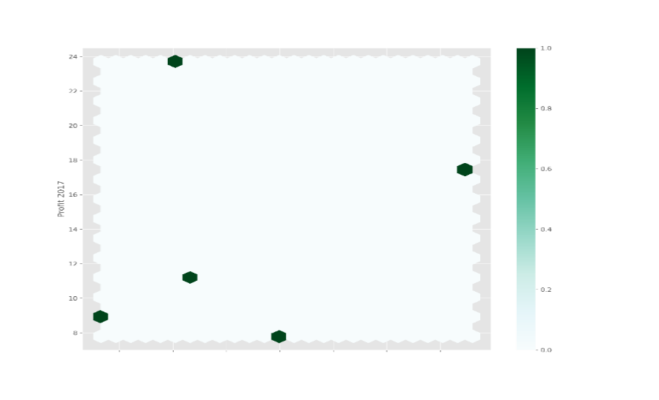

**B. Write python/R program to perform data visualization to create following advanced graphs/plots for the data.**

**1. Kernel Density Estimation (KDE) Graph**

**Code:**

import sys

import os

import pandas as pd

import matplotlib as ml

import numpy as np

from matplotlib import pyplot as plt

from google.colab import files

ml.style.use('ggplot')

fig1=plt.figure(figsize=(10, 10))

ser = pd.Series(np.random.randn(1000))

ser.plot(figsize=(10, 10),kind='kde')

sPicNameOut1='kde.png'

plt.savefig(sPicNameOut1,dpi=600)

plt.tight_layout()

plt.show()

files.download('kde.png')

**Output:**

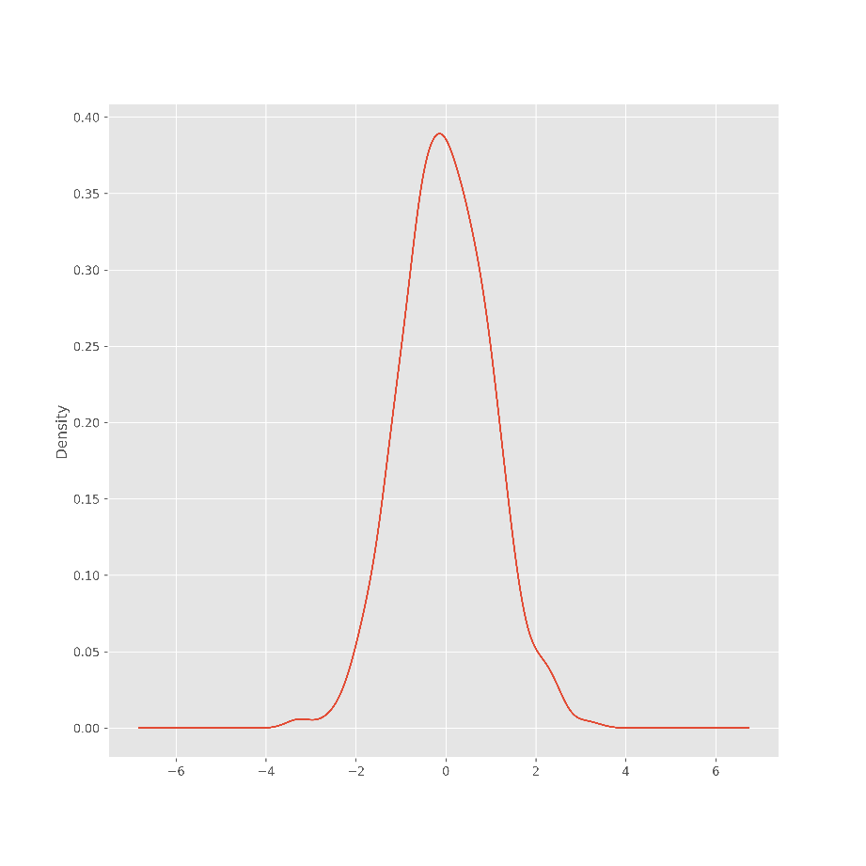

**2. Scatter Matrix**

**Code:**

import sys

import os

import pandas as pd

import matplotlib as ml

import numpy as np

from matplotlib import pyplot as plt

from google.colab import files

fig2=plt.figure(figsize=(10, 10))

from pandas.plotting import scatter_matrix

df = pd.DataFrame(np.random.randn(1000, 5), columns=['Y2014','Y2015','Y2016', 'Y2017', 'Y2018'])

scatter_matrix(df, alpha=0.2, figsize=(10, 10), diagonal='kde')

sPicNameOut2='scattermatrixgraph.png'

plt.savefig(sPicNameOut2,dpi=600)

plt.tight_layout()

plt.show()

files.download('scattermatrixgraph.png')

**Output:**

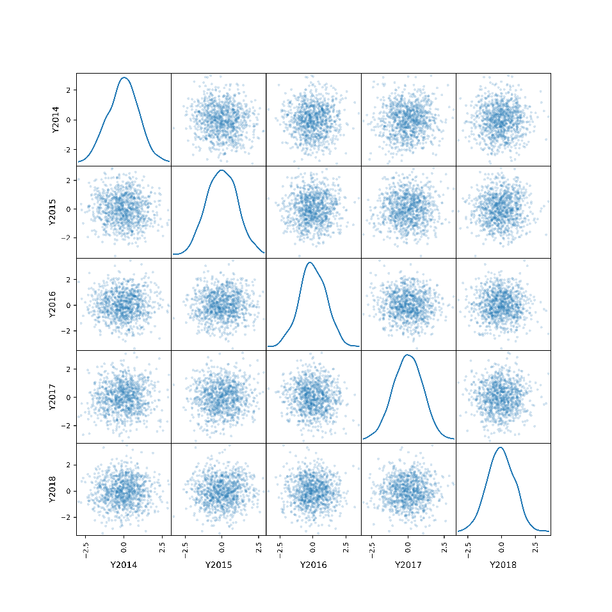

**3. Andrew’s Curves**

**Code:**

import sys

import os

import pandas as pd

import matplotlib as ml

import numpy as np

from matplotlib import pyplot as plt

from google.colab import files

from pandas.plotting import andrews_curves

import io

uploaded=files.upload()

data=pd.read_csv(io.BytesIO(uploaded['irisdata.csv']))

plt.figure(figsize=(10, 10))

andrews_curves(data, 'Name')

sPicNameOut1='Curves.png'

plt.savefig(sPicNameOut1,dpi=600)

plt.tight_layout()

plt.show()

files.download('Curves.png')

**Output:**

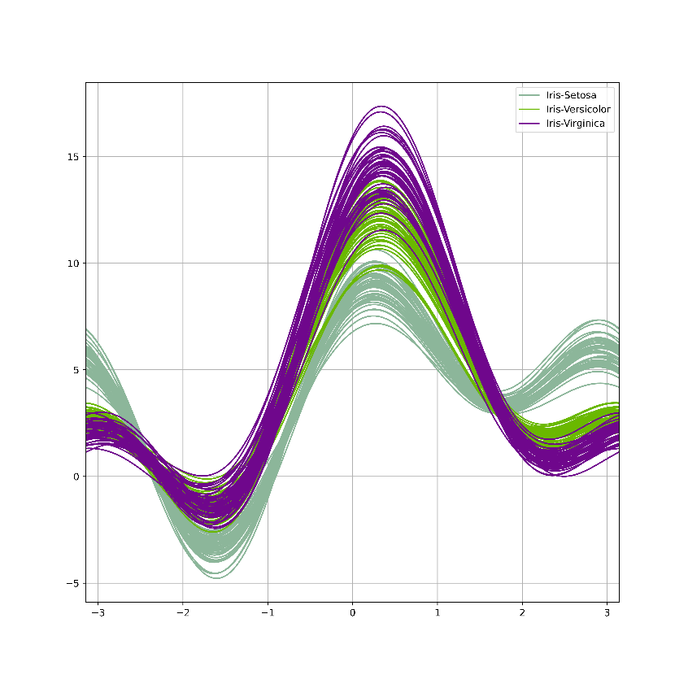

**4. Parallel Coordinates**

**Code:**

import sys

import os

import pandas as pd

import matplotlib as ml

import numpy as np

from matplotlib import pyplot as plt

from google.colab import files

from pandas.plotting import parallel_coordinates

import io

uploaded=files.upload()

data=pd.read_csv(io.BytesIO(uploaded['irisdata.csv']))

plt.figure(figsize=(10, 10))

parallel_coordinates(data, 'Name')

sPicNameOut2='coordinates.png'

plt.savefig(sPicNameOut2,dpi=600)

plt.tight_layout()

plt.show()

files.download('coordinates.png')

**Output:**

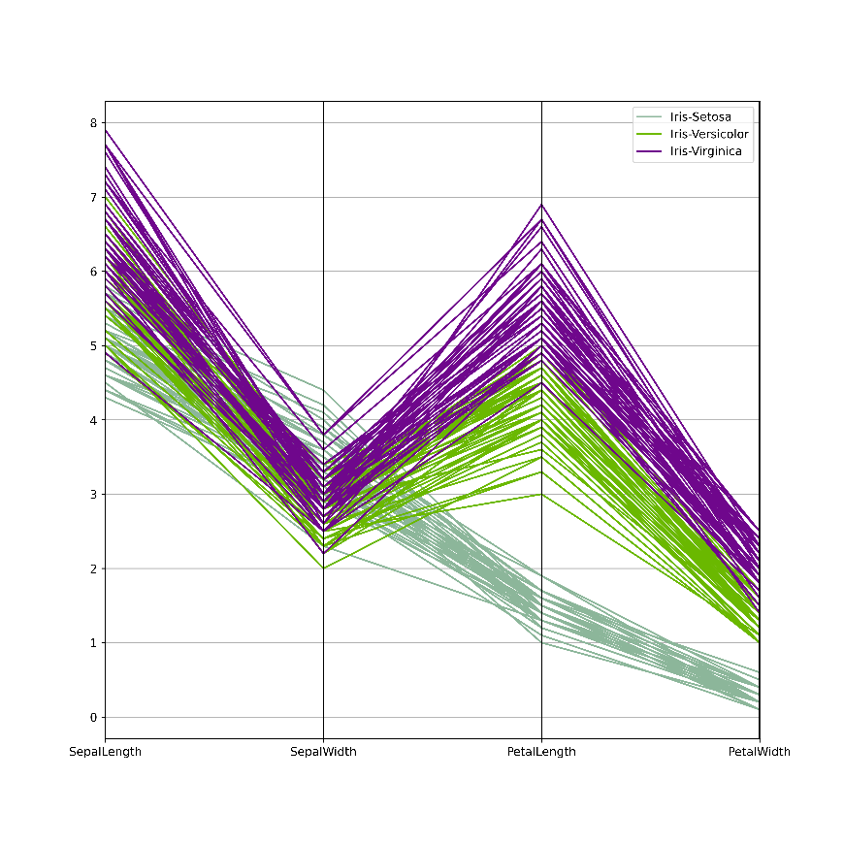

**5. RADVIZ method**

**Code:**

import sys

import os

import pandas as pd

import matplotlib as ml

import numpy as np

from matplotlib import pyplot as plt

from google.colab import files

from pandas.plotting import radviz

import io

uploaded=files.upload()

data=pd.read_csv(io.BytesIO(uploaded['irisdata.csv']))

plt.figure(figsize=(10, 10))

radviz(data, 'Name')

sPicNameOut3='radviz.png'

plt.savefig(sPicNameOut3,dpi=600)

plt.tight_layout()

plt.show()

files.download('radviz.png')

**Output:**

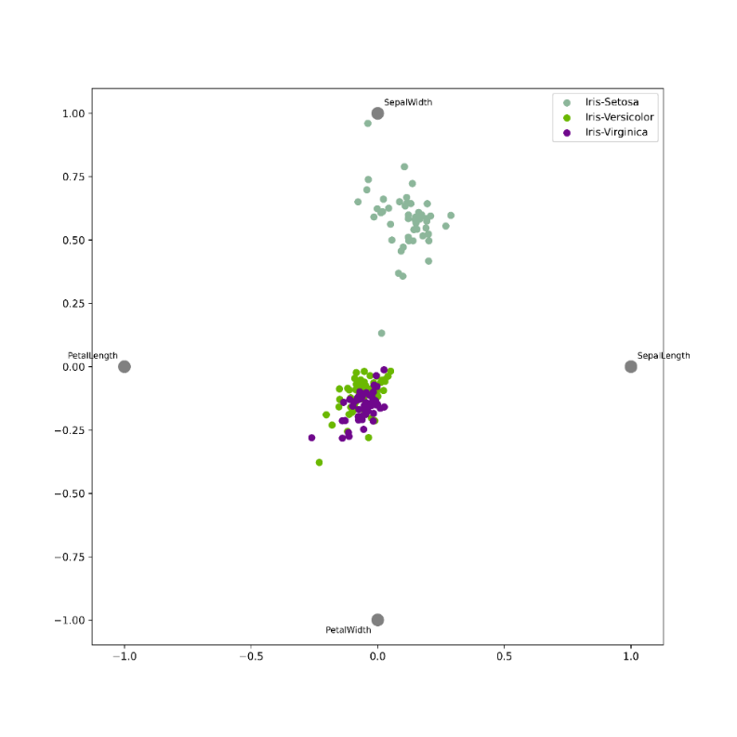

**6. Lag Plot**

**Code:**

import sys

import os

import pandas as pd

from matplotlib import style

from matplotlib import pyplot as plt

import numpy as np

from google.colab import files

style.use('ggplot')

from pandas.plotting import lag_plot

plt.figure(figsize=(10, 10))

data = pd.Series(0.1 * np.random.rand(1000) + 0.9 * np.sin(np.linspace(-99 * np.pi, 99 * np.pi, num=1000)))

lag_plot(data)

sPicNameOut1='lag_plot.png'

plt.savefig(sPicNameOut1,dpi=600)

plt.tight_layout()

plt.show()

files.download('lag_plot.png')

**Output:**

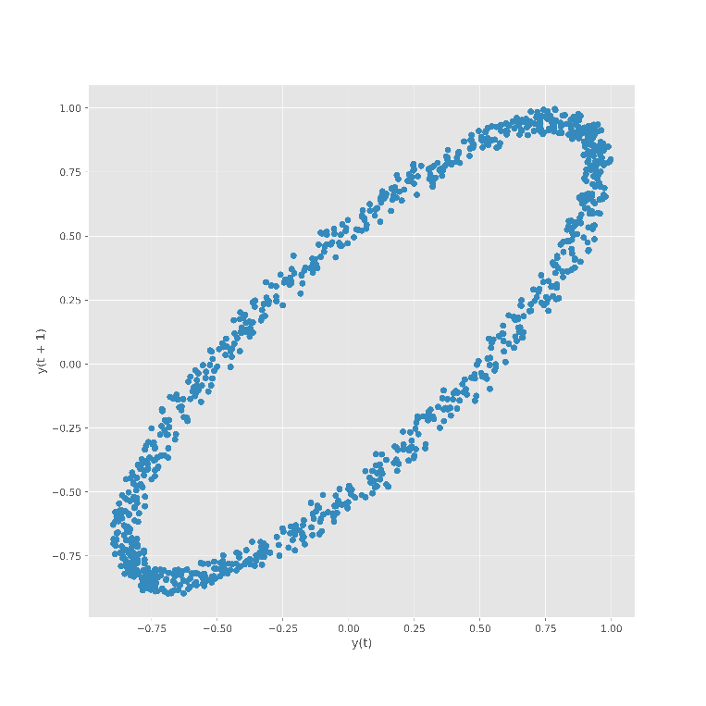

**7. Autocorrelation Plot**

**Code:**

import sys

import os

import pandas as pd

from matplotlib import style

from matplotlib import pyplot as plt

import numpy as np

from google.colab import files

from pandas.plotting import autocorrelation_plot

plt.figure(figsize=(10, 10))

data = pd.Series(0.7 * np.random.rand(1000) + 0.3 * np.sin(np.linspace(-9 * np.pi, 9 * np.pi, num=1000)))

autocorrelation_plot(data)

sPicNameOut2='autocorrelation_plot.png'

plt.savefig(sPicNameOut2,dpi=600)

plt.tight_layout()

plt.show()

files.download('autocorrelation_plot.png')

**Output:**

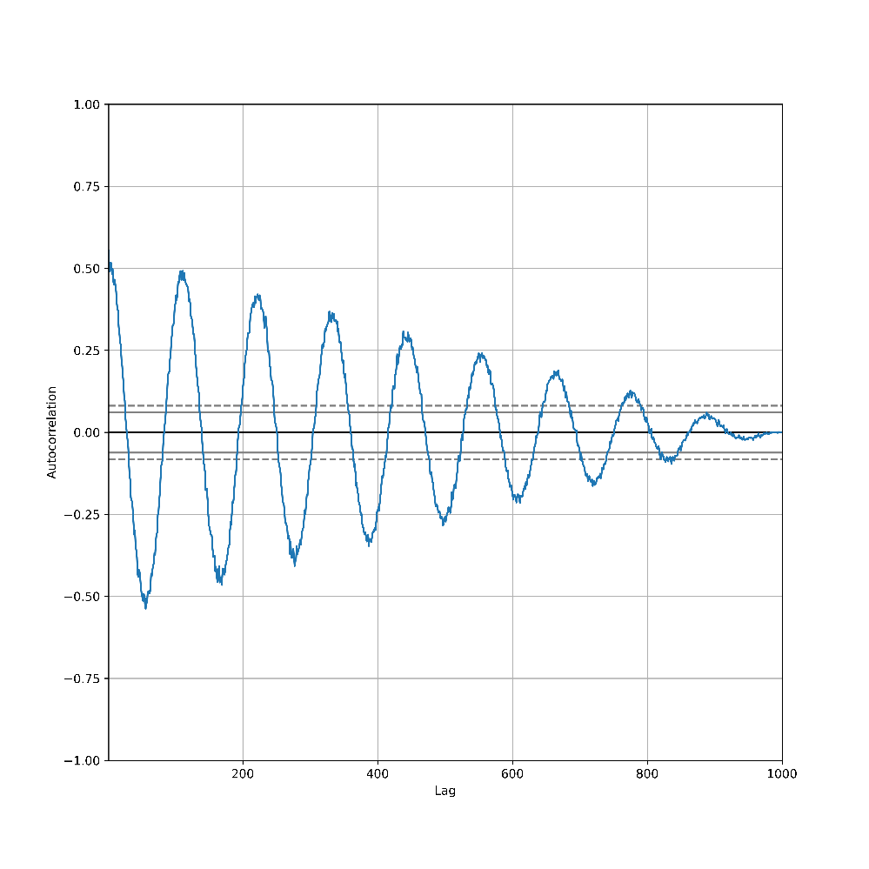

**8.Bootstrap Plot**

**Code:**

import sys

import os

import pandas as pd

from matplotlib import style

from matplotlib import pyplot as plt

import numpy as np

from google.colab import files

from pandas.plotting import bootstrap_plot

data = pd.Series(np.random.rand(1000))

plt.figure(figsize=(10, 10))

bootstrap_plot(data, size=50, samples=500, color='grey')

sPicNameOut3='bootstrap_plot.png'

plt.savefig(sPicNameOut3,dpi=600)

plt.tight_layout()

plt.show()

files.download('bootstrap_plot.png')

**Output:**

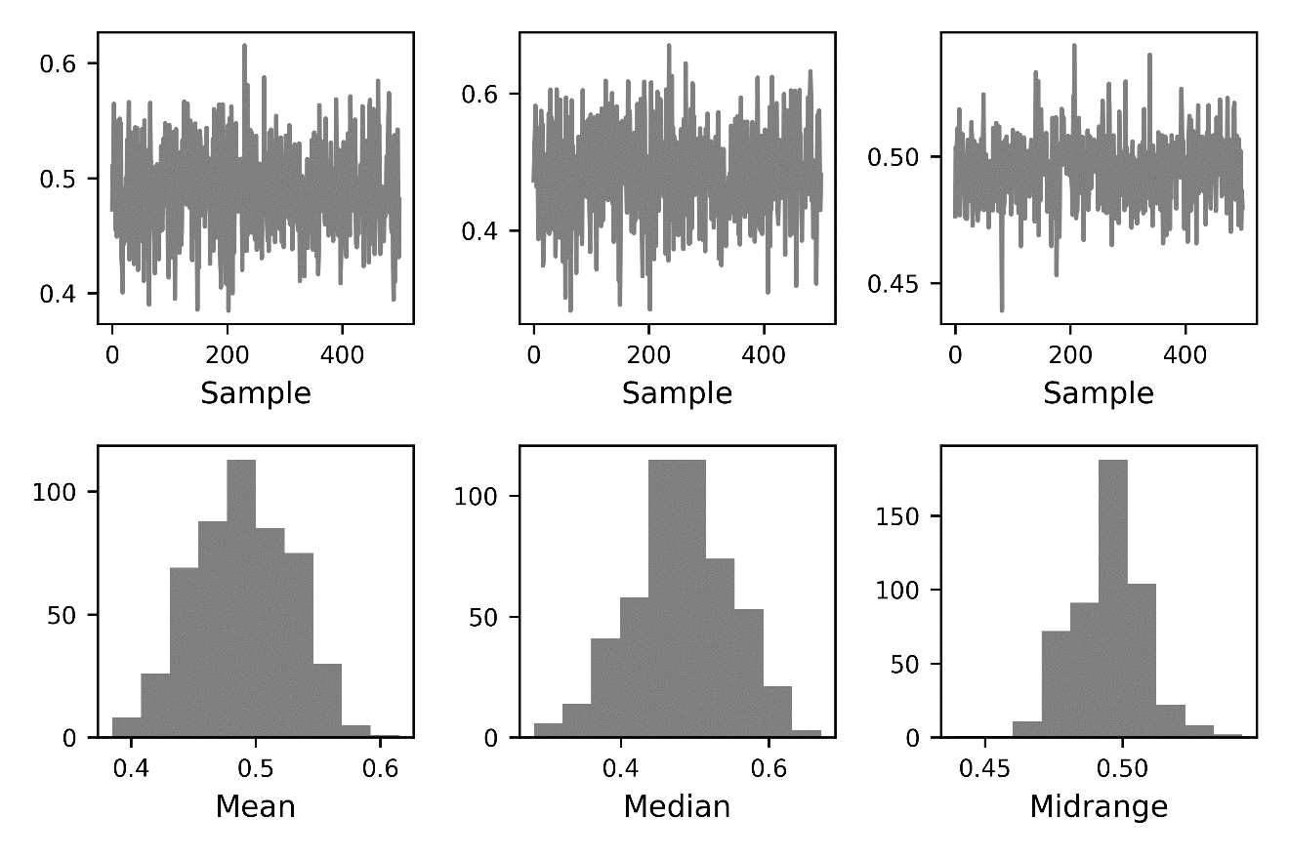

**9. Contour Graphs**

**Code:**

import sys

import os

import matplotlib

import numpy as np

import matplotlib.cm as cm

import matplotlib.mlab as mlab

import matplotlib.pyplot as plt

################################################################

if sys.platform == 'linux' or sys.platform == ' darwin':

Base=os.path.expanduser('~') + '/VKHCG'

else:

Base='C:/VKHCG'

print('################################')

print('Working Base :',Base, ' using ', sys.platform)

print('################################')

matplotlib.rcParams['xtick.direction'] = 'out'

matplotlib.rcParams['ytick.direction'] = 'out'

delta = 0.025

x = np.arange(-3.0, 3.0, delta)

y = np.arange(-2.0, 2.0, delta)

X, Y = np.meshgrid(x, y)

Z1 = mlab.bivariate_normal(X, Y, 1.0, 1.0, 0.0, 0.0)

Z2 = mlab.bivariate_normal(X, Y, 1.5, 0.5, 1, 1)

# difference of Gaussians

Z = 10.0 * (Z2 - Z1)

plt.figure(figsize=(10, 10))

CS = plt.contour(X, Y, Z)

plt.clabel(CS, inline=1, fontsize=10)

plt.title('Simply default with labels')

sPicNameOut0=Base+'/01-Vermeulen/06-Report/01-EDS/02-Python/contour0.png'

plt.savefig(sPicNameOut0,dpi=600)

plt.tight_layout()

plt.show()

plt.show()

**Output:**

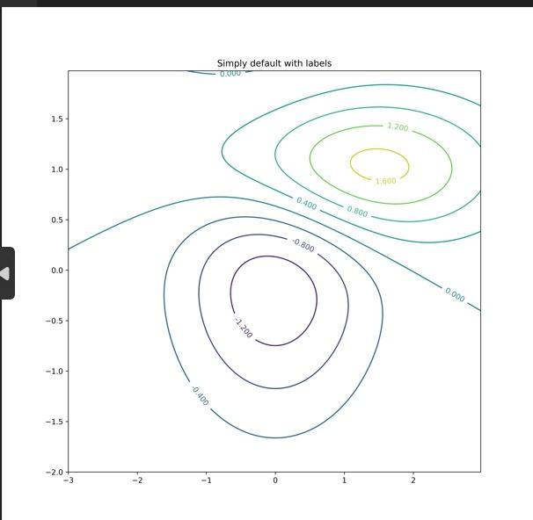

**10. 3D Graph**

**Code:**

import sys

import os

import numpy as np

import matplotlib.pyplot as plt

from mpl_toolkits.mplot3d import Axes3D

from sklearn import decomposition

from sklearn import datasets

################################################################

if sys.platform == 'linux':

Base=os.path.expanduser('~') + '/VKHCG'

else:

Base='C:/VKHCG'

print('################################')

print('Working Base :',Base, ' using ', sys.platform)

print('################################')

################################################################

np.random.seed(5)

centers = [[1, 1], [-1, -1], [1, -1]]

iris = datasets.load_iris()

X = iris.data

y = iris.target

fig = plt.figure(1, figsize=(16, 12))

plt.clf()

ax = Axes3D(fig, rect=[0, 0, .95, 1], elev=48, azim=134)

plt.cla()

pca = decomposition.PCA(n_components=3)

pca.fit(X)

X = pca.transform(X)

for name, label in [('Setosa', 0), ('Versicolour', 1), ('Virginica', 2)]:

ax.text3D(X[y == label, 0].mean(),

X[y == label, 1].mean() + 1.5,

X[y == label, 2].mean(), name,

horizontalalignment='center',

bbox=dict(alpha=.5, edgecolor='w', facecolor='w'))

# Reorder the labels to have colors matching the cluster results

y = np.choose(y, [1, 2, 0]).astype(np.float)

ax.scatter(X[:, 0], X[:, 1], X[:, 2], c=y, cmap=plt.cm.spectral,

edgecolor='k',marker='p',s=300)

ax.w_xaxis.set_ticklabels([])

ax.w_yaxis.set_ticklabels([])

ax.w_zaxis.set_ticklabels([])

sPicNameOut0=Base+'/01-Vermeulen/06-Report/01-EDS/02-Python/3DPlot.png'

plt.savefig(sPicNameOut0,dpi=600)

plt.show()

**Output:**

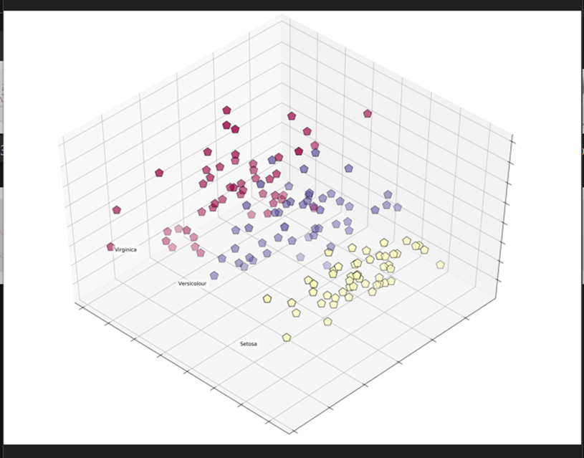

**Practical 9**

**AIM:** **Data Visualization with Power BI**

**Step 1: Connect to an Excel workbook**

1. Launch Power BI Desktop
2. From the Home ribbon, select **Get Data**. Excel is one of the **Most Common** data Collections, so you can select it directly from the **Get Data** menu.
3. If you select the Get Data button directly, you can also select File> Excel and select Connect.
4. In the Open File dialog box, select the Products.xlsx file.

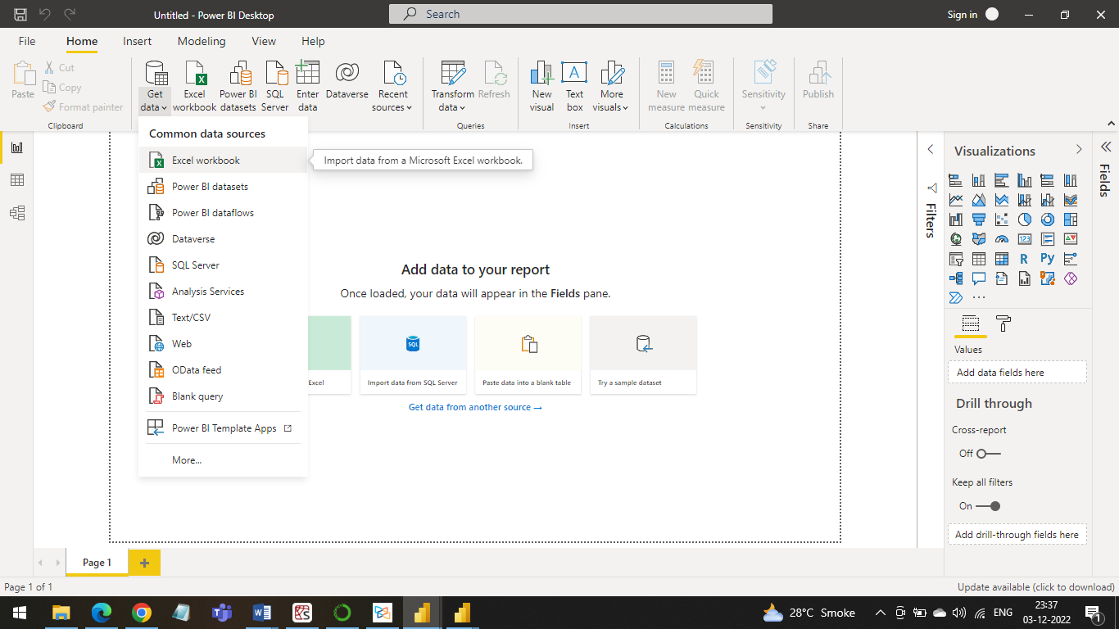

You can also open the Query Editor by selecting Edit Queries from the Home ribbon in Power BI Desktop. The following steps are performed in Query Editor.

1. In Query Editor, select the ProductID, ProductName, QuantityPerUnit, and UnitsInStock columns

*(use Ctrl+ Click to select more than one columns , or Shift+Click to select columns that are beside each other)*

1. Select Remove Columns -> Remove Other Columns from the ribbon, or right-click on a columns header and click Remove Other Columns.

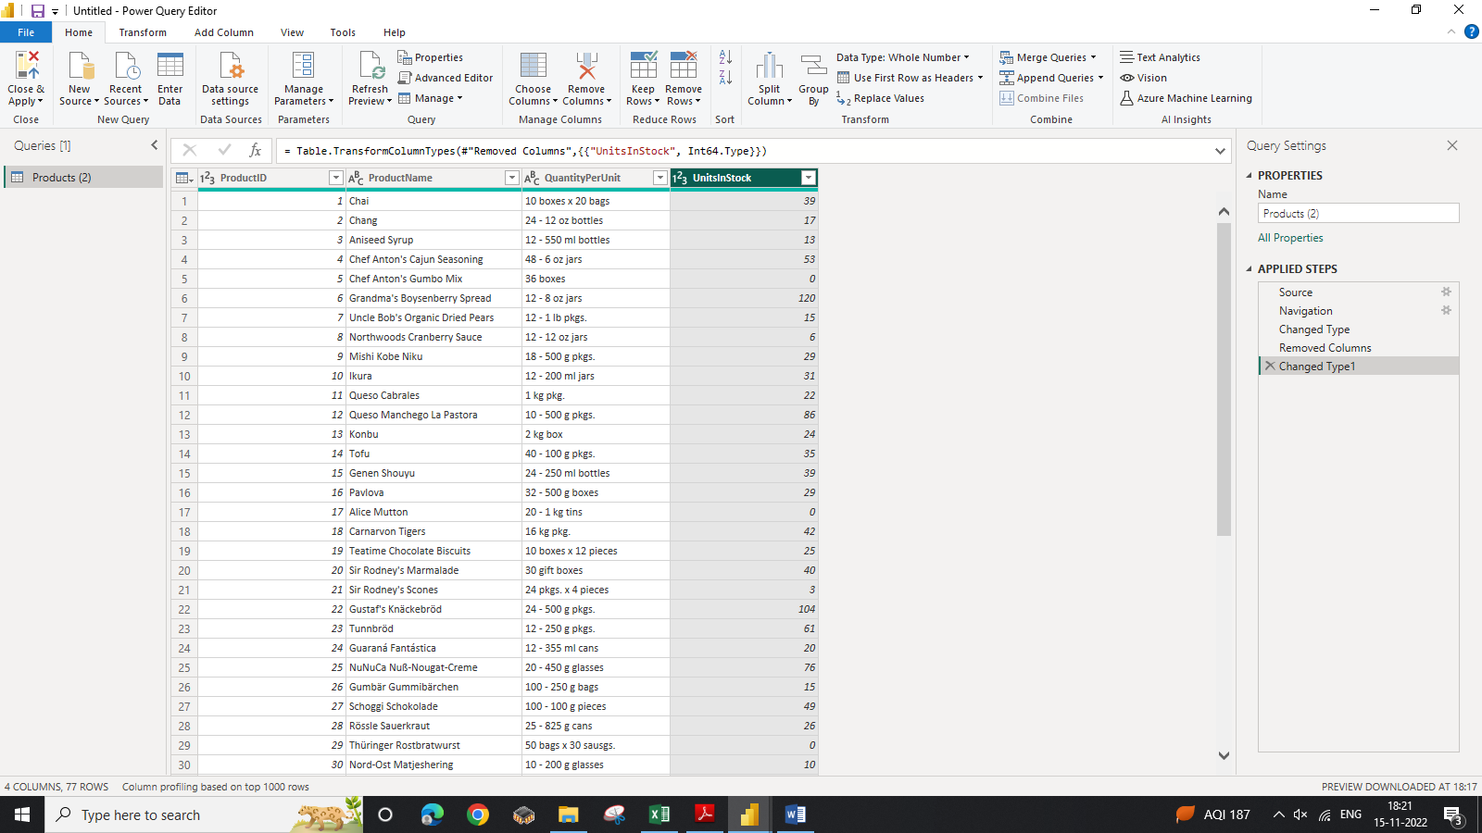

1. Change the data type of the UnitsInStock column

For the Excel workbook, products in stock will always be a whole number , so in this step you confirm the UnitsInStock column’s datatype is Whole Number.

1. Select the UnitsInStock column.
2. Select the Data Type drop-down button in the Home ribbon
3. If not already a Whole Number, set Whole Number for data type from the drop down *(the Data Type: button also displays the data type for the current selection).*

**Task 2: Import order data from an OData feed**

You import data into Power BI Desktop from the sample Northwind OData feed at the following

URL, which you can copy (and then paste) in the steps below:

http://services.odata.org/V3/Northwind/Northwind.svc/

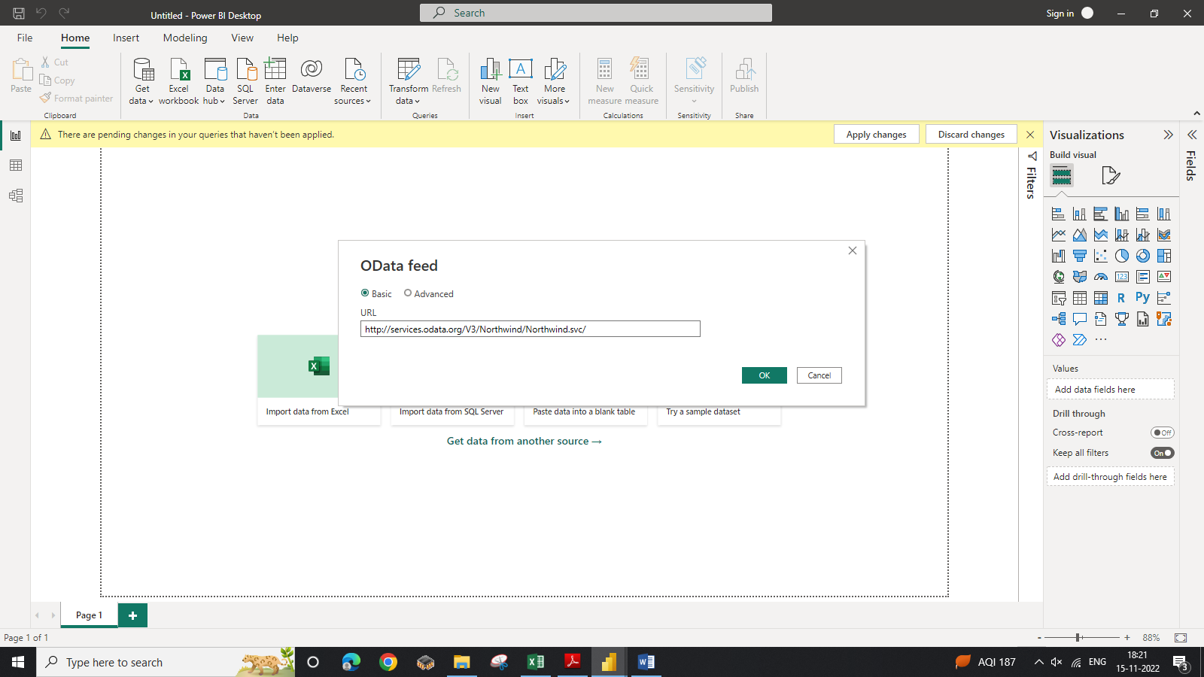

**Step 1: Connect to an OData feed**

1. From the **Home** ribbon tab in Query Editor, select **Get Data**.

2. Browse to the **OData Feed** data source.

3. In the **OData Feed** dialog box, paste the **URL** for the Northwind OData feed.

4. Select **OK**.

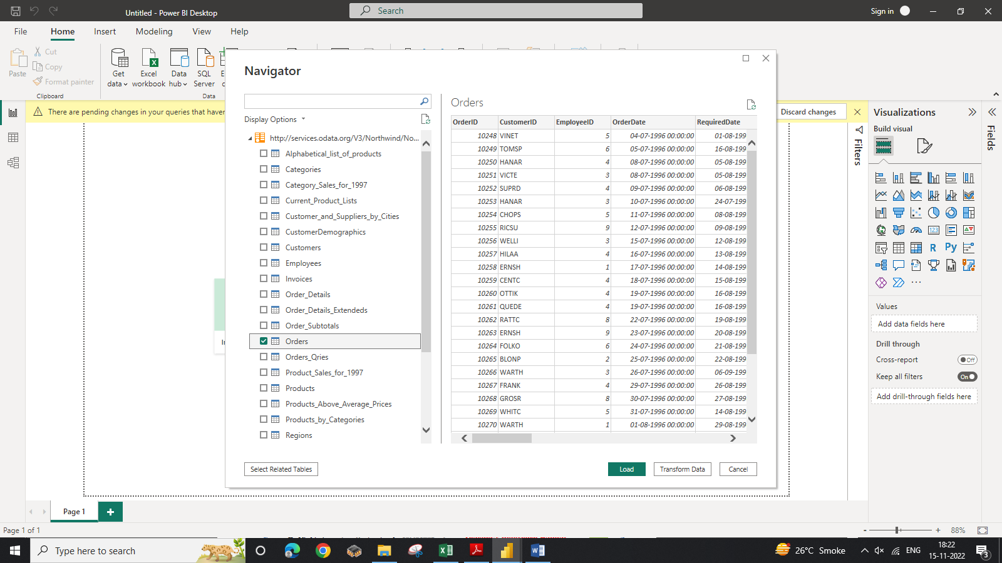

**Step 2: Expand the Order_Details table**

Expand the **Order_Details** table that is related to the **Orders** table, to combine the **ProductID,**

**UnitPrice**, and **Quantity** columns from **Order_Details** into the **Orders** table.

The **Expand** operation combines columns from a related table into a subject table. When the query runs, rows from the related table **(Order_Details)** are combined into rows from the subject table

**(Orders).**

After you expand the **Order_Details** table, three new columns and additional rows are added to the

**Orders** table, one for each row in the nested or related table.

1. In the **Query View,** scroll to the **Order_Details** column.

2. In the **Order_Details** column, select the expand icon ().

3. In the **Expand** drop-down: a. Select **(Select All Columns)** to clear all columns.

Select **ProductID, UnitPrice,** and **Quantity.**

click **OK**.

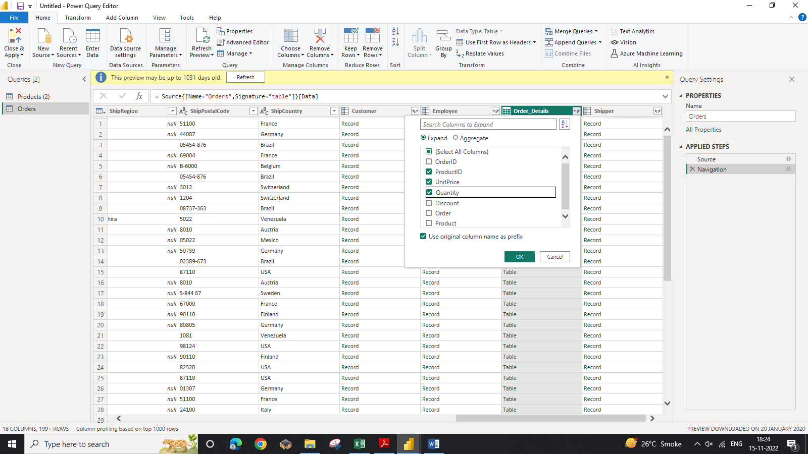

**Step 3: Remove other columns to only display columns of interest**

In this step you remove all columns except **OrderDate, ShipCity, ShipCountry,**

**Order_Details.ProductID, Order_Details.UnitPrice,** and **Order_Details.Quantity** columns. In the previous task, you used **Remove Other Columns**. For this task, you remove selected columns.

In the **Query View**, select all columns by completing a.

a. Click the first column **(OrderID)**.

b. Shift+Click the last column **(Shipper**).

c. Now that all columns are selected, use Ctrl+Click to unselect the following columns:

OrderDate, ShipCity, ShipCountry, Order_Details.ProductID, Order_Details.UnitPrice, and

Order_Details.Quantity.

Now that only the columns we want to remove are selected, right-click on any selected column

header and click Remove Columns.

**Step 4: Calculate the line total for each Order_Details row**

Power BI Desktop lets you to create calculations based on the columns you are importing, so you can

enrich the data that you connect to. In this step, you create a **Custom Column** to calculate the line

total for each **Order_Details** row.

Calculate the line total for each **Order_Details** row:

1. In the **Add Column** ribbon tab, click **Add Custom Column.**

2. In the Add Custom Column dialog box, in the Custom Column Formula textbox, enter

**[Order_Details.UnitPrice] * [Order_Details.Quantity].**

3. In the New column name textbox, enter LineTotal.

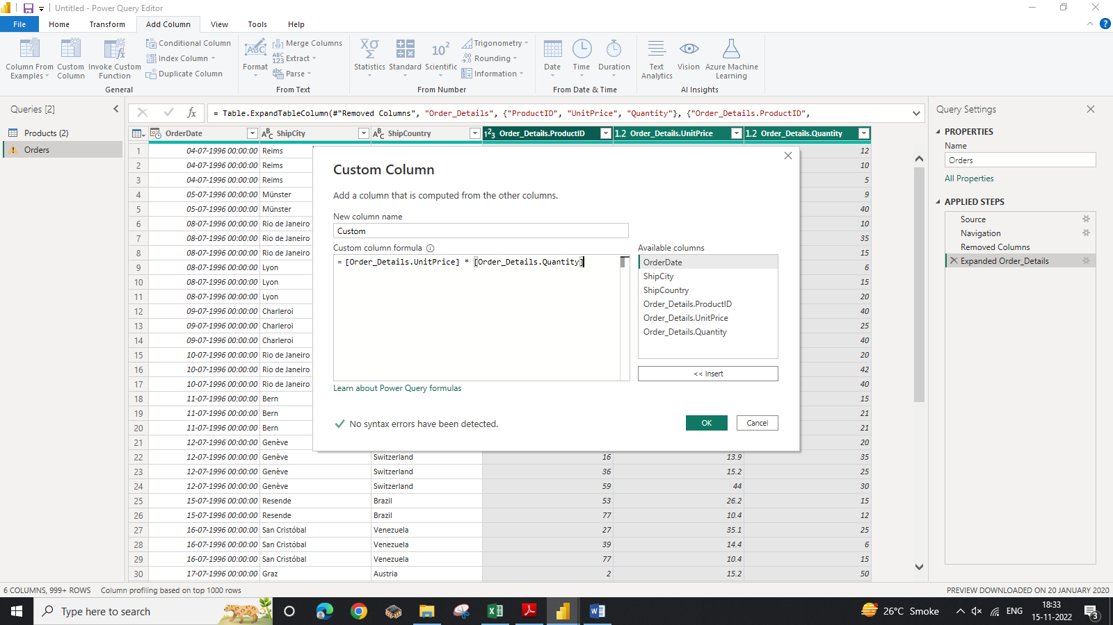

**Step 5: Set the datatype of the LineTotal field**

1. Right click the **LineTotal** column.

2. Select **Change Type** and choose **Decimal Number**.

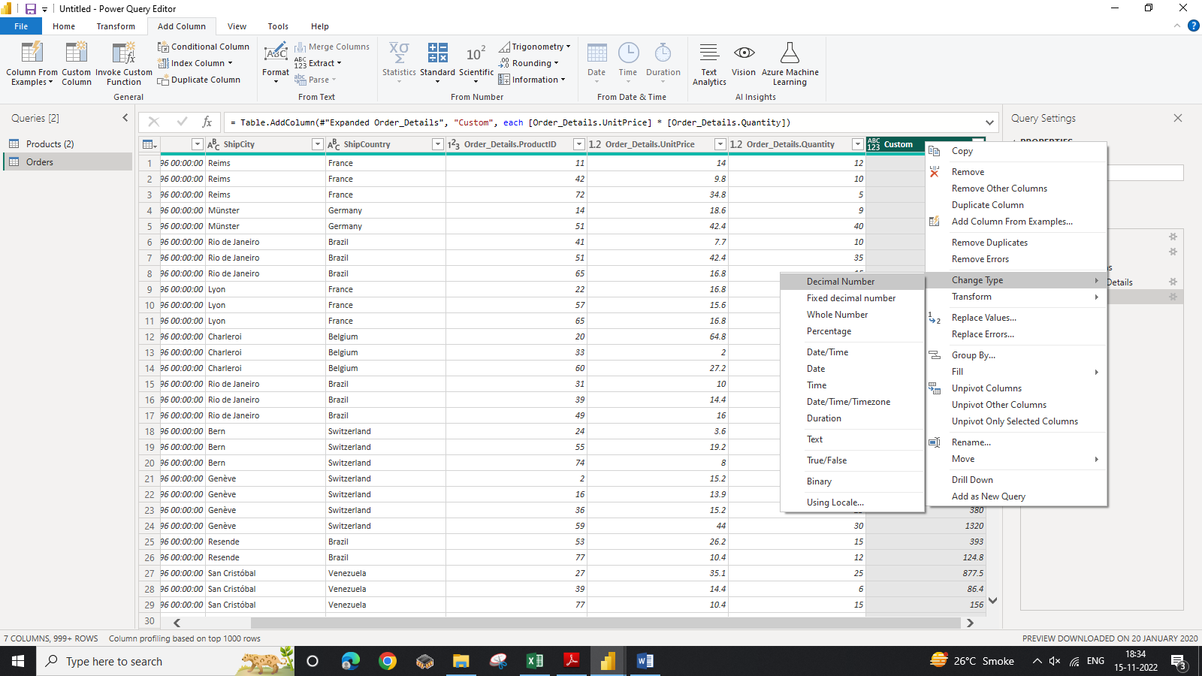

**Step 6: Rename and reorder columns in the query**

1. In **Query Editor,** drag the **LineTotal** column to the left, after **ShipCountry.**

2. Remove

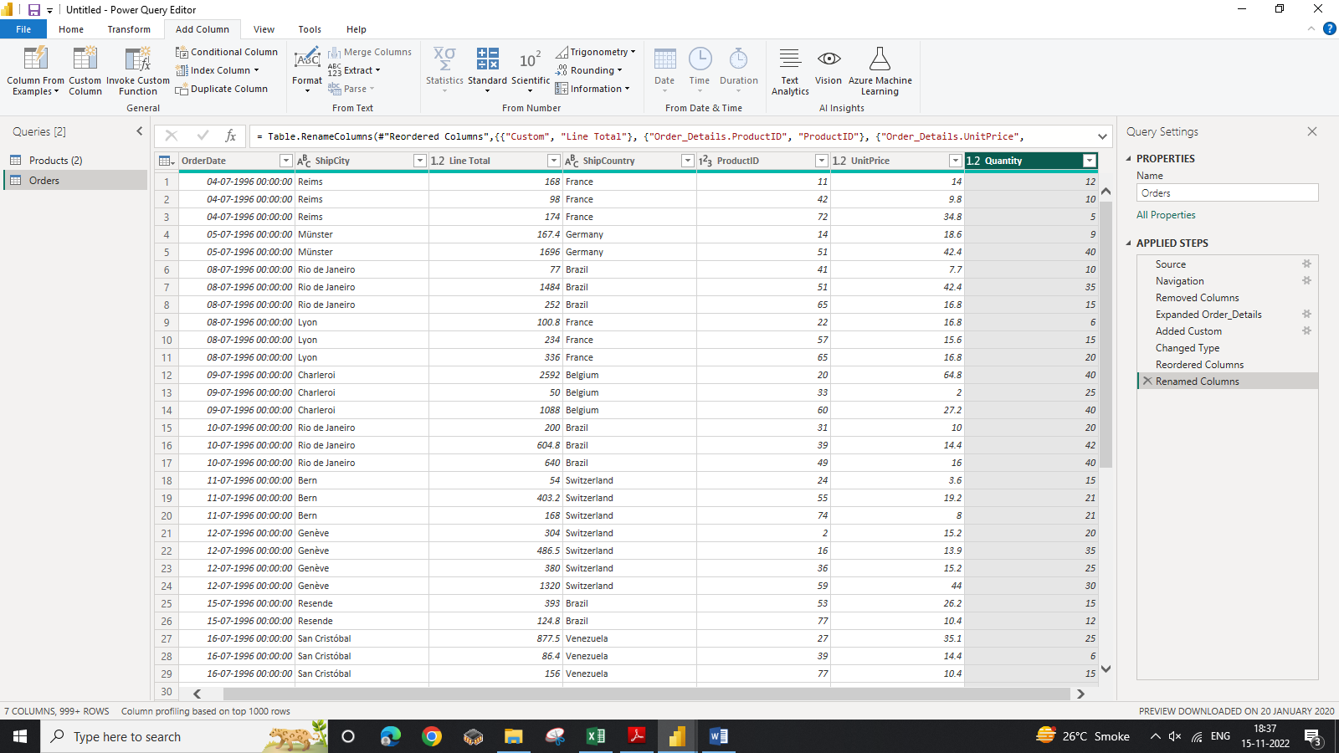

2. Remove the Order_Details. prefix from the **Order_Details.ProductID, Order_Details.UnitPrice**

and **Order_Details.Quantity** columns, by double-clicking on each column header, and then deleting

that text from the column name.

**Task 3: Combine the Products and Total Sales queries**

1.First, we need to load the model that we created in Query Editor into Power BI Deshtop. From the **Home** Ribbon of Query Editor, select **Close & Load**.

2. Power BI Desktop loads the data from the two queries

3. Once the data is loaded, select the Manage Relationships button Home ribbon

4. Select the New… button

5. When we attempt to create the relationship, we see that one already exists! As shown in the

Create Relationship dialog (by the shaded columns), the ProductsID fields in each query

already have an established relationship.

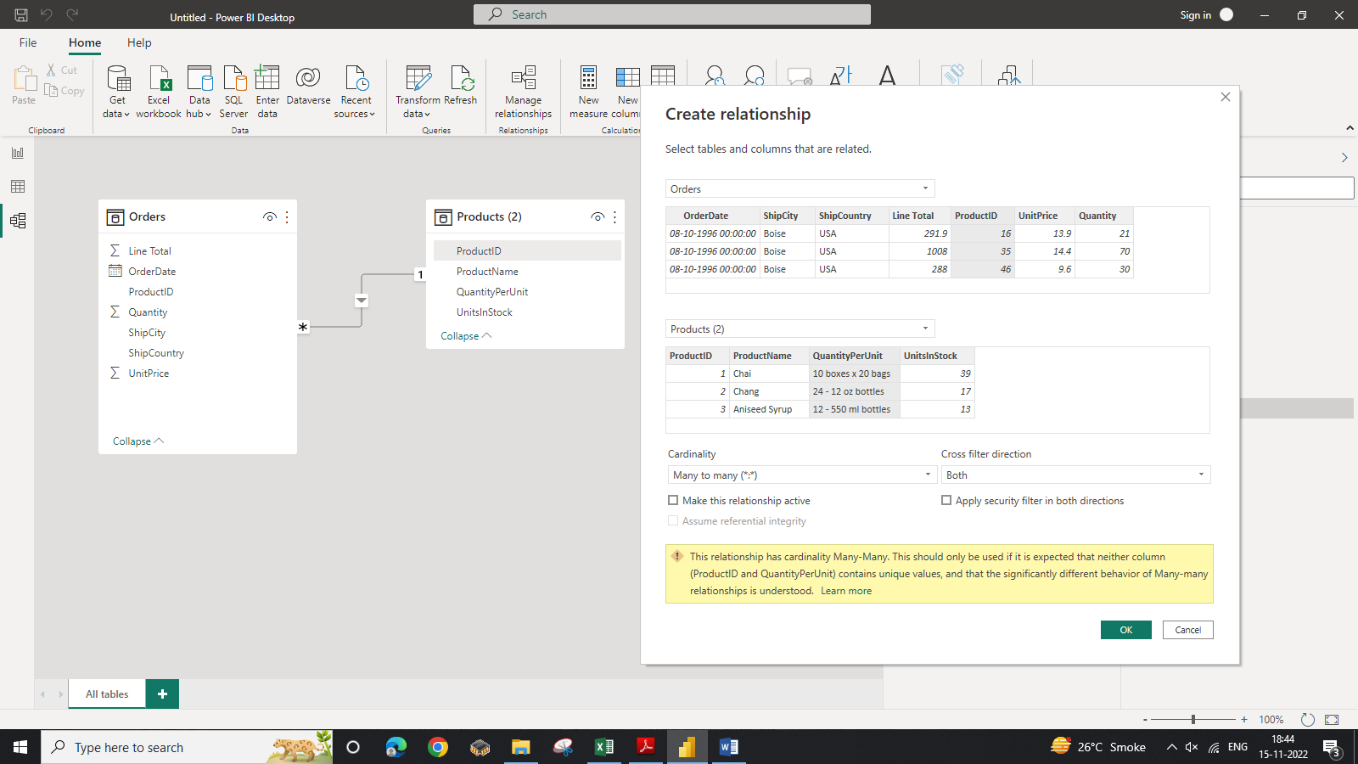

6.Select Cancel, and then select Relationship view in Power BI Desktop.

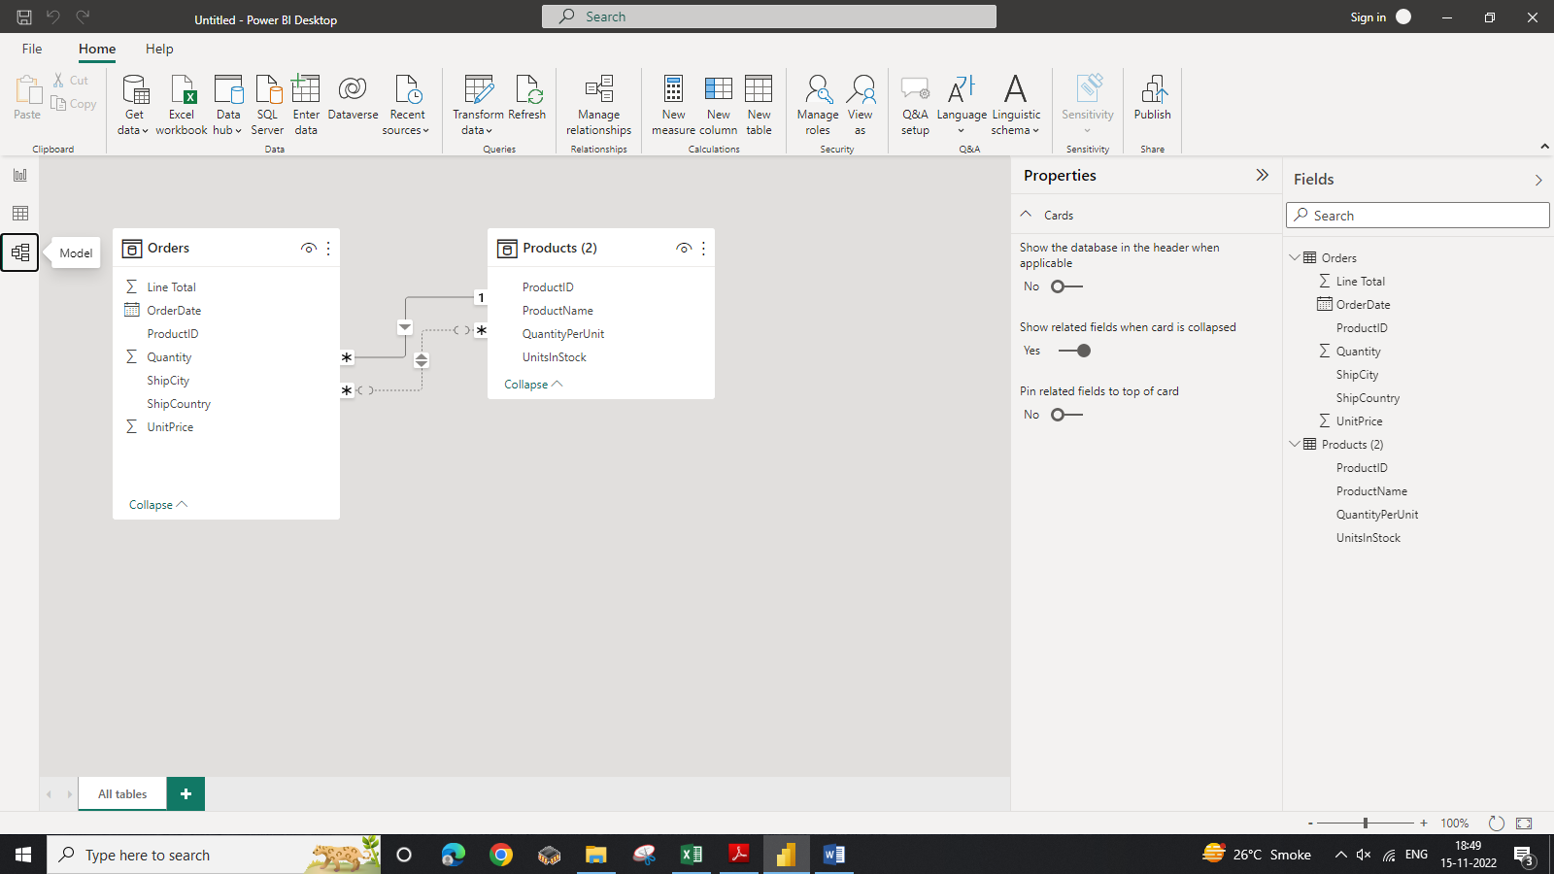

**Task 4: Build visuals using your data**

Step 1: Create charts showing Units in Stock by Product and Total Sales by Year

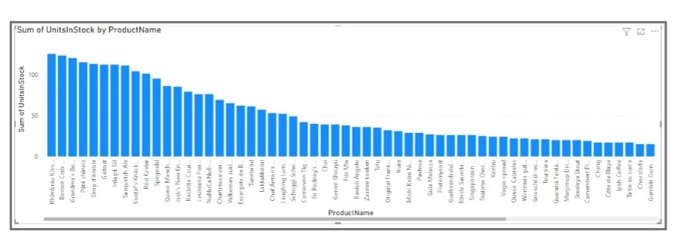

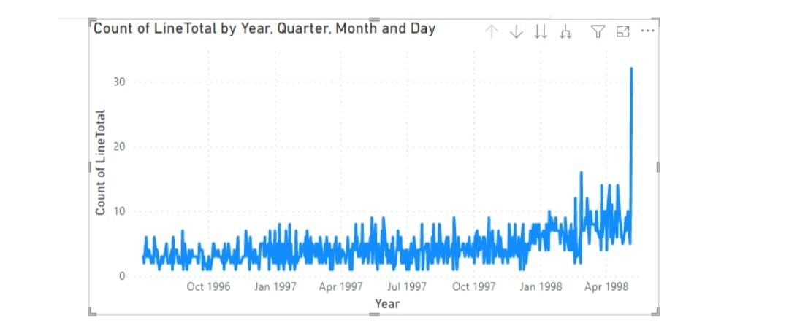

Step 2: Drag OrderDate to the canvas beneath the first chart, then drag LineTotal (again, the Fields pane) onto the visual, then select Line Chart. The following visualization is created.

Step 3: Next, drag ShipCountry to a spare on the canvas in the top right. Because you selected a geographic field , a map was created automatically . Now drag LineTotal to the Values field; the circles on the map for each country are now relative in size to the LineTotal for orders shipped to that country.

